MINISTRY OF HEALTH OF UKRAINE
MINISTRY OF EDUCATION AND SCIENCE OF UKRAINE
NATIONAL UNIVERSITY OF PHARMACY
DEPARTMENT OF CHEMISTRY OF NATURAL COMPOUNDS AND NUTRICIOLOGY
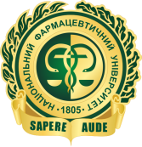 | 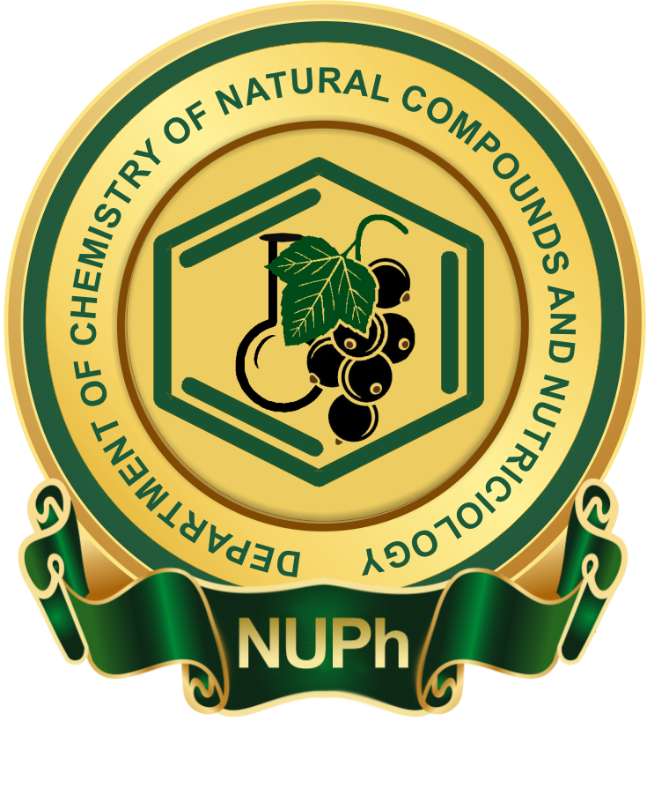

IІ INTERNATIONAL SCIENTIFIC AND PRACTICAL INTERNET-CONFERENCE
«CURRENT APPROACHES OF PHARMACEUTICAL SCIENCE IN DEVELOPMENT AND STANDARDIZATION OF MEDICINES AND DIETARY SUPPLEMENTS THAT CONTAIN COMPONENTS OF NATURAL ORIGIN»

ANNOUNCEMENT
Dear colleagues!
Department of Chemistry of Natural Compounds and Nutriciology of the National University of Pharmacy of the Ministry of Health and the Ministry of Education of Science of Ukraine invite you to participate in the II International Scientific and Practical Internet-Conference «Current approaches of pharmaceutical science in development and standardization of medicines and dietary supplements that contain components of natural origin», which will be held
on March 11, 2020.
The Conference is included into the Register of Congresses, Symposia and scientific and practical conferences of 2020 (UkrISTEI certificate № 429 from 13.08.2019).

CENTRAL AREAS OF FOCUS OF THE CONFERENCE
- Analysis of the market of herbal medicines, dietary supplements, medical and preventive, and cosmetic remedies;
- The search of new sources of medicinal plant material for the creation of medicines and dietary supplements;
- Standardization of medicines and their pharmaceutical analysis;
- Current approach to the technology of herbal medicines;
- Analysis of extemporal medicinal forms on the basis of plant-derived components;
- Pharmacological research of plant-derived medicines, determination of safety of dietary supplements.

TO PARTICIPATE IN THE CONFERENCE ARE INVITED
Scientists, Master’s degree students, post-doctoral students, lecturers of higher pharmaceutical and medical educational establishments, members of pharmaceutical enterprises, pharmaceutical firms.

FORM OF PARTICIPATION IN THE CONFERENCE
Virtual (only abstract publishing).

LANGUAGES OF THE CONFERENCE
Ukrainian, Russian, English.

ABSTRACT SUBMISSION
The abstract should be prepared in the word processor Microsoft Word (*.doc or *.docx).
All margins 2 cm, font Times New Roman, font size 14, spacing – 1,0, paragraph indention – 1,25 cm, spacing before and after paragraph – 0 pt (absent), full justification.
Total size of an abstract (А4 format), including tables, pictures and references should be 1-2 full pages.
Word and term shortenings in the title of abstract are not allowed; complete forms of shortenings in the text are given after the first mentioning. The International System of Units (SI) should only be used in the abstract.
The abstract heading includes: first line – abstract title (capital letters, bold), second line – last names and initials of the authors are separated by comma (bold italics), third line – full title of the organization (bold italics). The body of the abstract is given after one line.
The abstracts should contain the following parts: introduction, materials and methods, results and their discussion.
After the body of the abstract the list of references is given (not more than 5 sources in alphabetical order). The references are given in the text using the number of the literature source in square brackets.
Chemical structures are given in IsisDraw format, mathematic – using the built-in editor Microsoft Equation, pictures – in *.cdr format (versions not higher than Х8), *.jpg or *.tiff.
Abstracts formatted according to the requirements should be sent before
March 6, 2020 to the e-mail address cnckonf2018@gmail.com.
One file should contain one abstract. The file names should correspond with the name of the first author (e.g., Petrov А.А.doc). If more than one abstract is submitted by one author, the files should be numbered with arabic figures (e.g., Petrov А.А.1.doc).

ABSTRACT FORMATTING SAMPLE
IDENTIFICATION OF FLAVONOIDS IN APPLE TREE LEAVES
Petrov А.А., Ivanova N.О.
National University of Pharmacy, Kharkiv, Ukraine

Introduction. Text, text, text [1].
Materials and methods. Text, text, text.
Results and their discussion. Text, text, text.
References:

CONDITIONS OF PARTICIPATION
Participation in the Conference is free.
You will receive a message to your e-mail about abstract reception and their acceptance for publication.
The Proceedings of the Conference will be published in the Abstracts Book, which will also be available online on the Website of the Department of Natural Compounds and Nutriciology: http://cnc.nuph.edu.ua.

ORGANIZING COMMITTEE
National University of Pharmacy, Department of Chemistry of Natural Compounds and Nutriciology (Valentynivska (Blyukhera) str., 4, Kharkiv, Ukraine, 61168).
Contacts
Executive secretaries:
PhD (PharmSc), assistant professor Liliia M. Goriacha
PhD (PharmSc), assistant professor Viktoriia V. Protska
Senior Assistant Olena Iosypenko
Tel.: (0572) 67 93 63
E-mail: cnckonf2018@gmail.com
With particular attention and benevolence,
The Organizing Committee of the Conference:
Kotvitska А.А. – Rector of the National University of Pharmacy, Doctor of Pharmaceutical Sciences, Professor, Honored Worker of Science and Technology of Ukraine.
Fedosov А.І. – Chief Vice-Rector on educational work of the National University of Pharmacy, Doctor of Pharmaceutical Sciences, Professor.
Zagayko A.L. – Vice-Rector for scientific and pedagogic (educative) work of the National University of Pharmacy, Doctor of Biological Sciences, Professor.
Krutskykh Т.V. – Vice-Rector for scientific and pedagogic (educative) work of the National University of Pharmacy, Doctor of Pharmaceutical Sciences, Professor.
Kyslychenko V.S. – Head of the Department of Chemistry of Natural Compounds and Nutriciology of the National University of Pharmacy, Doctor of Pharmaceutical Sciences, Professor, Honored Worker of Science and Technology of Ukraine.

