16.03 – 7, 8 groups

18.03 – 1, 2 group

19.03 – 3, 4 groups

20.03 – 5, 6 group

LABORATORY CLASS. Topic: «Chemical, morphological and anatomical analysis of MPM containing alkaloids – І.»

OBJECTIVE.
Know the definition of the term “Alkaloids”, their classification, physical and chemical properties, the identification and quantitative analysis, pharmacological properties.

Analysis of medicinal plant material containing alkaloids

Chemical analysis of medicinal plant material containing alkaloids

Task 1. Extract alkaloids in form of salts from medicinal plant material for the general quality reactions
Method. Place 1.0 g of powdered plant material in a glass conical flask, add 25 ml of 1% hydrochloric acid. Attach a reflux condenser to the flask and boil on a water bath for 30 minutes stirring from time to time. Cool and filter the solution through a paper filter. The filtrate is used for the general quality reactions.
Task 2. Conduct general and colour quality reactions on alkaloids. Make a conclusion.
Method. Put 1 drop of the filtrate and 1 drop of a reagent on subject glass and mix them up by a glass stick.
General reactions
1. Reaction with Wagner’s reagent (iodine in potassium iodide).
Observation: ____________________________________________________________________
2. Reaction with Mayer’s reagent (potassium mercuric iodide).
Observation: ____________________________________________________________________
3. Reaction with Dragendorff’s reagent (potassium bismuth iodide).
Observation: ____________________________________________________________________
4. Reaction with Scheibler’s reagent (1 % phosphotungestic acid).
Observation: ____________________________________________________________________
5. Reaction with Bertrand’s reagent (1 % silicotungestic acid).
Observation: ____________________________________________________________________
6. Reaction with 1 % phosphomolybdic acid.
Observation: ____________________________________________________________________
7. Reaction with 1 % picric acid.
Observation: ____________________________________________________________________
8. Reaction with 0.1 % tannin solution.
Observation: ____________________________________________________________________
Conclusion:______________________________________________________________________
________________________________________________________________________________

Colour reactions
9. Reaction with concentrated sulphuric acid.
Observation: ____________________________________________________________________
10. Reaction with concentrated nitric acid.
Observation: ____________________________________________________________________
11. Reaction with Erdmann’s reagent (concentrated sulphuric and nitric acids).
Observation: ____________________________________________________________________
12. Reaction with Froed’s reagent (ammonium molybdate in concentrated sulphuric acid).
Observation: ____________________________________________________________________
13. Reaction with Marqui’s reagent (formaldehyde in concentrated sulphuric acid).
Observation: ____________________________________________________________________
14. Reaction with 1 % sodium nitroprusside.
Observation: ____________________________________________________________________
Conclusion:______________________________________________________________________
________________________________________________________________________________

Task 3. Extract the purified sum of alkaloids from belladonna leaf for quality reaction. Make a conclusion
Method. Place 1.0 g of the powdered belladonna leaf in a glass conical flask, add 10 ml of 0.05 % sulphuric acid and stir for 2 minutes. Filter, add 1 ml of concentrated ammonia and 5 ml of water and thoroughly shake with 15 ml of ether. Separate ether layer and filter it through anhydrous sodium sulphate. Transfer ether extract to a flat-bottomed dish and evaporate to dryness on a water-bath. Dissolve the dry residue in 0.5 ml of concentrated nitric acid and evaporate to dryness on a water-bath. Add 10 ml of acetone and 3% potassium hydroxide alcoholic solution by drops.
Observation:_____________________________________________________________________
________________________________________________________________________________
Conclusion:______________________________________________________________________
________________________________________________________________________________
Task 4 Do the chromatographic determination of alkaloids in belladonna leaf comparing to the standard. Compare R_{f}, colouring of spots.
Method. Place 0.6 g of pulverized plant material in a flask. Add 15 ml of 0.05 mole/l sulphuric acid, stir for 2 minutes, filter. Wash a filter by 0.05 mole/l sulphuric acid to receive 20 ml of filtrate. Add 1 ml of concentrated ammonia solution to the filtrate, transfer to the separating funnel and treat it by 10 ml twice. Separate ether layes, unite it and filter it through anhydrous sodium sulphate. Ether is distilled off, dry residue is dissolved in 0.5 ml of methanol.
Put filtrate and solutions of hyoscyamine and scopolamine as standards on the start line of chromatographic plates with a size 7×15 cm, covered with silica gel layer. A plate is chambered with mixture of solvents acetone: water: concentrated ammonia (90:7:3) and chromatographed. When front line of solvents passes near 10 cm from the start line, a plate is taken out, dried in the drying box at 100 °C during 15 min, processed with Dragendorff’s reagent. The chromatogram is analyzed in the day light. Alkaloids appear as orange or brown spots on a yellow background.
Scheme of the chromatogram | Chromatogram of extracts containing alkaloids
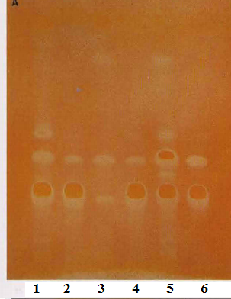 | Chromatography conditions: sorbent: silicagel 60 F254  solvents system-acetone – water - concentrated ammonia (90:7:3)  Derivatizing reagent: Dragendorff’s reagent  - Belladonna leaves; 2- hyoscyamine; 3- Henbane leaves; 4- scopolamine; 5 - Stramonium leaves; 6 - mixture of hyoscyamine sulfate and scopolamine hydrobromide

Task 5. Determine the content of alkaloids in Solanaceae family plants. Compare result with the standard.
Method. 1. Extraction. Place 0.0150 g of pulverized plant material, accurately weighed, in a 250 ml flask, add 150 ml of ether, 7 ml of concentrated ammonia solution and shake during 1 hour. Filter through cotton in the 200 ml flask.
2. Purification. Add 5 ml of water to the filtrate, shake vigorously and leave to clarification of ether layer, then measure 90 ml of ether extract by a graduated cylinder to a 200 ml separating funnel. A cylinder is twice rinsed with 10 ml of ether and added to the ether extract.
Ether extract is treated by 1 % hydrochloric acid solution successively by 20, 15 and 10 ml (a test with Mayer’s reagent), each time filtered through a moistened with water filter, to another separating funnel of the same capacity. The filter is twice washed with 1 % hydrochloric acid solution for 5 ml, added to general acid extract.
Acid extract is alkalified by ammonia to the alkali medium on phenolphthalein, and alkaloids extract is treated by 20, 15, 10 ml of chloroform, shaking up for 3 minutes. Chloroform is filtered in a 100 ml round-bottomed retort through a paper filter, moistened with chloroform and 4-5 g of anhydrous sodium sulphate. A filteris twice washed with 5 ml of chloroform. Chloroform is distilled off on a bath to 1-2 ml, and the remain is blown out to the complete disappearance of chloroform smell.
3. Titration. The dry residue is dissolved in 15 ml of 0.02 mole/l hydrochloric acid solution, heated on an water bath, add 2 drops of methyl orange alcoholic solution and 1 drop of methylene dark blue and the excess of hydrochloric acid is titrated by 0.02 mole/l sodium hydroxide solution to the yellow colouring.
4. Calculation. Content of alkaloids in terms of hyoscyamine in percents (X) is calculated using formula:
where 1 ml 0,02 mole/l of hydrochloric acid solution corresponds to 0,005780 of hyoscyamine, g;
V - volume of 0.02 mole/l sodium hydroxide solution used for titration, ml;
m - mass of plant material, g which corresponds to the measured V of the ether extract;
W - loss in weight at drying of plant material, %.
Conclusion:______________________________________________________________________

16.03 – 7, 8 groups

18.03 – 1, 2 group

19.03 – 3, 4 groups

20.03 – 5, 6 group

LABORATORY CLASS. Topic: «Chemical, morphological and anatomical analysis of MPM containing alkaloids – IІ.»

OBJECTIVE.
Know the macro- and microscopic signs of medicinal plant material containing protoalkaloids, purine alkaloids and pseudoalkaloids.

Macro- and microscopic analysis of medicinal plant material containing protoalkaloids

Objects: capsicum, ephedra, colchicum.
Capsicum fruit
Latin name of medicinal plant material

Latin name of the plant | English name of the plant
Family
 | Place for medicinal plant material
Specific features:__________________________________________________________________
________________________________________________________________________________
________________________________________________________________________________
Uses in medicine __________________________________________________________________
________________________________________________________________________________
Ephedra stem
Latin name of medicinal plant material

Latin name of the plant | English name of the plant
Family
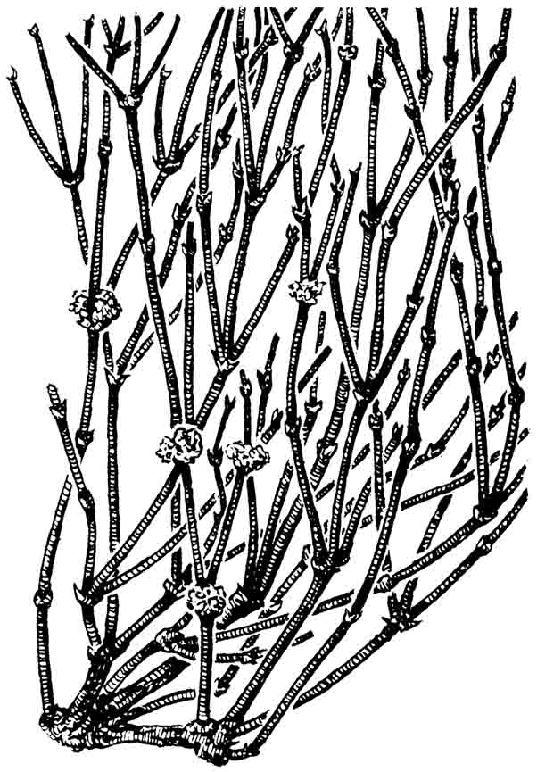  Original appearance of medicinal plant material | Place for medicinal plant material
Specific features:__________________________________________________________________
________________________________________________________________________________
________________________________________________________________________________
Uses in medicine __________________________________________________________________
________________________________________________________________________________
Fresh Colchicum corm
Latin name of medicinal plant material

Latin name of the plant |  | English name of the plant
Family
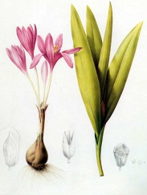 | Uses in medicine________________________________________________  _____________________________________________________________  _____________________________________________________________  _____________________________________________________________  _____________________________________________________________

Macro- and microscopic analysis of medicinal plant material containing purine alkaloids
Objects: tea, coffee, cola, cocoa, guarana.
Tea leaf
Latin name of medicinal plant material

Latin name of the plant |  | English name of the plant
Family
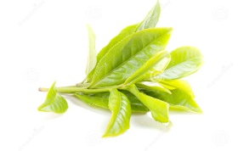 | Uses in medicine________________________________________________  _____________________________________________________________  _____________________________________________________________  _____________________________________________________________
Coffee bean
Latin name of medicinal plant material

Latin name of the plant |  | English name of the plant
Family
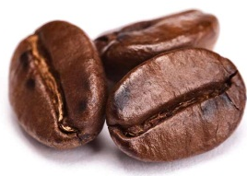 | Uses in medicine________________________________________________  _____________________________________________________________  _____________________________________________________________  _____________________________________________________________
Cocoa seed
Latin name of medicinal plant material

Latin name of the plant |  | English name of the plant
Family
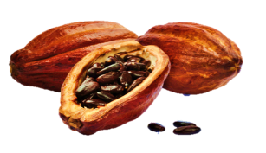 | Uses in medicine________________________________________________  _____________________________________________________________  _____________________________________________________________  _____________________________________________________________

Macro- and microscopic analysis of medical plant material containing pseudoalkaloids

Objects: aconite, delphinium, yew, kangaroo apple, veratrum.
Aconite root
Latin name of medicinal plant material

Latin name of the plant | English name of the plant
Family
 | Place for medicinal plant material
Specific features:__________________________________________________________________
________________________________________________________________________________
Uses in medicine __________________________________________________________________
________________________________________________________________________________
Delphinium herb
Latin name of medicinal plant material

Latin name of the plant | English name of the plant
Family
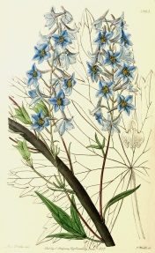 | Place for medicinal plant material
Specific features:__________________________________________________________________
________________________________________________________________________________
Uses in medicine __________________________________________________________________
________________________________________________________________________________ Yew
Latin name of medicinal plant material

Latin name of the plant | English name of the plant
Family
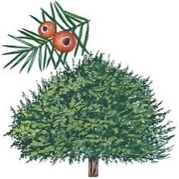 | Place for medicinal plant material
Specific features:__________________________________________________________________
________________________________________________________________________________
Uses in medicine __________________________________________________________________
________________________________________________________________________________ Kangaroo Apple herb
Latin name of medicinal plant material

Latin name of the plant | English name of the plant
Family
Specific features:__________________________________________________________________
________________________________________________________________________________
Uses in medicine __________________________________________________________________

Veratrum rhizomes and roots
Latin name of medicinal plant material

Latin name of the plant | English name of the plant
Family
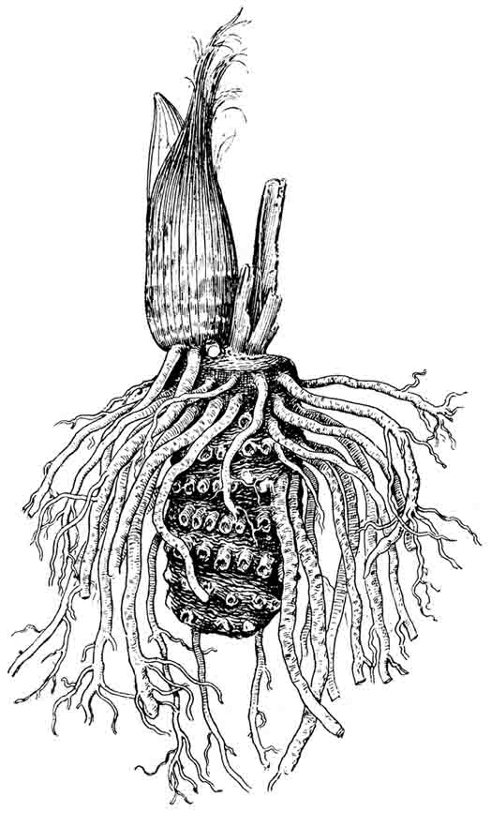 | Place for medicinal plant material
Specific features:__________________________________________________________________
________________________________________________________________________________
Uses in medicine __________________________________________________________________
________________________________________________________________________________

06.04 – 7, 8 groups

08.04 – 1, 2 group

09.04– 3, 4 groups

10.04 – 5, 6 group

LABORATORY CLASS. Topic: «Chemical, morphological and anatomical analysis of MPM containing alkaloids – IІI.»

OBJECTIVE.
Know the macro- and microscopic signs of medicinal plant material containing tropane, pyrrolizidine, quinolizidine, isoqunoline and indole alkaloids.

Macro- and microscopic analysis of medicinal plant material containing tropane, pyrrolizidine, quinolizidine alkaloids

Objects: belladonna, stramonium, datura, henbane, coca, senecio, bush pea.

Belladonna leaf
Latin name of medicinal plant material

Latin name of the plant | English name of the plant
Family
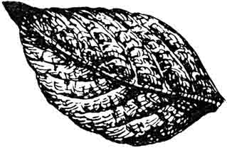 | Place for medicinal plant material
Specific features:__________________________________________________________________
________________________________________________________________________________
________________________________________________________________________________

Microscopic analysis of belladonna leaf
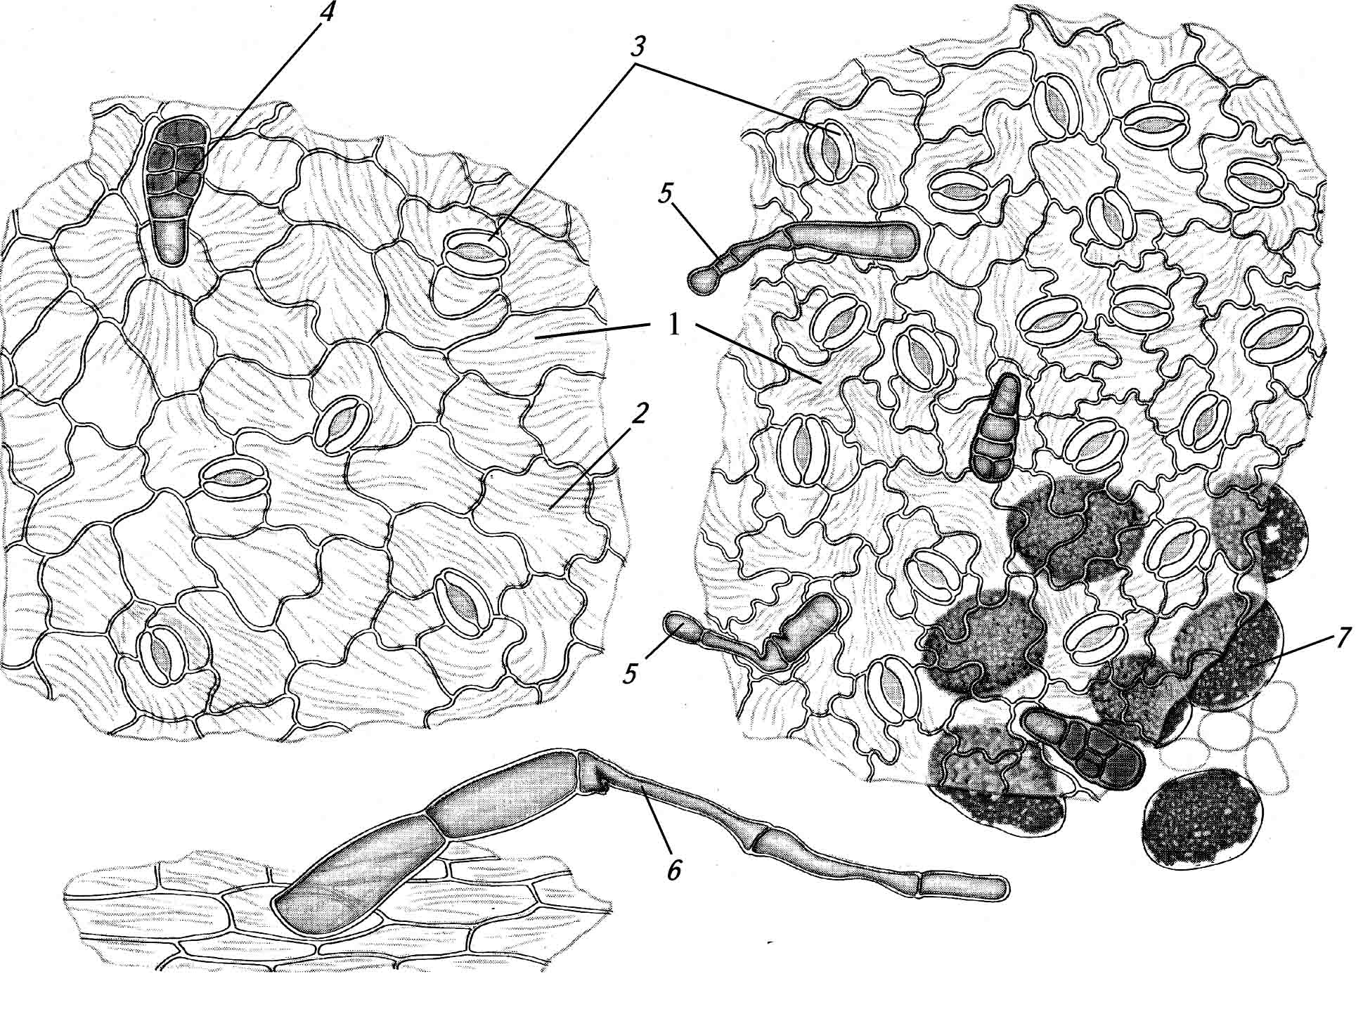 | Anatomical features of belladonna leaf  1.  2.  3.  4.  5.  6.  7.
Uses in medicine __________________________________________________________________
________________________________________________________________________________
Belladonna root
Latin name of medicinal plant material

Latin name of the plant | English name of the plant
Family
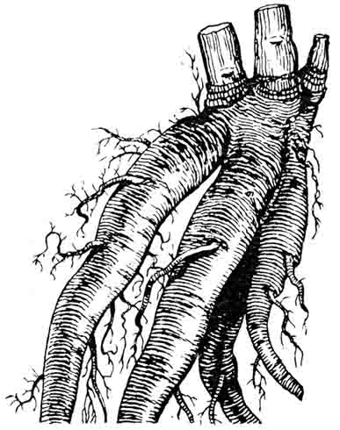 | Place for medicinal plant material
Specific features:__________________________________________________________________
________________________________________________________________________________
________________________________________________________________________________
Uses in medicine __________________________________________________________________
________________________________________________________________________________
Stramonium leaf
Latin name of medicinal plant material

Latin name of the plant | English name of the plant
Family
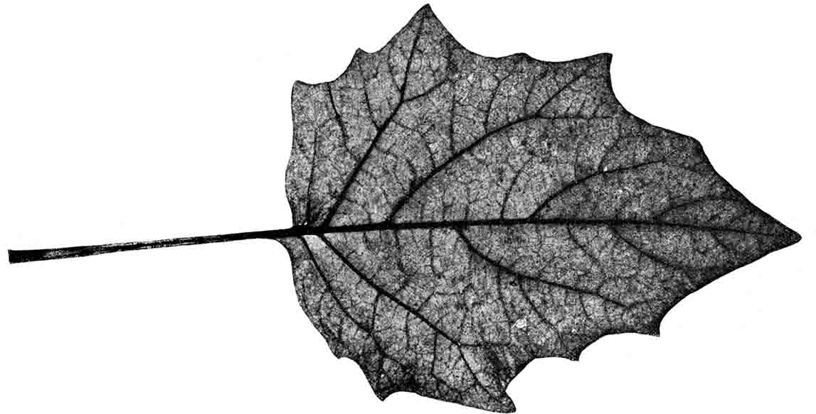 | Place for medicinal plant material
Specific features:__________________________________________________________________
________________________________________________________________________________
________________________________________________________________________________
Microscopic analysis of stramonium leaf
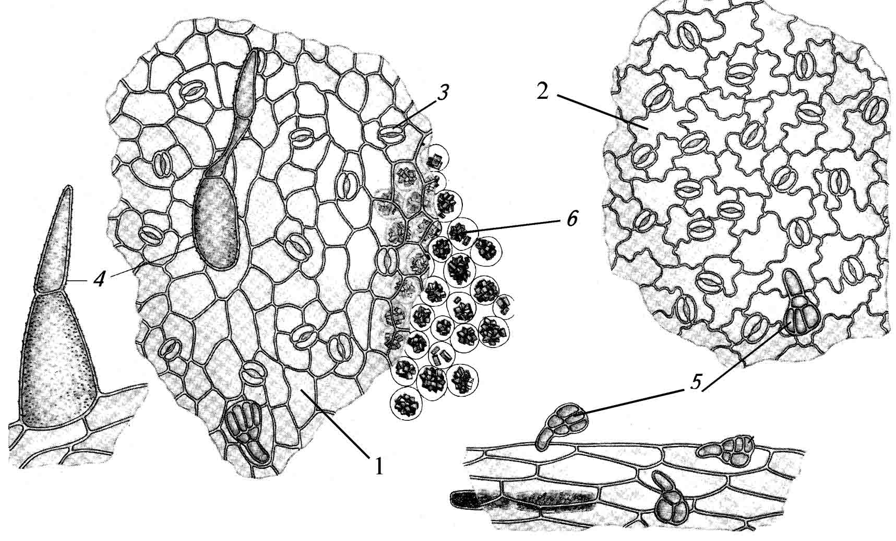 | Anatomical features of stramonium leaf  1.  2.  3.  4.  5.  6.
Uses in medicine __________________________________________________________________
________________________________________________________________________________
Henbane leaf
Latin name of medicinal plant material

Latin name of the plant | English name of the plant
Family
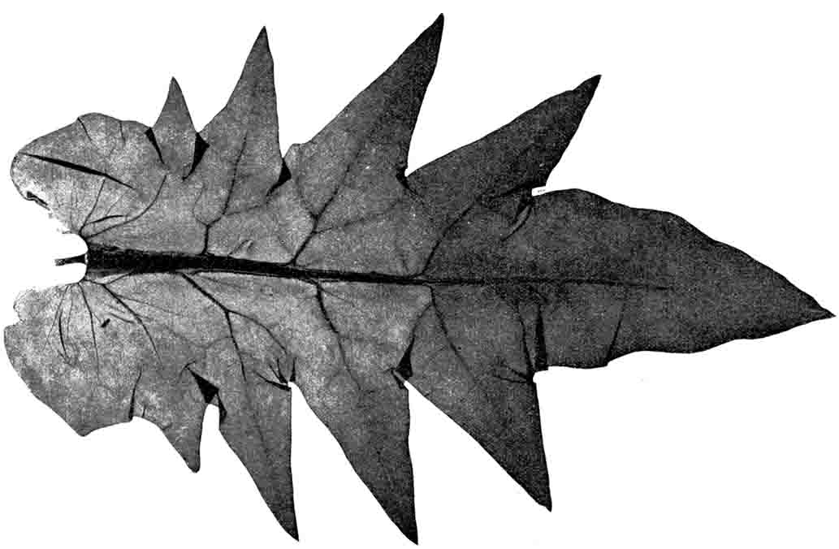 | Place for medicinal plant material
Adulteration:
1. _________________________________________________________________________
2. _________________________________________________________________________
3. _________________________________________________________________________

Microscopic analysis of henbane leaf
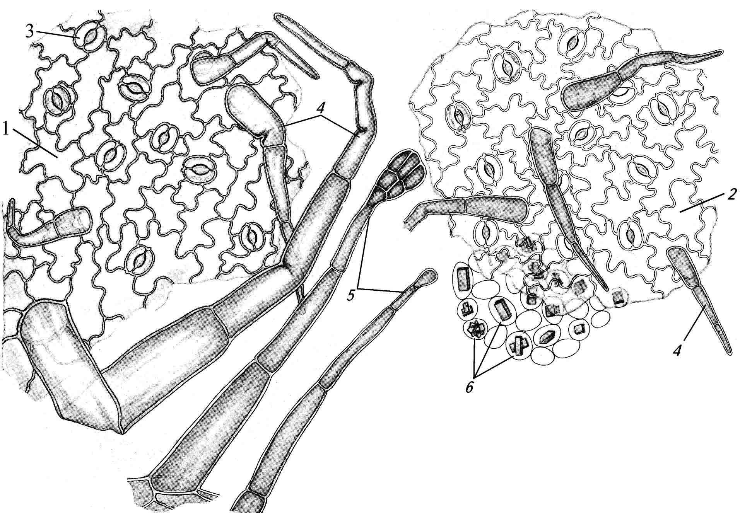 | Anatomical features of henbane leaf  1.  2.  3.  4.  5.  6.
Specific features:__________________________________________________________________
________________________________________________________________________________
________________________________________________________________________________
Uses in medicine __________________________________________________________________
________________________________________________________________________________
Thermopsis herb
Latin name of medicinal plant material

Latin name of the plant | English name of the plant
Family
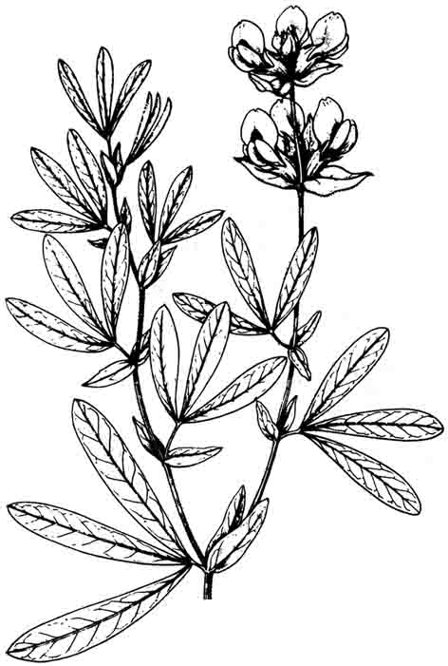 | Place for medicinal plant material
Specific features:__________________________________________________________________
________________________________________________________________________________
________________________________________________________________________________
Microscopic analysis of Thermopsis leaf
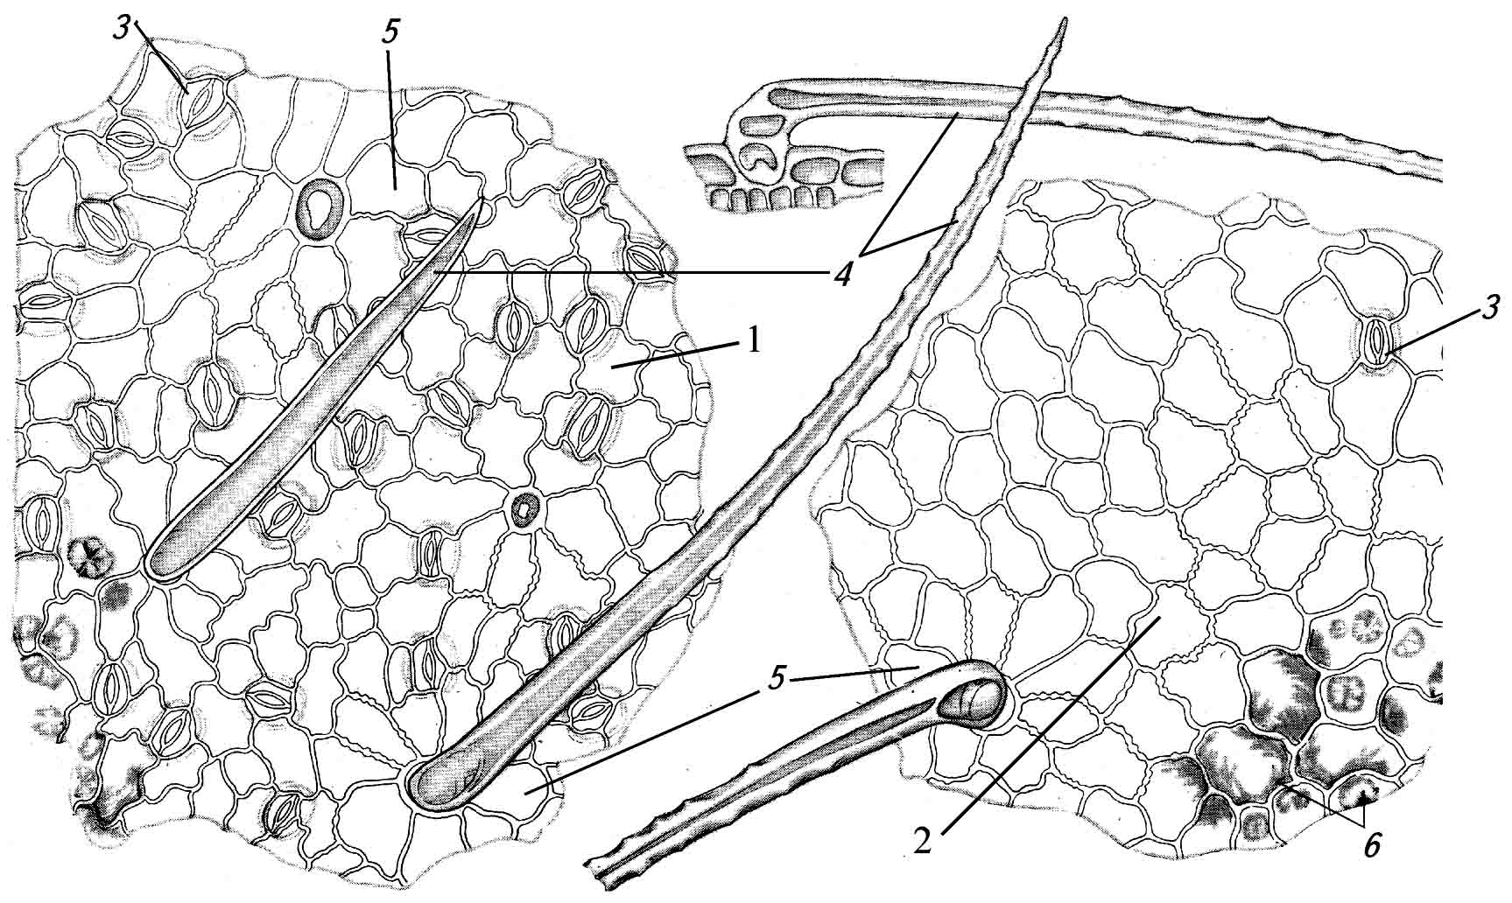 | Anatomical features of Bush pea leaf  1.  2.  3.  4.  5.
Uses in medicine __________________________________________________________________
________________________________________________________________________________
Macro- and microscopic analysis of medical plant material containing isoquinoline, indole alkaloids

Objects: poppy, tulip poppy, plum poppy, celandine, barberry, passionflower, snakeweed, periwinkle, catharanthus, ergot, hatchet-vetch.

Celandine herb
Latin name of medicinal plant material

Latin name of the plant | English name of the plant
Family
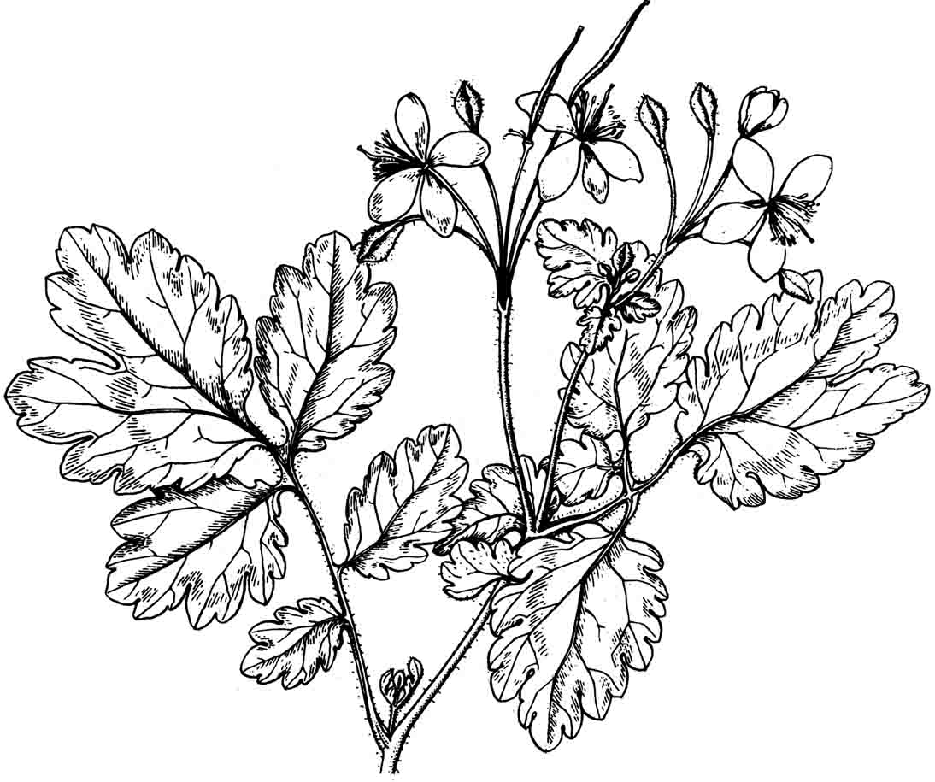 | Place for medicinal plant material
Specific features:__________________________________________________________________
________________________________________________________________________________
________________________________________________________________________________

Microscopic analysis of celandine leaf
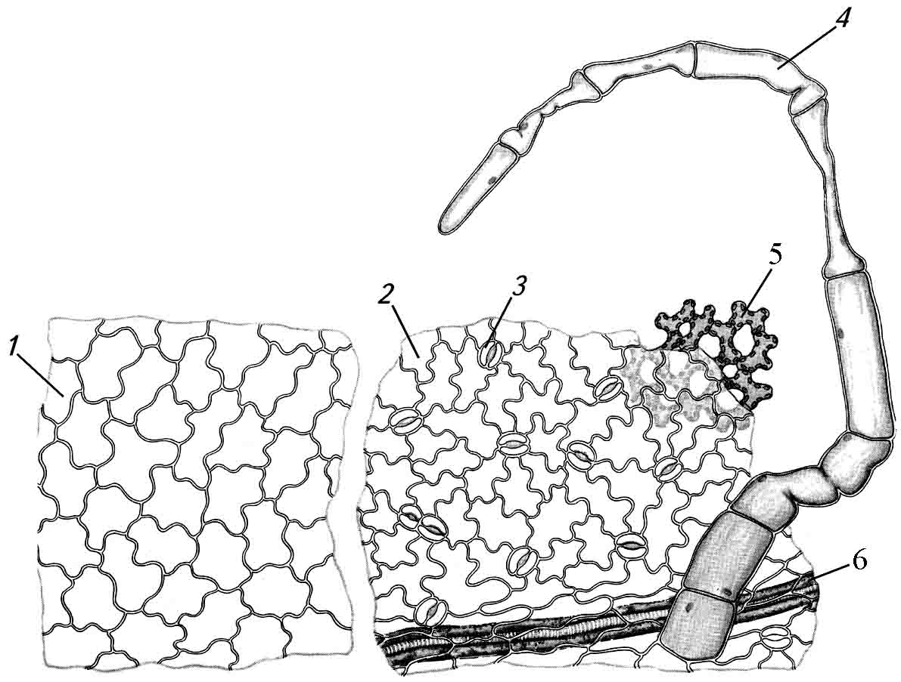 | Anatomical features of celandine leaf  1.  2.  3.  4.  5.  6.
Uses in medicine __________________________________________________________________
________________________________________________________________________________
Tulip poppy herb
Latin name of medicinal plant material

Latin name of the plant | English name of the plant
Family
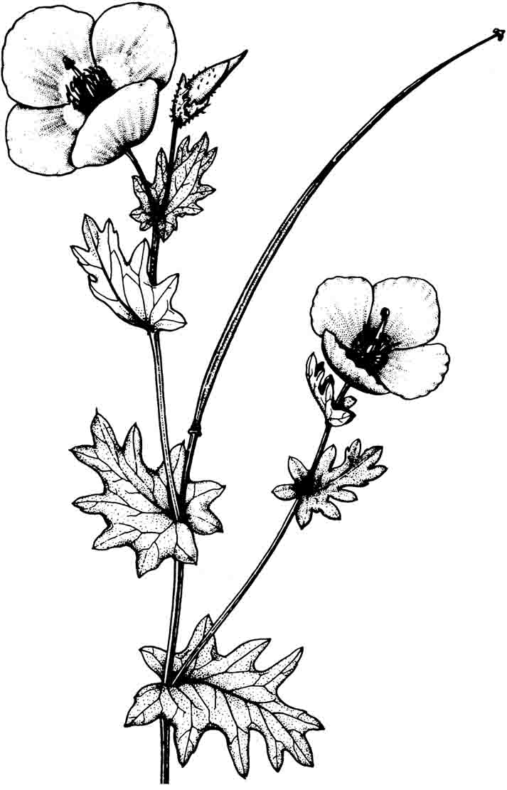 | Place for medicinal plant material
Specific features:__________________________________________________________________
________________________________________________________________________________
________________________________________________________________________________
Uses in medicine __________________________________________________________________
________________________________________________________________________________
Barberry root
Latin name of medicinal plant material

Latin name of the plant | English name of the plant
Family
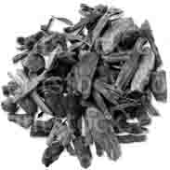 | Place for medicinal plant material

Specific features:__________________________________________________________________
________________________________________________________________________________
________________________________________________________________________________
Uses in medicine __________________________________________________________________
________________________________________________________________________________
Barberry leaf
Latin name of medicinal plant material

Latin name of the plant | English name of the plant
Family
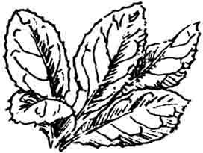 | Place for medicinal plant material
Specific features:__________________________________________________________________
________________________________________________________________________________
________________________________________________________________________________
Uses in medicine __________________________________________________________________
________________________________________________________________________________
Passionflower herb
Latin name of medicinal plant material

Latin name of the plant | English name of the plant
Family
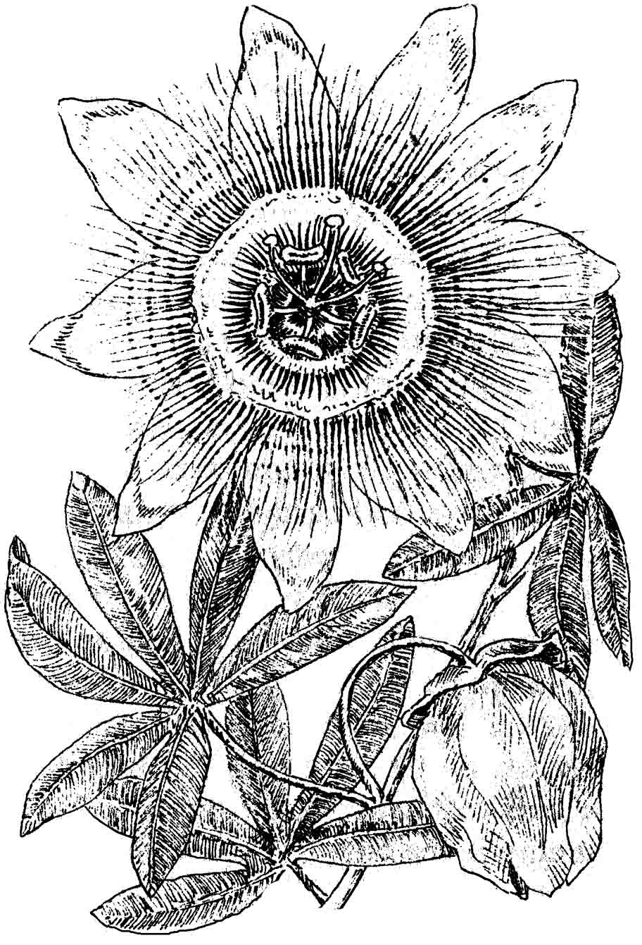 | Place for medicinal plant material
Specific features:__________________________________________________________________
________________________________________________________________________________
________________________________________________________________________________
Uses in medicine __________________________________________________________________
________________________________________________________________________________
Snakeweed root
Latin name of medicinal plant material

Latin name of the plant | English name of the plant
Family
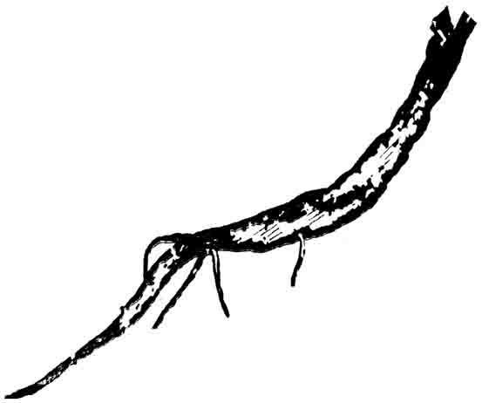 | Place for medicinal plant material
Specific features:__________________________________________________________________
________________________________________________________________________________
________________________________________________________________________________
Uses in medicine __________________________________________________________________
________________________________________________________________________________
Common periwinkle herb
Latin name of medicinal plant material

Latin name of the plant | English name of the plant
Family
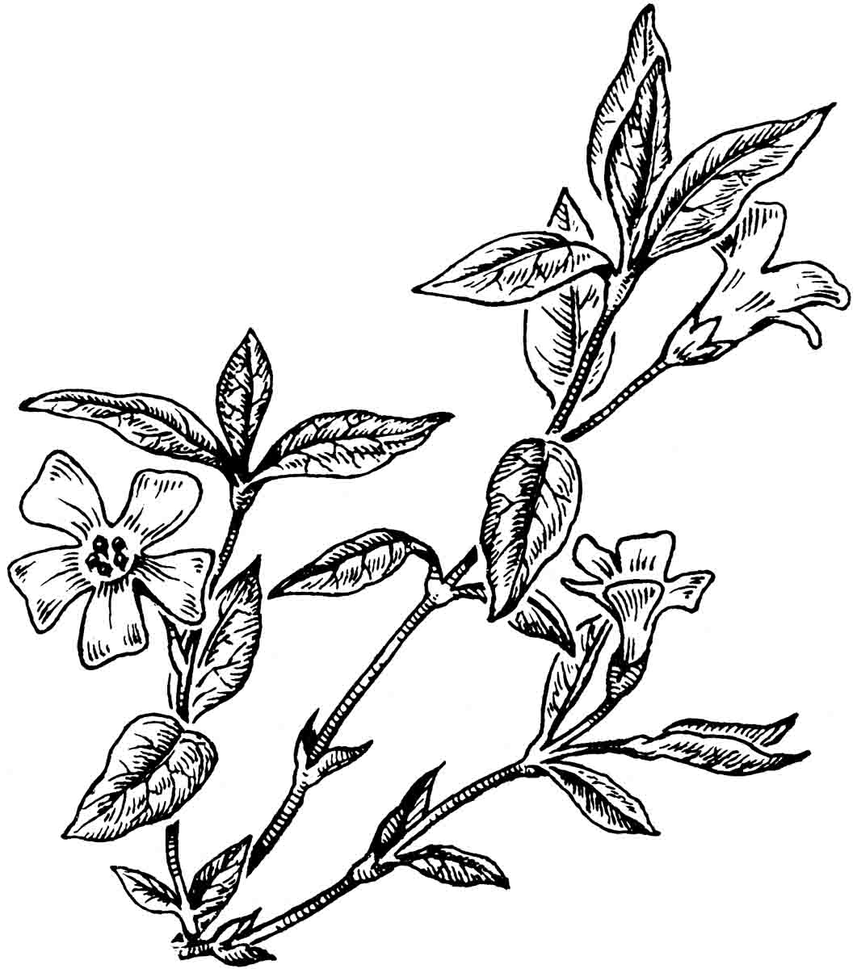 | Place for medicinal plant material
Adulteration:
1. _________________________________________________________________________
2. _________________________________________________________________________
Specific features:__________________________________________________________________
________________________________________________________________________________
Uses in medicine __________________________________________________________________
________________________________________________________________________________
Catharanthus (Madagascar periwinkle) herb
Latin name of medicinal plant material

Latin name of plant source | English name of plant source
Family
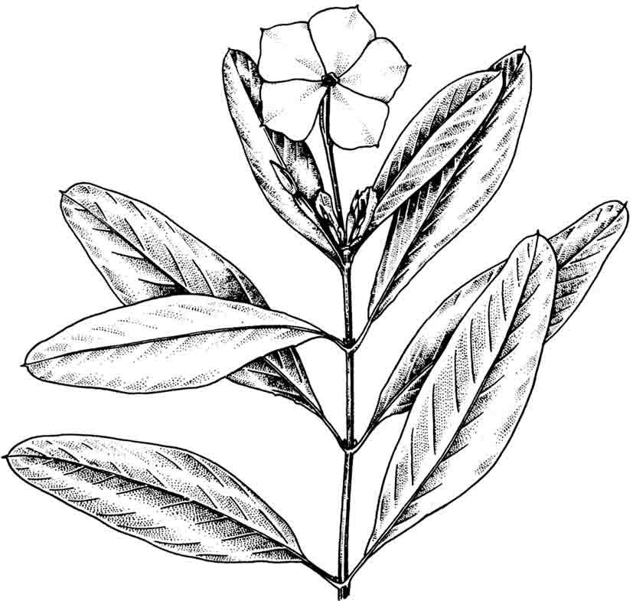 | Place for medicinal plant material

Specific features:__________________________________________________________________
________________________________________________________________________________
________________________________________________________________________________
Uses in medicine __________________________________________________________________
________________________________________________________________________________
Ergot
Latin name of medicinal plant material

Latin name of the plant | English name of the plant
Family
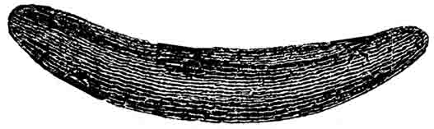 | Place for medicinal plant material
Specific features:__________________________________________________________________
________________________________________________________________________________
________________________________________________________________________________
Uses in medicine __________________________________________________________________
________________________________________________________________________________
Hatchet-vetch stem
Latin name of medicinal plant material

Latin name of the plant | English name of the plant
Family
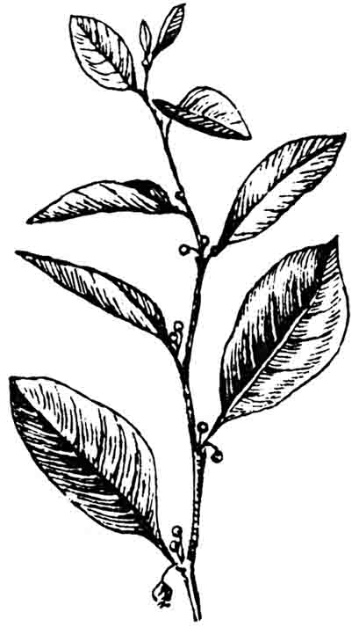 | Place for medicinal plant material
Specific features:__________________________________________________________________
________________________________________________________________________________
________________________________________________________________________________
Uses in medicine __________________________________________________________________
________________________________________________________________________________

