SUBSTANTIAL MODULE 1.

MICROSCOPICAL DESCRIPTIONS:

Topic: POLYSSACCHARIDES

MARSHMALLOW ROOT - Althaeae radices

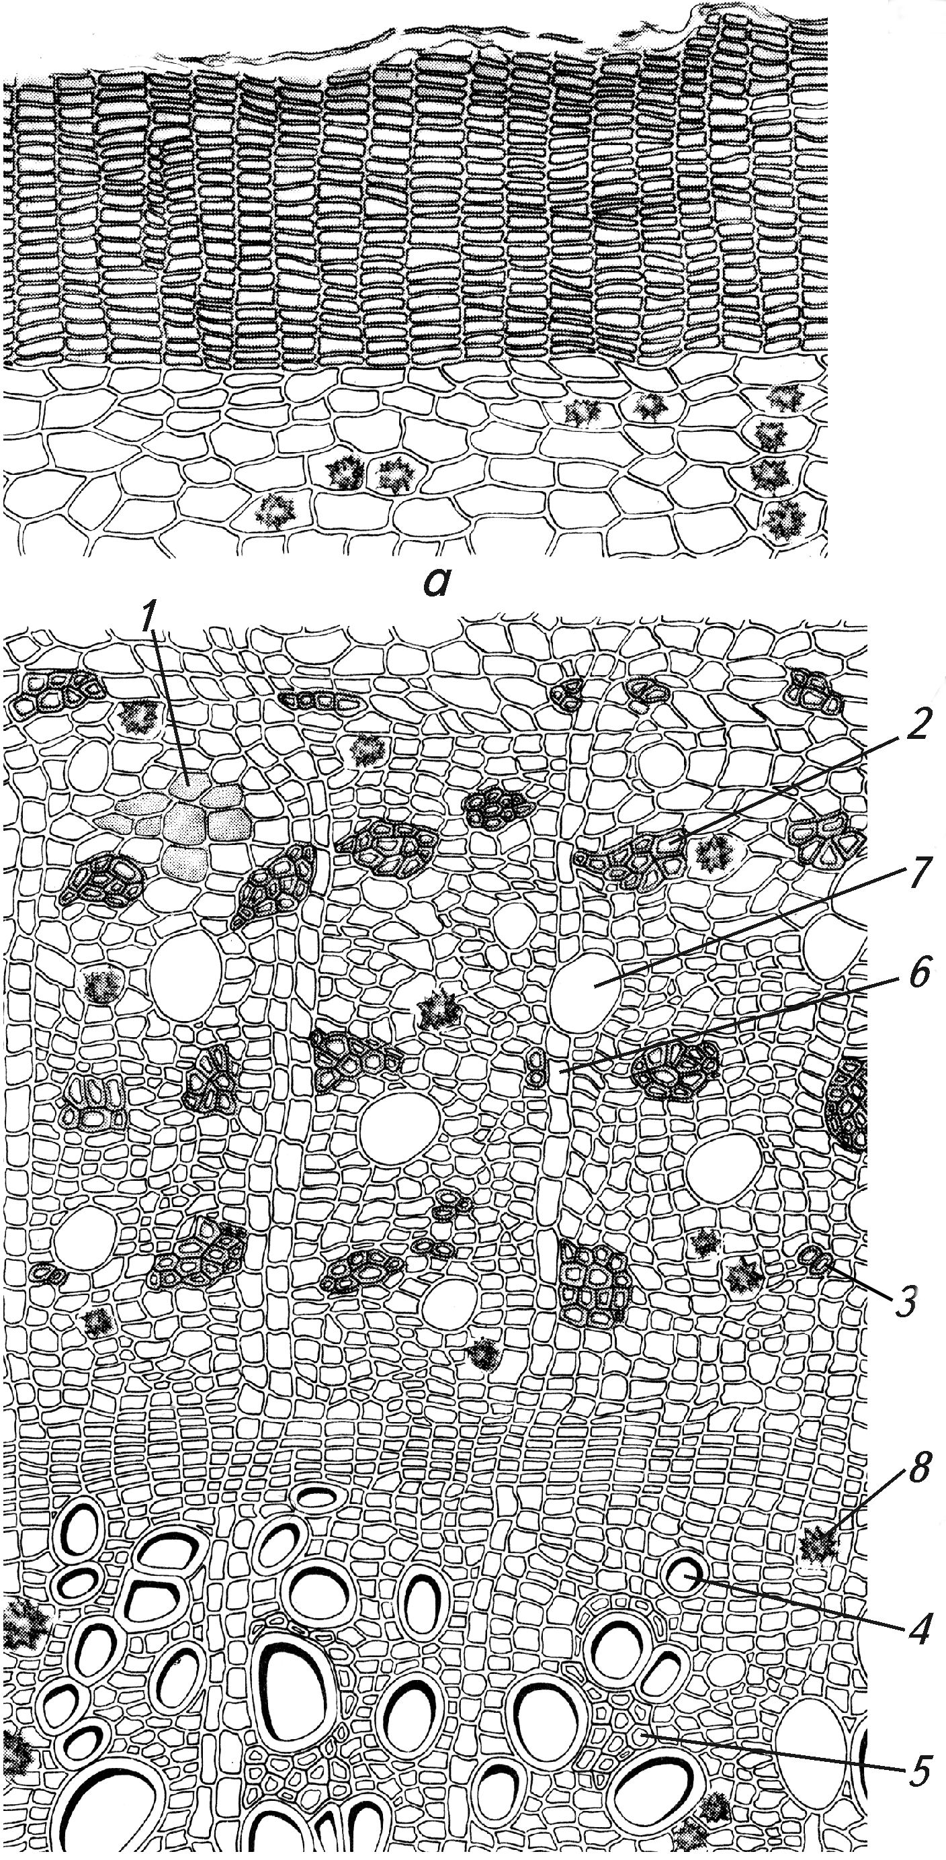 | Anatomical features of marshmallow root:  1 – parenchymal cells with starch grains;  2 – bast fibers;  3 – small groups of fibers;  4 – vessels;  5 – tracheids;  6 – medullar rays;  7 – cells with mucilage;  8 – druses.
MARSHMALLOW LEAF – ALTHAEAE FOLIА

Anatomical features of marshmallow leaf:

1 – upper epidermal cells;
2 – lower epidermal cells;
3 – druses;
4 – druses;
5 – simple multicellular hairs;
6 – star-shaped hairs;
7 – basis of a hair.
COMMON PLANTAIN LEAF – PLANTAGINIS MAJORIS FOLIА
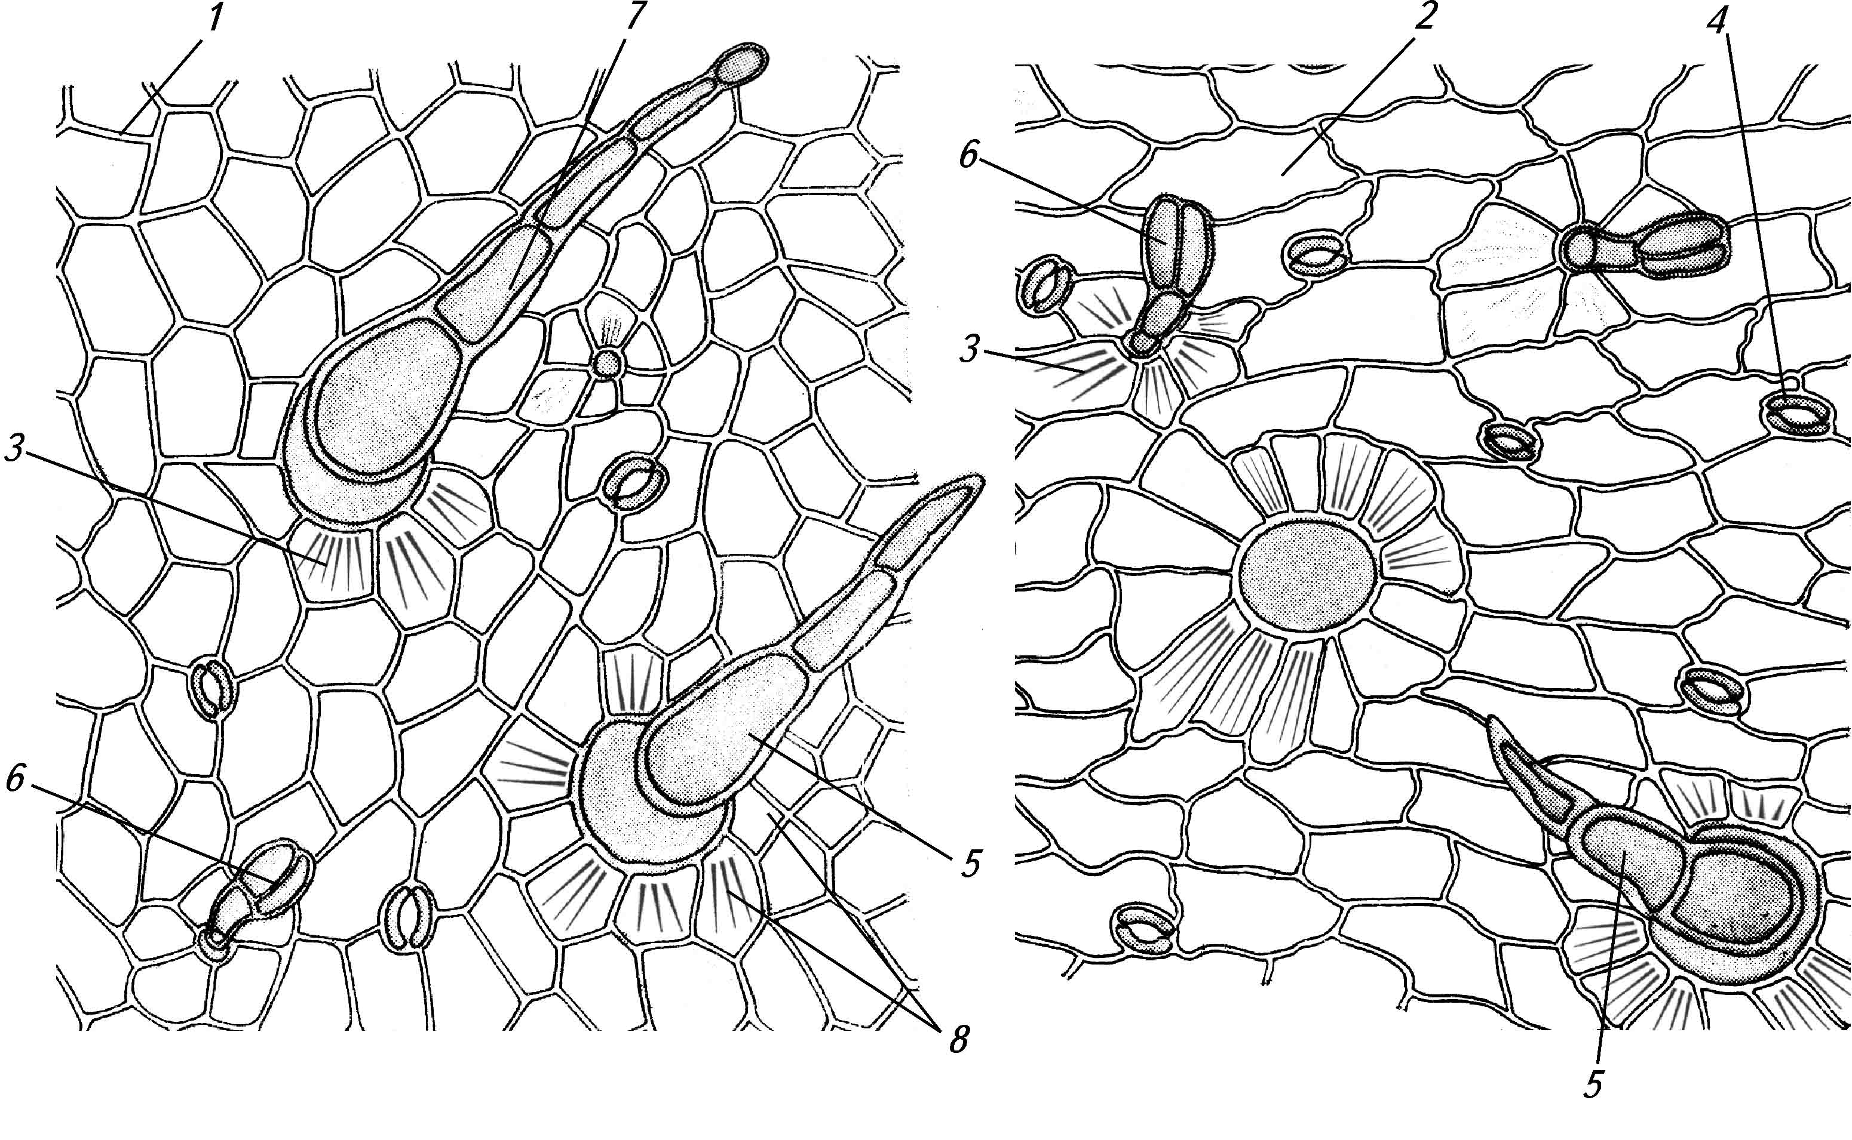 | Anatomical features of сommon plantain leaf:  1 – upper epiderm;  2 – lower epiderm;  3 – cuticle folds;  4 – stomata;  5 – simple hair;  6 – capitate hair on a single-celled stalk;  7 – capitate hair on a multicellular stalk
Topic: VITAMINS.
DOG ROSE FRUITS – ROSAE FRUCTUS

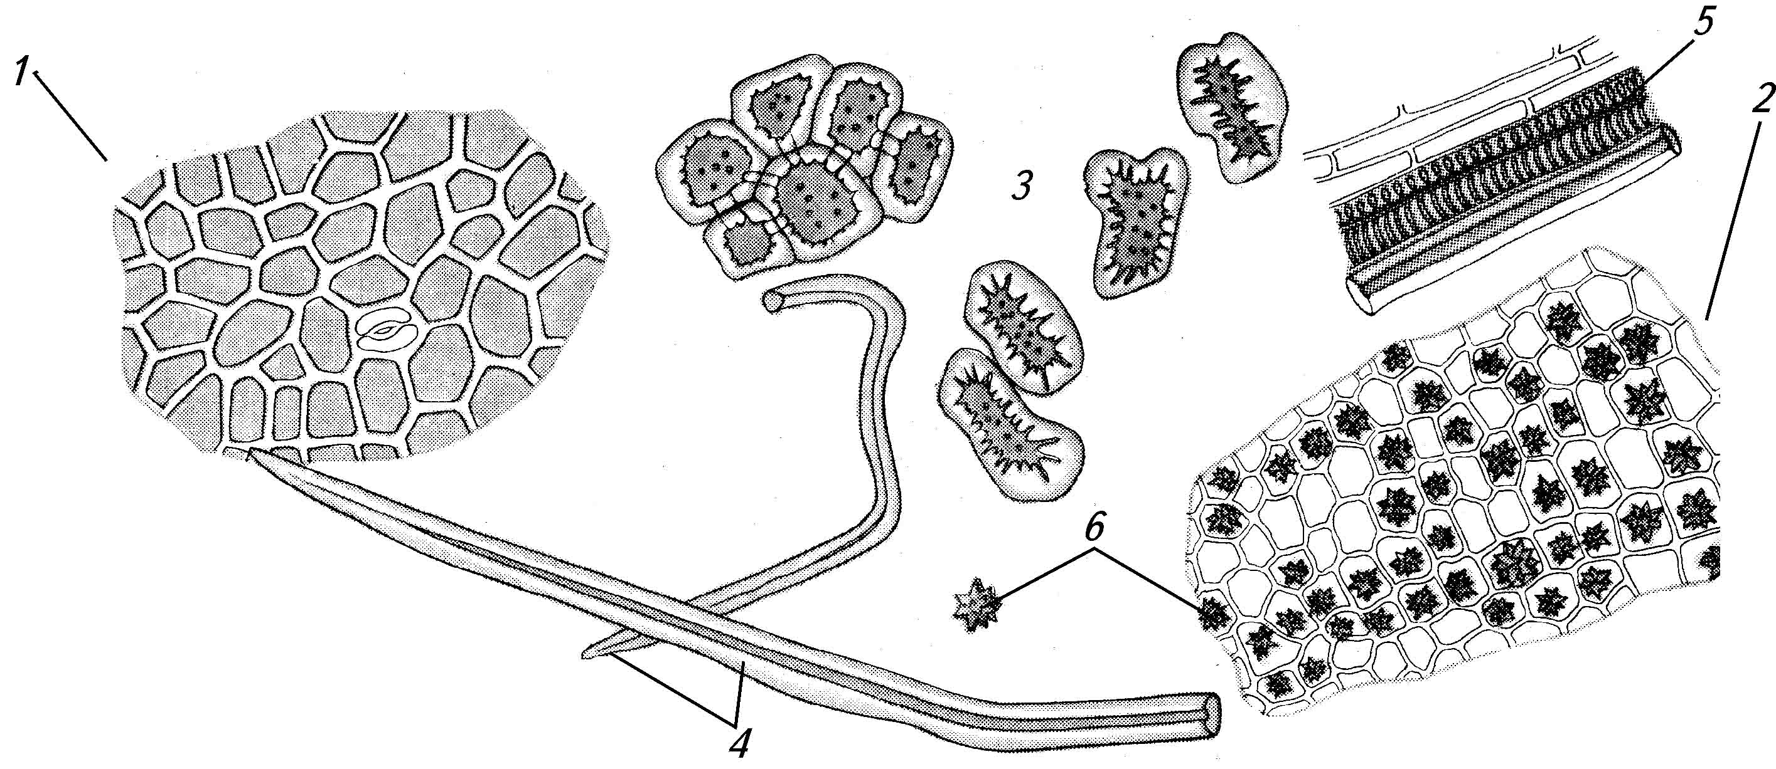 | Anatomical features of dog rose fruits:  1 – hypanthium epiderm;  2 – hypanthium flesh with cells bearing chromoplasts and druses; 3 – stony cells;  4 – large simple hairs;  5 – fragments of vessels;  6 – druses.
NETTLE LEAF – URTІCAE FOLІA

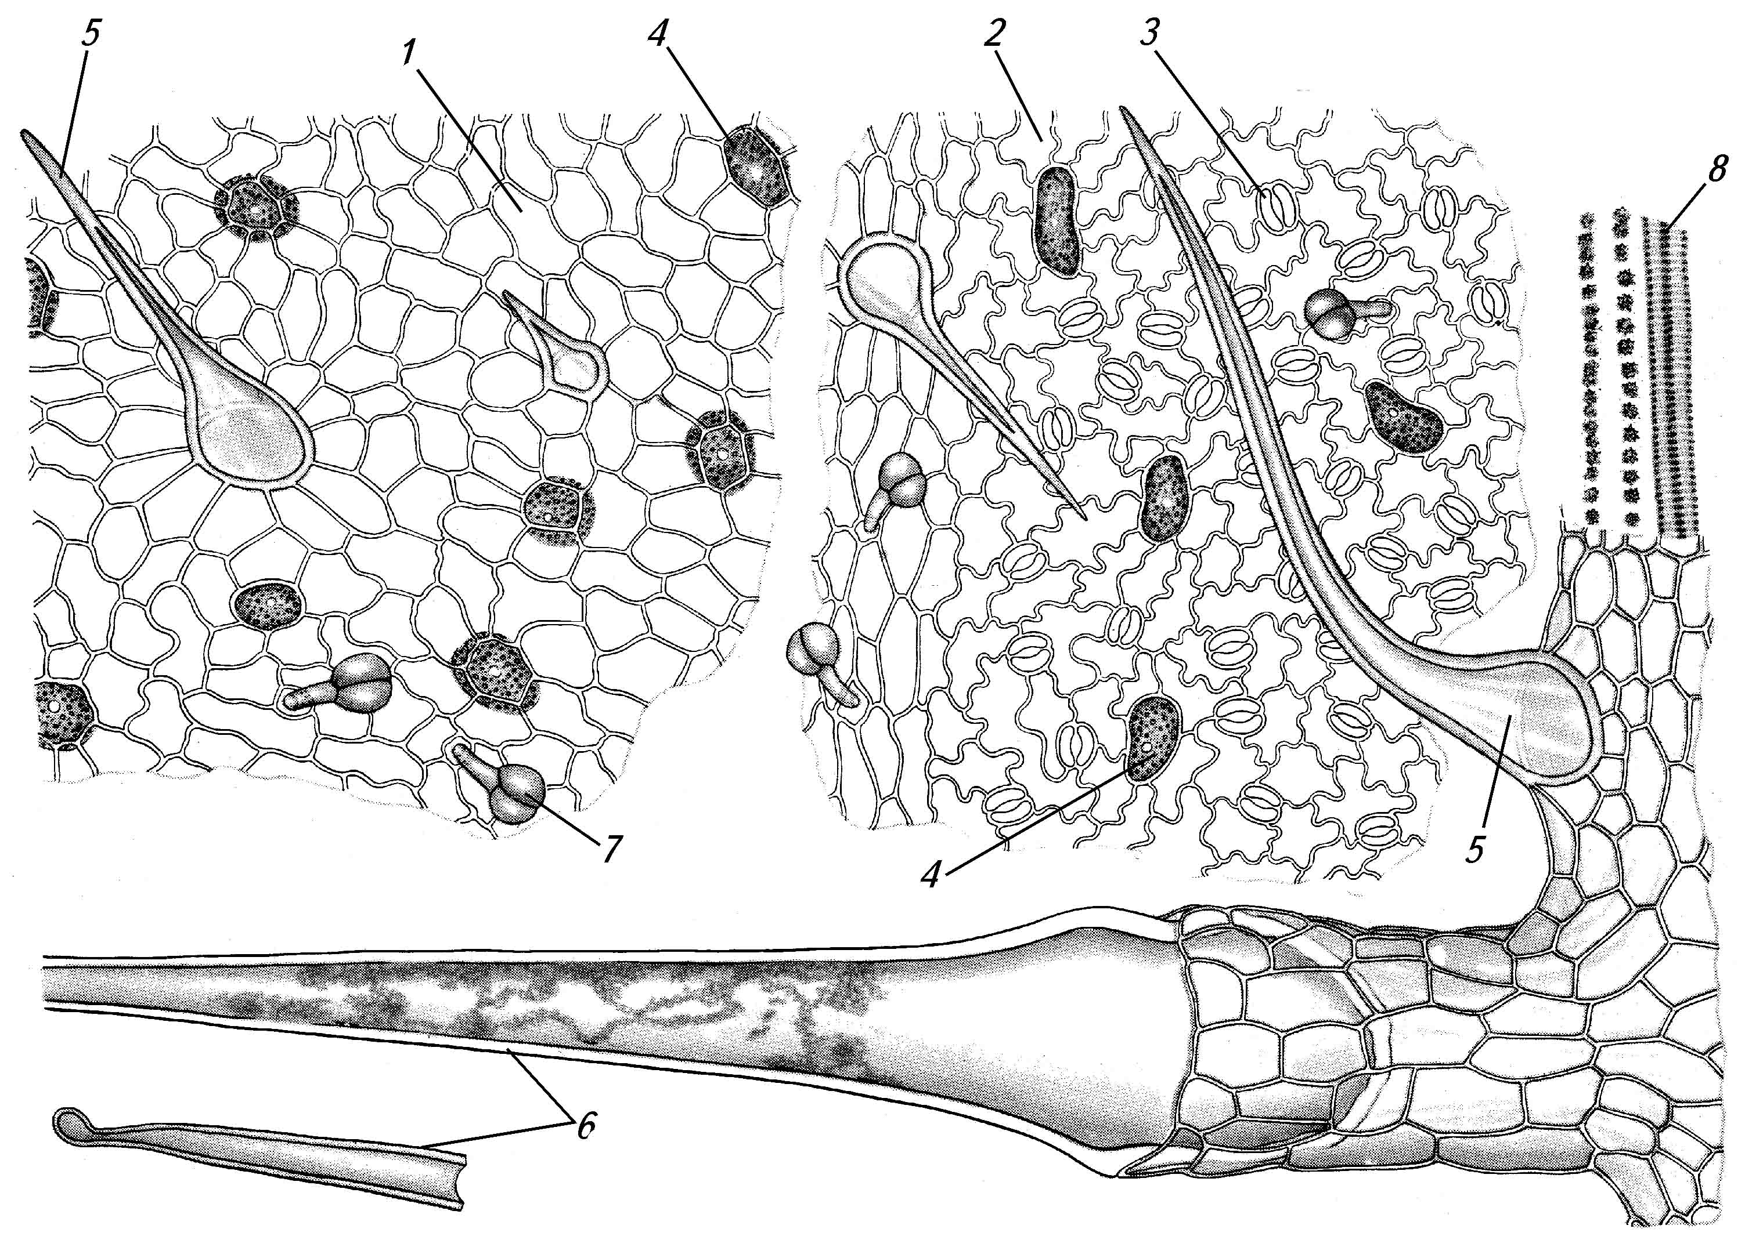 | Anatomical features of nettle leaf:  1 – upper epiderm;  2 – lower epiderm;  3 – stomata;  4 – cistiliths;  5 – siple retort-shaped hairs;  6 – stinging hair;  7 – glandular hairs;  8 – druses along the vein.

SHEPHERD’S PURSE HERB – Bursae pastorіs Herba

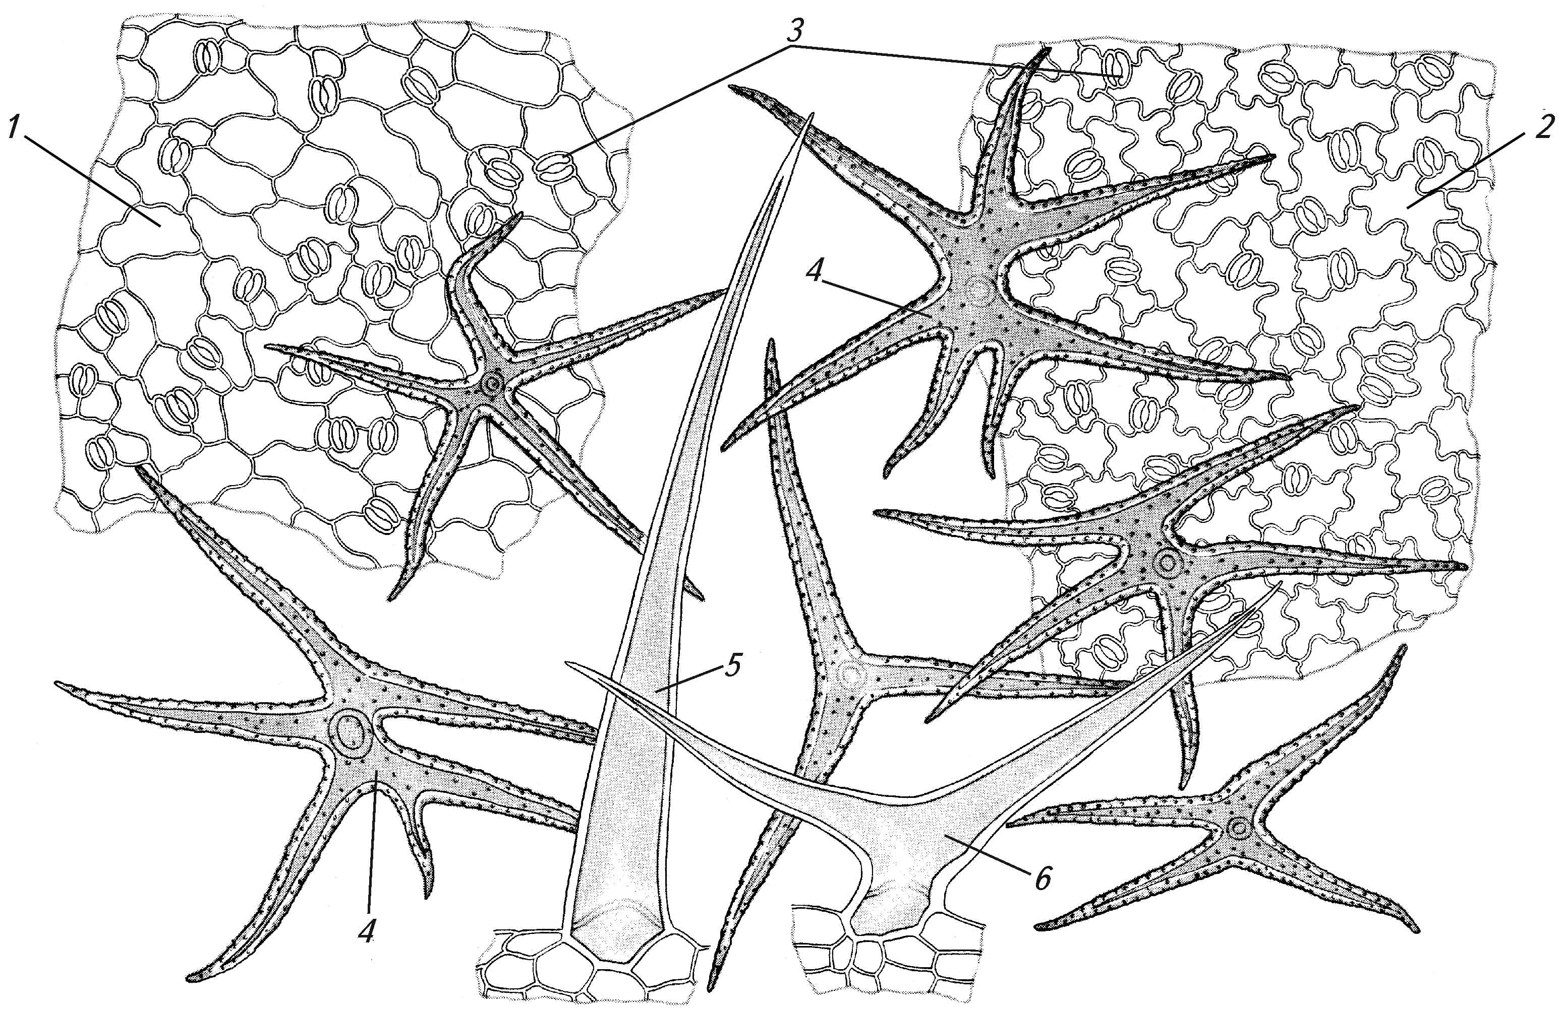 | Anatomical features of shepherd’s purse herb:  1 – upper epiderm;  2 – lower epiderm;  3 – stomata;  4 – simple multiended hairs;  5 – large single-cellular hair;  6 – double-ended simple hair.

