PHARMACOGNOSY

for 3rd year students 22 Public health 226 «Pharmacy, industrial parmacy», educational program «Pharmacy» Фм17(5,0д) англ 1, 2, 3, 4, 5, 6, 7, 8 groups

13.04 – 7, 8 groups

15.04 – 1, 2 group

16.04 – 3, 4 groups

17.04 – 5, 6 group

**LABORATORY CLASS. Topic: « MP and MPM, containing different groups of BAC.»**

**THE THEORETICAL PART.**

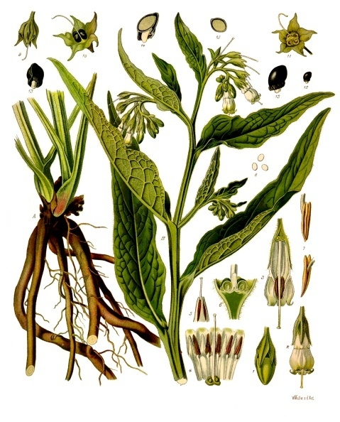**COMFREY ROOT -** *SYMPHYTI RADIX*

**Comfrey** - *Symphytum officinale* L., Fam. Boraginaceae

Synonym(s): Healing herb.

**Plant.** A bristly perennial herb, 50-150 cm in height; the leaves are long and narrowing at the ends, with a coarse reticulate venation. The campanulate corolla is yellowish white or violet-red.

**Area of distribution.** Native throughout almost the whole Europe and naturalized in North America. The drug comes from cultivated plants.

**Description.** The dark brown to black pieces of root are longitudinally corrugated outside and have a short fracture. The cross section shows a pale-colored cortex and a whitish to pale brown radiate xylem with broad medullary rays. With a hand lens, wide vessels, single or groups of 2-3, it can be seen scattered in the rows of xylem parenchyma. Fragments of rhizome with the pith may also be present. The taste is mucilaginous, somewhat sweetish and slightly astringent.

**Constituents.** The drug containsallantoin – 075–2.55 %, alkaloidspyrrolizidine-type. 0.3 %: symphytine, symlandine, echimidine, intermidine, lycopsamine, myoscorpine, acetyllycopsamine, acetylintermidine, lasiocarpine, heliosupine, viridiflorine and echiumine.

|  |  |  |  |  |
| --- | --- | --- | --- | --- |
|  | | | | |
|  |  | R1 | R2 | R3 |
| Intermidine | H | H | OH |
| Echimidine | angelyl | H | OH |
| Acetylintermidine | acetyl | H | OH |
| Lycopsamine | H | O H | H |
| Symphytine | tiglyl | OH | H |



Allantoin

It has also carbohydrates gum (arabinose, glucuronic acid, mannose, rhamnose, xylose); mucilage (glucose, fructose); tannins of pyrocatechol type – 2,4%; triterpenes: Sitosterol and stigmasterol (phytosterols), steroidal saponins and isobauerenol. Other constituents are caffeic acid, carotene – 0.63%, chlorogenic acid, choline, lithospermic acid, rosmarinic acid and silicic acid.

**Application**. Included into BHP, Complete German Commission E, Martindale.

Comfrey is stated to possess vulnerary, cell-proliferant, astringent, antihaemorrhagic and demulcent properties. It has been used for colitis, gastric and duodenal ulcers, haematemesis, and has been applied topically for ulcers, wounds and fractures.

**Contraindications.** In view of the hepatotoxic properties documented for the pyrrolizidine alkaloid constituents, comfrey should not be taken internally. The topical application of comfrey-containing preparations to broken skin should be avoided.

**Side Effects.** Comfrey is characterized by its pyrrolizidine alkaloid constituents. The hepatotoxicity of these compounds is well known, and cases of human poisoning involving comfrey have been documented.

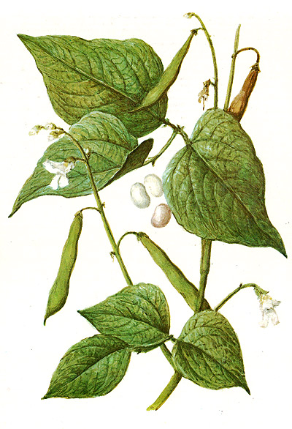**KIDNEY-BEAN PODS (WITHOUT SEEDS) - *PHASEOLI PERICARPIUM***

**KIDNEY-BEAN** - Phaseolus vulgaris L., Fam. Fabaceae.

Synonym(s): Bean.

**Plant.** A twinning or low bushy annual, up to 4 m high, with ternate leaves and white pale pink or violet flowers

**Area of distribution.** An ancient cultivated plant. The drug comes entirely from cultivated plants grown in various European countries: Bulgaria. Hungary, the former USSR, former Yugoslavia.

**Description** The drug consists of the fruit walls freed from seeds. The material is in the form of yellowish white, somewhat curled, thin pieces of the fruit wall up to 15 cm long. The outside surface is pale yellow and slightly wrinkled, while the inside one is covered with a whitish, shiny membrane (the endocarp and inner niesocarp layers). Occasionally, yellow fragments of the stalks are present. The taste is somewhat mucilaginous.

**Constituents.** Silicic acid have been thought perhaps to be responsible for the antidiabetic action. Recently, the content of chromium salts has been seen as possibly significant in regard to the antidiabetic activity; it also contains allantoin, choline, flavonoids.

**Application**. Included into DAC.

Used only in folk medicine as a diuretic and weak antidiabetic.

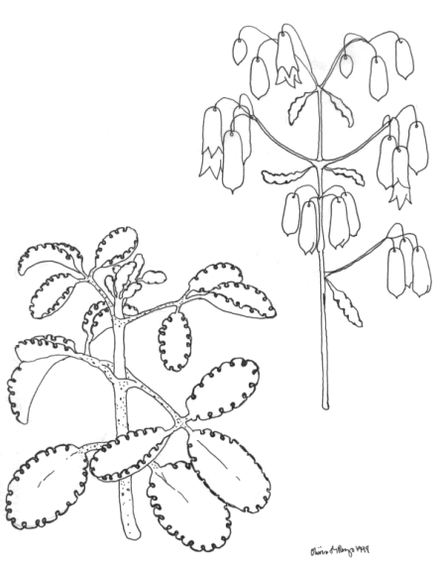**KALANCHOE HERB - *KALAHCHOES CORMUS RECENS***

**Kalanchoe** - *Kalanchoe pinnata* (Lam.) Person, Fam. *Crassulaceae*.

Synonym(s): Air Plant, Life Plant, Miracle Leaf, *Bryophyllum pinnatum* (Lam.) Kurz.

**Plant.** It is a succulent plant native to Madagascar. It is distinctive for the profusion of miniature plantlets that form on the margins of its leaves, a trait it has in common with the other members of the [*Bryophyllum*](http://en.wikipedia.org/w/index.php?title=Bryophyllum&action=edit&redlink=1) section of the *Kalanchoe* genus.

It is a popular houseplant and has become naturalized in temperate regions of Asia, the Pacific and Caribbean.

**Area of distribution.** Plants of the genus *Bryophyllum* (family) occur in tropical Africa, America and Asia, Hawaii, India, China, Australia and Madagascar, and have been traditionally used in these regions in multiple pathological situations.

**Constituents.** Several components have been identified in *B. pinnatum* preparations, which are likely to have biological effects and might therefore have the therapeutic potential, namely bufadienolides; flavonoids, flavonoid glycosides, cinnamic acid derivatives, phenols and organic acids

**Application.** In traditional medicine, *Kalanchoe* species have been used to treat ailments such as infections, rheumatism and inflammation. *Kalanchoe* extracts have also immunosuppressive effects. *Kalanchoe pinnata* has been recorded in Trinidad and Tobago as being used as a traditional treatment for hypertension and for the treatment of kidney stones in India.

Bufadienolide compounds isolated from *Kalanchoe pinnata* include [bryophillin A](http://en.wikipedia.org/w/index.php?title=Bryophillin_A&action=edit&redlink=1), which showed a strong antitumor promoting activity, while bersaldegenin-3-acetate and [bryophillin C](http://en.wikipedia.org/w/index.php?title=Bryophillin_C&action=edit&redlink=1) which were less active. Bryophillin C also showed insecticidal properties.

[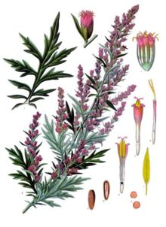](http://en.wikipedia.org/wiki/File:Koeh-016.jpg)**MUGWORT HERB – *ARTEMISIAE VULGARIS* *HERBA***

Mugwort- *Artemisia vulgaris* L., Fam. Asteraceae.

Synonym(s): Common Wormwood, Felon Herb, Chrysanthemum Weed, Wild Wormwood, Old uncle Henry.

**Plant.** It is a tall [herbaceous](http://en.wikipedia.org/wiki/Herbaceous) [perennial plant](http://en.wikipedia.org/wiki/Perennial_plant) growing 1–2 m tall, with a woody root. The [leaves](http://en.wikipedia.org/wiki/Leaf) are 5–20 cm long, dark green, [pinnate](http://en.wikipedia.org/wiki/Pinnate), with dense white [tomentose](http://en.wikipedia.org/wiki/Tomentose) hairs on the underside. The erect stem often has a red-purplish tinge. Rather small flowers (5 mm long) are radially symmetrical with many yellow or dark red petals. The narrow and numerous capitula (flower heads) spread out in [racemose](http://en.wiktionary.org/wiki/racemose) [panicles](http://en.wikipedia.org/wiki/Panicles). It flowers from July to September.

**Area of distribution.** It is native to temperate Europe, Asia, northern [Africa](http://en.wikipedia.org/wiki/Africa) and [Alaska](http://en.wikipedia.org/wiki/Alaska) and is naturalized in North America where some consider it an [invasive](http://en.wikipedia.org/wiki/Invasive_species) weed. It is a very common plant growing on nitrogenous soils, like weedy and uncultivated areas, such as waste places and roadsides.

**Description.** A mugwort leaf with the pointed leaves is characteristic of a mature plant

**Constituents.** The mugwort plant contains essential oils (the main components are [cineole](http://en.wikipedia.org/wiki/Cineole) and [thujone](http://en.wikipedia.org/wiki/Thujone)), [flavonoids](http://en.wikipedia.org/wiki/Flavonoid), [triterpenes](http://en.wikipedia.org/wiki/Terpene), and [coumarin](http://en.wikipedia.org/wiki/Coumarin) derivatives.

**Application.** It was used as an [anthelminthic](http://en.wikipedia.org/wiki/Anthelminthic). The plant is used in [Ayurveda](http://en.wikipedia.org/wiki/Ayurveda) for cardiac complaints as well as feelings of unease, unwellness and general malaise. Mugwort pollen is one of the main sources of [hay fever](http://en.wikipedia.org/wiki/Hay_fever) and allergic [asthma](http://en.wikipedia.org/wiki/Asthma), in [North Europe](http://en.wikipedia.org/wiki/North_Europe), [North America](http://en.wikipedia.org/wiki/North_America) and in parts of [Asia](http://en.wikipedia.org/wiki/Asia).

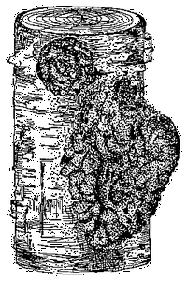**CHAGA – *FUNGUS BETULINUS***

**Chaga** - *Inonotus obliquus* (Pers) Pil., Fam. Hymenochaetaceae.

Synonym(s): shelf fungus, polypore, cinder conk, the Russian term 'чага**'**.

**Plant.** It is a fungus parasitic on birch and other trees.

**Area of distribution.** *I. obliquus* grows in birch forests of Russia, Korea, Eastern and Northern Europe, Northern areas of the United States, in the North Carolina mountains and in Canada.

**Description.** The Chaga mushroom is considered a medicinal mushroom that has a place in Russian and Eastern European folk medicine. The sterile conk is irregularly formed and has the appearance of burnt charcoal. The fertile fruit body can be found very rarely as a [resupinate](http://en.wikipedia.org/wiki/Resupination#Fungi) (crustose) fungus on or near the clinker, usually appearing after the host tree is completely dead.

**Constituents.** Chemical investigations show that *I. obliquus* produces a diverse range of the secondary metabolites, including phenolic compounds, melanins, and lanostane-type triterpenoids. Among these are the active components for the antioxidant, antitumoral, and antiviral activities and for improving the human immunity against infection of pathogenic microbes.

[Betulin](http://en.wikipedia.org/wiki/Betulin) and [betulinic acid](http://en.wikipedia.org/wiki/Betulinic_acid), are compounds found naturally in chaga and birch trees. The compounds are now being studied for use as a [chemotherapeutic agent](http://en.wikipedia.org/wiki/Chemotherapeutic_agent). Whereas Betulin as it is found in birch bark is indigestible by humans, the Chaga mushroom converts it into a form that can be digested orally. In an animal study, researchers found betulin from the birch bark lowered cholesterol, obesity and improved insulin resistance.

|  |  |
| --- | --- |
|  |  |
| [Betulin](http://en.wikipedia.org/wiki/Betulin) | [Betulinic acid](http://en.wikipedia.org/wiki/Betulinic_acid) |

**Application.** Geographically, however, this fungus is restricted to very cold habitats and grows very slowly, suggesting that Chaga is not a reliable source of these bioactive compounds. Attempts for culturing this fungus axenically all resulted in a reduced production of bioactive metabolites. In China, Japan and South-Korea hot water extracts of the nonlinear, complex (1→3) and (1→6) [β-glucan](http://en.wikipedia.org/wiki/Beta-glucan) [polysaccharides](http://en.wikipedia.org/wiki/Polysaccharides) that are found in Chaga are being produced, sold and exported as anti-cancer medicinal supplements. Recent research in Japan and China has been focused more on the anti-cancer potential and showed the effects of these specific polysaccharides to be comparable to chemo therapy and radiation, but without the side effects. Further research indicated these polysaccharides have strong anti-inflammatory and immune balancing properties, stimulating the body to produce natural killer cells to control infections and tumor growth instead of showing a direct toxicity against pathogens.

The mycelial endo-polysaccharide of *I. obliquus* was identified as a candidate for use as an immune response modifier and indicate that the anticancer effect of endo-polysaccharide is not directly tumorcidal, but rather is immuno-stimulating. It has also have anti-inflammatory properties.

**Contraindications:** Due to the hypoglycemic activity of Chaga polysaccarides caution may be taken by those with hypoglycemia.