NUTRICIOLOGY
for 4 course students 22 Public health 226 «Pharmacy, industrial pharmacy», educational program «Pharmacy for foreign students»
Фм17*(5,0д) англ 1, 2 groups

25.03 - groups 1, groups 2

PRACTICAL CLASS. Topic: « Dietary supplements. Analysis of labeling of DS and quality control”
OBJECTIVE.
Know the definition of the term “Dietary supplements”, their classification, labeling, chemical composition, indication, and contraindication, interaction with drugs, comparison with drugs.
RELEVANSE
Dietary Supplements - vitamin, mineral or vitamin and herbal supplements alone and / or combined in the form of tablets, powders for oral administration together with food or added to food within physiological norms for further comparison with the conventional power consumption of these substances. Dietary supplements also include or contain different substances or mixtures of substances, including proteins, carbohydrates, amino acids, edible oils and extracts of plant and animal materials, which are deemed necessary or useful for nutrition and general health.

CONTROL QUESTIONS
1. Define the concept of "Dietary Supplements".
2. To characterize the main differences between the drug and the DS.
3. Classification of DS.
4. Basic principles of usage Ds.
5. Give a description of the group of nutraceuticals. Give examples.
6. Give a description of the group of parapharmaceuticals. Give examples.
7. Give a description of the eubiotic group. Definition of "probiotics", "prebiotics", "symbiotics". Give examples.
8. List the organizations responsible for quality control DS.
9. To understand the main requirements for labeling of DS. Pay attention to the differences in the marking of DS and drugs.
10. Consider the composition of the DS and, depending on the composition, give advice on the application of DS.

11. Name the compounds below, specify to which class of substances it belong, what methods of analysis are used for it. Indicate its biological activity.

CH3 - (CH2-CH = CH) ₃ - (CH2)₇ -COOH  A | 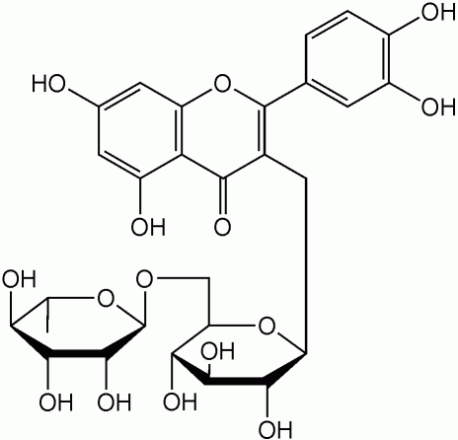  B

12.Name the compounds below, specify to which class of substances it belong, what methods of analysis are used for it. Indicate its biological activity.
A | 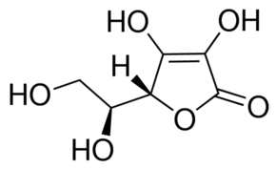  B

- Name the compounds below, specify to which class of substances it belong, what methods of analysis are used for it. Indicate its biological activity.
CH3 - (CH2-CH = CH) ₃ - (CH2)₇ -COOH  A | 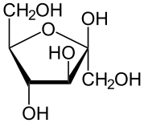  B

- Name the compounds below, specify to which class of substances it belong, what methods of analysis are used for it. Indicate its biological activity.
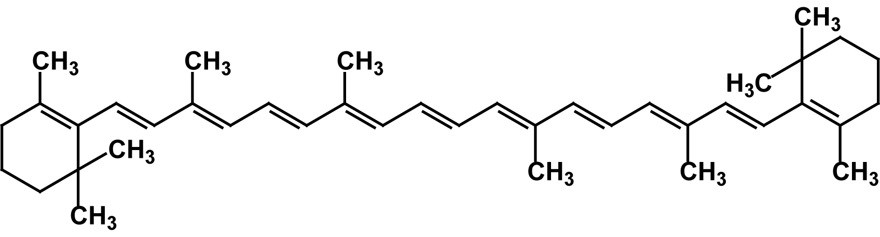  A | B

15.Name the compounds below, specify to which class of substances it belong, what methods of analysis are used for it. Indicate its biological activity.
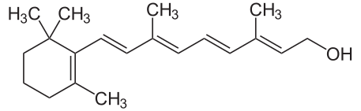  A | 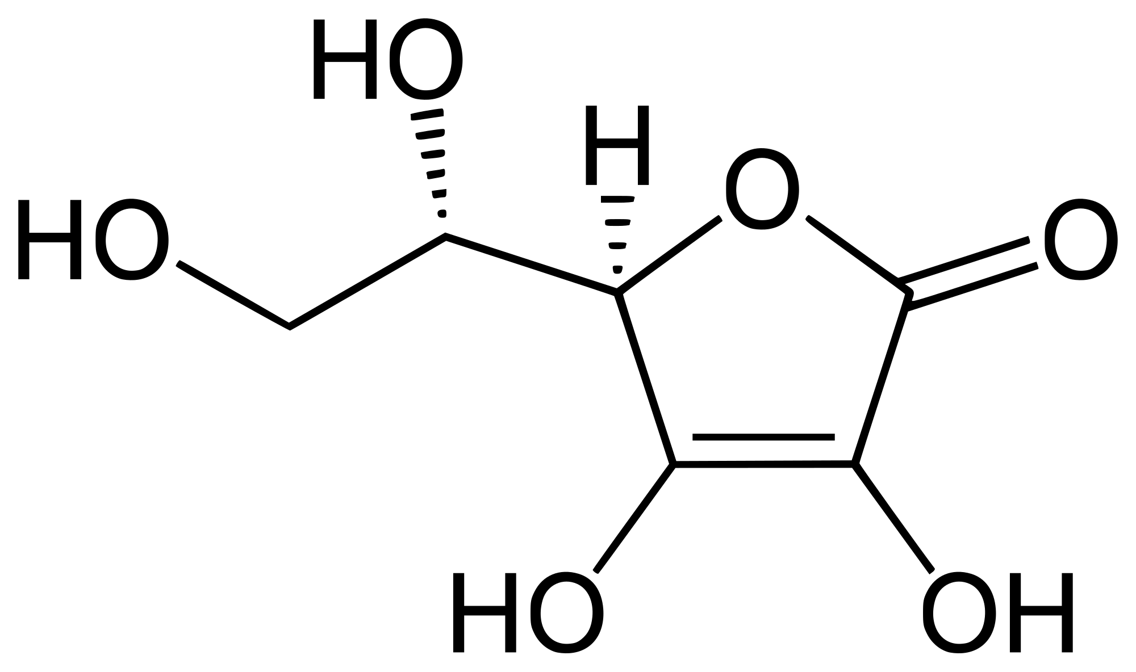  B

16.Name the compounds below, specify to which class of substances it belong, what methods of analysis are used for it. Indicate its biological activity.
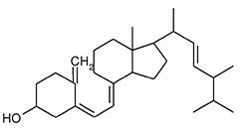  A | 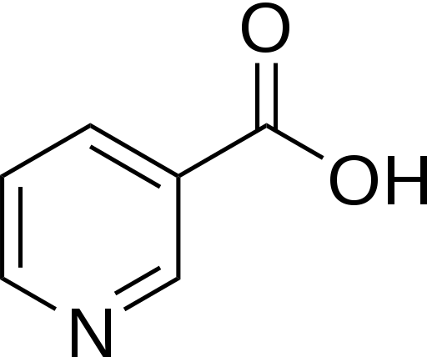  B

17. Name the compounds below, specify to which class of substances it belong, what methods of analysis are used for it. Indicate its biological activity.
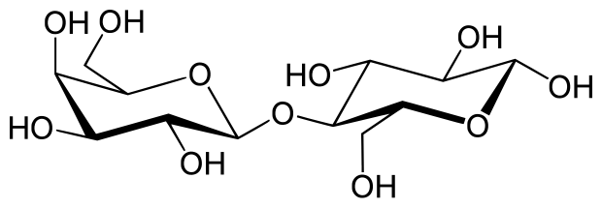  A | B

18. Name the compounds below, specify to which class of substances it belong, what methods of analysis are used for it. Indicate its biological activity.
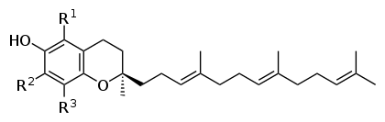 A | B

PRACTICAL TASKS.
You have to fill in your laboratory hand-book on the topic: Dietary supplements. Analysis of labeling of DS and quality control.

