

MINISTRY OF HEALTH OF UKRAINE
THE NATIONAL UNIVERSITY OF PHARMACY

Department of chemistry of natural compounds and nutriciology

Laboratory Workbook
on the nutriciology
student_____ course _____ groups
_______________________ faculty
specialties ____________________

Kharkov - 2020

Approved by CMC of the National University of Pharmacy
(Protocol №3, 27.03.2014)

Compiled by:

Laboratory workbook on nutriciology / // Publishing house NUF, 2020 – 36 pages.

Topic: THE ROLE OF NUTRITION IN THE ENSURING OF THE VITAL ACTIVITY OF ORGANISM
Questions to the classes
1. Definition of science “Nutriciology”. Goals and objectives of Nutriciology.
2. Types of nutrition, characteristics, disadvantages and benefits.
3. Balance of macronutrients: proteins, fats, carbohydrates.
4. Biological value of proteins, essential amino acids and their role.
5. Biological role of fats, polyunsaturated fatty acids, cholesterol.
6. Significance of different types of carbohydrates in the body.
7. The value of vitamins, vitamin products, the main causes of hypovitaminosis
8. Definition of the essential substances, their role in human health.
9. Combination of food products.
10. Concept of balanced (rational nutrition) nutrition.

Nutritiology is ______________________________________________________________
_________________________________________________________________________________.
Nutrients are_______________________________________________________________
________________________________________________________________________________.
Nutrition is__________________________________________________________________
_________________________________________________________________________________.
Functions of nutrition:
1) _______________________________________________________________________________;
2)________________________________________________________________________________;
3)________________________________________________________________________________; 4)________________________________________________________________________________; 5)________________________________________________________________________________; 6)________________________________________________________________________________; 7)________________________________________________________________________________.
Rational nutrition is___________________________________________________________
_________________________________________________________________________________.
Preventive nutrition is_________________________________________________________
_________________________________________________________________________________.
Therapeutic-preventive nutrition is______________________________________________
_________________________________________________________________________________.
Curative (dietary) nutrition is__________________________________________________
_________________________________________________________________________________.
Food Pyramid
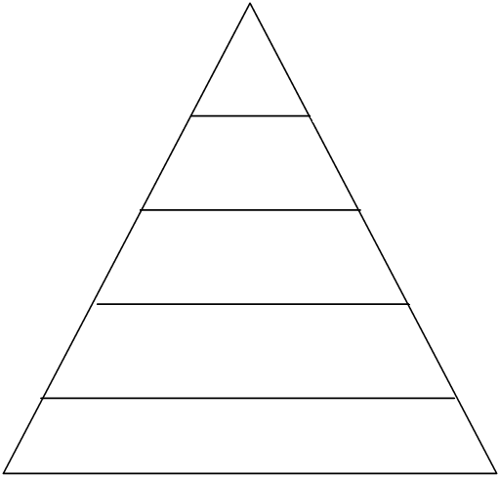

CONCLUSIONS:_____________________________________________________________________________________________________________________________________________________

INDEPENDENT WORK
Describe traditional types of nutrition
Type of nutrition | Permitted products | Prohibited products | Features of nutrition
Vegetarianism

Separate nutrition

Nutrition in Christianity

Nutrition in Islam

Nutrition in Judaism

Nutrition in Hinduism

Nutrition in Buddhism

Nutrition in Taoism

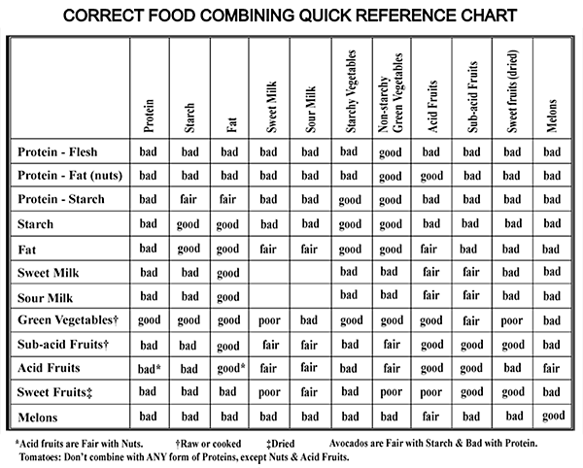

- Proteins-proteins
- Proteins- lipids
- Proteins- acids
- Carbohydrates - carbohydrates
- Carbohydrates- sugars

Topic: MACRO- AND MICRONUTRIENTS

Question to the classes
1. Macronutrients, classification, meaning for the body, food sources, daily dose
2. Micronutrients, classification, values for the organism, food sources, daily dose
3. Essential substances, classification, importance for the organism, food sources, daily dose
4. Vitamins, classification, values for the body, food sources, daily dose
5. Mineral substances, classification, values for the organism, food sources, daily dose

Nutritiology is ______________________________________________________________
_________________________________________________________________________________
Nutrients are ______________________________________________________________
________________________________________________________________________________
Macronutrients are ____________________________________________________________
___________________________________________________________________________________. To macronutrients belong __________________________________________________________
________________________________________________________________________________
Micronutrients are ___________________________________________________________
_________________________________________________________________________________. The main groups of micronutrients are _______________________________________________
______________________________________________________________________________.
Essential nutrients are ________________________________________________________
___________________________________________________________________________________.
The main groups of essential nutrients are ____________________________________________
______________________________________________________________________________.

Analysis of food products labeling
Sample name | Labeling | Conclusions
1.

2.

CONCLUSIONS:____________________________________________________________________________________________________________________________________________________.

INDEPENDENT WORK
Specify the main dietary sources of major macro-and micronutrients and the daily maintenance for them.
Nutrient | Dietary sources | Daily maintenance
Proteins

Fats

Carbohydrates

Vitamin А

Vitamin В₁

Vitamin В₂

Vitamin В₅

Vitamin В₆

Vitamin В₉

Vitamin В₁₂

Vitamin С

Vitamin D

Vitamin Е

Vitamin Н

Vitamin К

Vitamin РР

Potassium

Sodium

Magnesium

Calcium

Iron

Copper

Zinc

Phosphorus

Sulfur

Iodine

Fluor

Topic: DIET. NUTRITIONAL STATUS AND METHODS FOR ITS DETERMINATION. THERAPEUTIC NUTRITION

Question to the classes
1. Definition of the concept of a diet.
2. Daily diet.
3. The energy and nutritional value of food.
4. Calculation of daily energy consumption.
5. Nutritional status and methods of its determination.
6. Medical nutrition.
7. Strategy and tactics of medical nutrition.
8. Diseases caused by the low of consumption of proteins, fats, carbohydrates, vitamins, and elements.
9. Diseases caused by excessive consumption of proteins, fats, carbohydrates, vitamins and elements.
10.Hypo- and hypervitaminosis. Deficiency and excess mineral intake

Daily diet is___________________________________________________________________
____________________________________________________________________________________.
The main characteristics of the diet are ______________________________________________ ___________________________________________________________________________________.
Nutritional status is __________________________________________________________
__________________________________________________________________________________.
Methods for determination of nutritional status:_______________________________________
______________________________________________________________________________________________________________________________________________________________________
___________________________________________________________________________________.

Determination of nutritional status
Methods | Observations and calculations | Conclusions
Determination of body mass index

Determination of skin-fat fold of triceps

Determination of muscle circumference of shoulder

Calculation of energy and nutritional value of the diet using computer software
Program | Results | Conclusions

CONCLUSIONS:____________________________________________________________________________
____________________________________________________________________________________________.

INDEPENDENT WORK
Specify the indications for use of numbering system diets.
Diet | Indications for use
№ 1

№ 2

№ 3

№ 4

№ 5

№ 6

№ 7

№ 8

№ 9

№ 10

№ 11

№ 12

№ 13

№ 14

№ 15

Topic: DIETARY SUPPLEMENTS: ANALYSIS OF LABELING AND QUALITY

Question to the classes
1. Define the concept of "Dietary Supplements".
2. To characterize the main differences between the drug and the DS.
3. Classification of DS.
4. Basic principles of usage Ds.
5. Give a description of the group of nutraceuticals. Give examples.
6. Give a description of the group of parapharmaceuticals. Give examples.
7. Give a description of the eubiotic group. Definition of "probiotics", "prebiotics", "symbiotics". Give examples.
8. List the organizations responsible for quality control DS.
9. To understand the main requirements for labeling of DS. Pay attention to the differences in the marking of DS and drugs.
10. Consider the composition of the DS and, depending on the composition, give advice on the application of DS.

Dietary supplements are ________________________________________________________
___________________________________________________________________________________.
Functional food is________________________________________________________________
____________________________________________________________________________________.
Food additives are _______________________________________________________________
____________________________________________________________________________________.
Nutraceuticals are_______________________________________________________________
____________________________________________________________________________________.
Parapharmaceuticals are _________________________________________________________
____________________________________________________________________________________.
Eubiotics are _________________________________________________________________
__________________________________________________________________________________.

Analysis of labeling and quality of dietary supplements
Methods | Observations | Conclusions
Analysis of the labeling of dietary supplements in comparison with the drugs.
Dietary supplement

Drug:

Determination of dry residue of liquid dietary supplements

CONCLUSIONS:____________________________________________________________________________
____________________________________________________________________________________________.

INDEPENDENT WORK
Describe the main differences between dietary supplements and drugs.
Comparison criterion | Drugs | Dietary supplements
Purpose of the application
Indications to application
Composition
Dosage
Mode of application
Product form
Effectiveness
Safety
Side effects
Bioavailability
Quality control
Registration authority (in Ukraine)

Topic: NUTRITIONAL CORRECTION OF FOOD ALLERGY AND FOOD INTOLERANCE
Question to the classes
1. Define the disease of malnutrition.
2. Mechanism of action of food allergy.
3. List the types of food allergies.
4. List foods that are highly allergenic.
5. List the foods that are allergenic.
6. List foods that are low-allergenic.
7. What is an eliminated diet?
8. Rules for cooking dishes for persons with food allergy.
9. Give definition of food intolerance.
10. List the types of food intolerance.
11. What is enzymopathy?
12. Give a definition of phenylketonuria.
13. Give a definition of galactosemia.
14. Characterize lactase deficiency.
15. What is celiac disease? Describe it.
16. What is the reason for the intolerance of alcohol?

Food intolerance is_____________________________________________________________
___________________________________________________________________________________.

Types of food intolerance:
1. ___________________________________________________________________________.
А)_____________________________________________________________________;
B)_____________________________________________________________________;
C)_____________________________________________________________________;
D)_____________________________________________________________________;
E)_____________________________________________________________________.
2.___________________________________________________________________________.
3.___________________________________________________________________________.
4.___________________________________________________________________________.

Food allergy is ________________________________________________________________
___________________________________________________________________________________.

Classification of food products according to the degree of allergenicity
Products with high allergenicity | Products with moderate allergenicity | Products with low allergenicity

CONCLUSIONS:____________________________________________________________________________
____________________________________________________________________________________________.

INDEPENDENT WORK
Describe the elimination diet, applied in food allergy.
Recommended products | Deprecated products | Meal regimen

Specify morbid conditions arising from severe disturbances of nutrition ("diseases of nutritional disorders").
Nutrient | Insufficient intake | Excess input
Proteins

Fats

Carbohydrates

Vitamin А

Vitamin В₁

Vitamin В₂

Vitamin В₆

Vitamin В₉

Vitamin В₁₂

Vitamin С

Vitamin D

Vitamin Е

Vitamin К

Vitamin РР

Potassium

Sodium

Magnesium

Calcium

Iron

Copper

Manganese

Zinc

Phosphorus

Iodine

Fluor

Topic: NUTRITIONAL CORRECTION OF DIABETES

Question to the classes
1. Factors contributing to the development of diabetes.
2. Indicate the main symptoms of developing diabetes mellitus.
3. Diabetic syndrome.
4. Describe the types of diabetes.
5. Key indicators that determine diabetes mellitus.
6. What diet is recommended in diabetes mellitus? Provide the chemical composition and energy value of the daily ration for this diet.
7. What is a glycemic index of food products.
8. Describe the concept of simple and complex carbohydrates.
9. Provide foods with high, medium and low glycemic index.
10. What is a bread unit? How do you use this concept when dieting patients with diabetes mellitus.
11. Describe the diet of patients with diabetes mellitus.
12. DS with diabetes mellitus. Sugar-substituters and sweeteners.

Diabetes is ___________________________________________________________________
__________________________________________________________________________________.
The main forms of diabetes:
1) __________________________________________________________________________;
2) __________________________________________________________________________.
Glycemic index is ______________________________________________________________
__________________________________________________________________________________.
Bread unit is __________________________________________________________________
__________________________________________________________________________________.
Classification of food products according to the glycemic index
Products with high glycemic index | Products with moderate glycemic index | Products with low glycemic index

Correction of diet in diabetes
Methods | Calculations | Conclusions
Comparison of the glycemic index of the proposed sets of products
Set 1

Set 2

Correction of diet of diabetic patient

CONCLUSIONS:____________________________________________________________________________
____________________________________________________________________________________________.

INDEPENDENT WORK
Specify the basic biological, laboratory and nutritiological indicators associated with diabetes.
Indicator | Value
Blood glucose, norm
Blood glucose, the appearance of glycosuria
Carbohydrates intake in diabetes

Describe the diet in diabetes.
Recommended products | Deprecated products | Meal regimen

HYPOGLICEMIA
Hypoclicemia is
Hypoglycemia is caused by(reason)
Symptoms
Treatments, diet

Briefly describe the main sweeteners.
Sweetener | Characteristic
Fructose

Sorbitol, xylitol

Saccharine

Aspartame

Stevia

Тopic: NUTRITIONAL CORRECTION OF OBESITY AND GASTROINTESTINAL TRACT DISEASES

Question to the classes
1. Give the definition of "esophagitis" and recommendations for special diet.
2. Give the definition of "peptic ulcers of the esophagus" and recommendations special diet.
3. Give the definition of "gastritis type B" and recommendations for special diet.
4. Give the definition of "gastritis type A" and recommendations for special diet.
5. Give the definition of "reflux" and recommendations for special diet.
6. Give the definition of "chronic pancreatitis" and recommendations for special diet.
7. Give the definition of "cholelithiasis" and recommendations for special diet.
8. Give the definition of "acute pancreatitis" and recommendations for special diet.
9. Give the definition of "dyskinesia of the biliary tract" and recommendations for special diet.
10. Give the definition of "liver cirrhosis" and recommendations for special diet.
11. Give the definition of "stomach ulcer and recommendations for special diet.
12. Give the definition of "chronic enterocolitis" and recommendations for dietary nutrition.
13. Give the definition of "Botkin's disease" and recommendations for special diet.
14. Give the definition of "peptic ulcer of the esophagus" and recommendations for special diet.
15. Give the definition of "bowel dysbiosis" and recommendations for dietary nutrition.
16. Give the definition of "chronic cholecystitis" and recommendations for dietary nutrition.
17. Specify and characterize the numbered diet for gastritis of type B.
18. Specify and characterize the numbered diet with gastritis type A.
19. Specify and characterize the numbered diet with intestinal dysbiosis.
20. Specify and characterize the dietary program for hepatitis A.
21. Specify and characterize the dietary code for dyskinesia of the biliary tract.
22. Specify and characterize the dietary plan for stomach ulcer
23. Specify and characterize the numbered diet for liver cirrhosis.
24. Specify and characterize the dietary plan for chronic pancreatitis
25. Specify and characterize the dietary diet in chronic enterocolitis.
26. Specify and characterize the dietary plan for cholelithiasis.
27. Specify and characterize the dietary diet in chronic cholecystitis.
28. Specify and characterize the dietary plan for acute pancreatitis.
29. Stimulants of intestinal peristalsis, nutrients that inhibit peristalsis of the intestine.
30. DS -ingredients for the treatment of diseases of organs of a GITt.

Obesity is ____________________________________________________________________
___________________________________________________________________________________.
Anorexia– is _________________________________________________________________
__________________________________________________________________________________.
Bulimia – is _________________________________________________________________
_________________________________________________________________________________.
Cellulite – это _______________________________________________________________
_________________________________________________________________________________.

Definition of obesity by anthropometric methods
Methods | Observations and calculations | Conclusions
Determination of the ratio of waist and hips circumferences

Quality analysis of dietary supplements applied to treatment of gastrointestinal tract diseases
Methods | Observations and calculations | Conclusions
Determination of pH of dietary supplements with antacid activity

CONCLUSIONS:____________________________________________________________________________
____________________________________________________________________________________________.

INDEPENDENT WORK
Describe the diets in obesity and gastrointestinal tract diseases
Рекомендуемые продукты |  | Исключаемые продукты |  | Режим питания
Obesity
Iesophagitis is

Stomach ulcer and duodenal ulcer is
Gastritis is

Factors of the disease

General recommendations
Hypoacid gastritis is

Pancreatitis is

Chronic diseases of the liver and gallbladder

Factors of the disease

General recommendations

Diverticulosis is

Factors of the disease

General recommendations

Constipation is

Factors of the disease

General recommendations

Diarrhea is

Factors of the disease

General recommendations

Topic: NUTRITIONAL CORRECTION OF CARDIOVASCULAR SYSTEM DISEASES

Question to the classes
1. List diseases of the cardiovascular system.
2. The main reasons of diseases of the cardiovascular system.
3. Factors contributing to the development of atherosclerosis.
4. Consumption of which nutrients are recommended and not recommended for atherosclerosis.
5. What foods and beverages should be excluded from the diet when coronary heart disease
6. What diet is recommended for chronic heart failure?
7. Give a definition of hypertension.
8. Describe a diet for persons with hypertension.
9. Which foods and beverages need to be excluded from the diet in hypertension.
10. What are the main reasons of myocardial infarction?
11. Curative food for coronary artery disease.
12. Basic principles of nutrition for hypertension, heart failure, myocardial infarction, and others.
13. DS-agents for the treatment of CVD.

Quality analysis of dietary supplements applied to treatment of cardiovascular system diseases
Methods | Observations | Conclusions
Identification of plant extract in the dietary supplements by thin layer chromatography

CONCLUSIONS:____________________________________________________________________________
____________________________________________________________________________________________.

INDEPENDENT WORK
Specify the basic biological, laboratory and nutritiological indicators associated with the cardiovascular system.
Index | Number
Total cholesterol, norm
Intake of cholesterol in atherosclerosis
Pulse, norm
Blood pressure, norm
Intake of water in hypertension
Intake of salt in hypertension

Describe the diets in cardiovascular system diseases
Recommended products | Deprecated products | Meal regimen
Atherosclerosis
Hypertension
Chronic heart failure
Ischemic heart disease

Make characteristics of agents of dietary supplements for cardiovascular diseases

Agent of DS | Indication for usage

List the main sources of SODIUM

Topic: NUTRITIONAL CORRECTION OF URINARY AND MUSCULOSKELETAL SYSTEMS DISEASES
Question to the classes
1. Definition of the concept of osteoporosis, etiology, symptoms and diet therapy.
2. Definition of the concept of osteoarthritis, etiology, symptoms and diet therapy.
3. Definition of the concept of rheumatoid arthritis, etiology, symptoms and diet therapy.
4. Definition of the concept of bursitis, etiology, symptoms and diet therapy
5. Definition of the concept of osteochondrosis, etiology, symptoms and diet therapy.
6. Definition of ankylosing spondylitis (Bekhterev's disease), etiology, symptoms and diet therapy.
7. Definition of the concept of periarthritis, etiology, symptoms and diet therapy.
8. Definition of the concept of osteomyelitis, etiology, symptoms and diet therapy.
9. Definition of gout, etiology, symptoms and diet therapy.
10. DS for the diseases of skeletal system and urinary tract

Quality analysis of dietary supplements applied to treatment of urinary and musculoskeletal systems diseases
Methods | Observations | Conclusions
Determination of calcium in dietary supplements

Identification of plant extract in the dietary supplements by thin layer chromatography

CONCLUSIONS:____________________________________________________________________________
____________________________________________________________________________________________.

INDEPENDENT WORK
Describe the diets in urinary and musculoskeletal systems diseases
Recommended products | Deprecated products | Meal regimen
Arthrosis
Rheumatoid arthritis
Osteoporosis
Nephritis
Urolithiasis

Make characteristics of agents of dietary supplements for diseases of skeletal and urinary system

Agent of DS | Indication for usage

TASKS FOR EXTRACURRICULAR WORK

Specify the chemical origin and pharmacological activity of minor food components used in the composition of dietary supplements
Component | Chemical origin | Pharmacological activity
Lecitin

Chitosan

Chondroitine sulphate

Glucoseamine

Succinic acid

Betain

Taurin

3-hydroxymethyl-indole (indole-3-carbinol)
Chlorophylls

Resveratrol

Ornitin

Specify the composition and pharmacological activity of raw materials of animal origin used in the composition of dietary supplements
Medicinal raw materials | Biologically active substances | Pharmacological activity
Mumie

Propolis

Royal Jelly

Honey

Bee pollen

Specify the composition and pharmacological activity of raw materials of plant origin used in the composition of dietary supplements
Medicinal raw materials | Biologically active substances | Pharmacological activity
Lady's Mantle herb- Alchemillae Herba

Meadowsweet herb - Filipendulae ulmariae Herba

Fern leaf dropwort rhizome- Filipendulae hexapetalae Rshizomata et radices
Hibiscus flower, Red-sorrel, Carcade - Hibisci Flores

Horrehound black herb - Ballotae Herba nigrae

Archangel root - Angelicae Rhizoma et radix

Lovage root - Levistici Radix

Centella herb, Gotu cola (smart herb) - Centellae asiaticae Herba

Ash tree leaves - Fraxini Folium

Garlic bulb - Allii sativi Bulbus

Iceland moss - Cetrariae islandicae Tallus

Ihsphagula husk - Plantaginis ovatae Seminis tegumentum

Mullein flower - Verbasci Flores

Serenoa fruit –Sabalis serrulatae Fructus

Pygeum bark - Pruni africanae Cortex

Olive leaves - Oleae Folium

Devil’s claw root - Harpagophyti Radix

Mangosteen bark –Garciniae Cortex

Cimicifuga rhizome –Cimicifugae Rhizomata

Cocklebur herb –Agrimoniae Herba

Tormentil white rhizome –Potentillae albae Rhizoma

Couchgrass rhizome – Elytrigiae Rhizomata

Rooibos leaves –Aspalathi linearis Folia

Stevia (sweet herb)–Steviae Herba

Marsh cinquefoil root
–Comari Rhizomata cum radicibus

Common comfrey root–Symphyti Radix

Mistletoe – Viscum album

Myrtle leaves – Myrti Folia

Ginger rhizome – Zinziberi Rhizoma

Red clover herb –Trifolii pratensis Herba

Fodder galega herb– Galegae Herba

Fruits and leaves of grape – Vitis Fructus, Folium

Spirulina

Chlorella

Shiitake (Lentinula edodes) (mushroom)

Reishior, Lingzhi- Ganoderma (mushroom)

Brewer's yeast- Saccharomyces

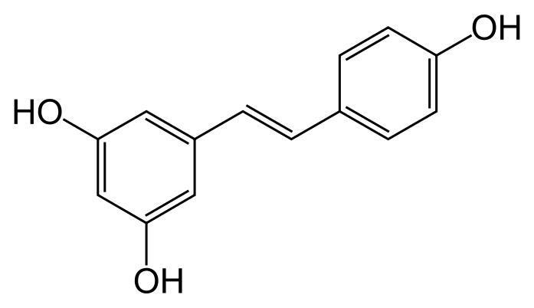 |  | 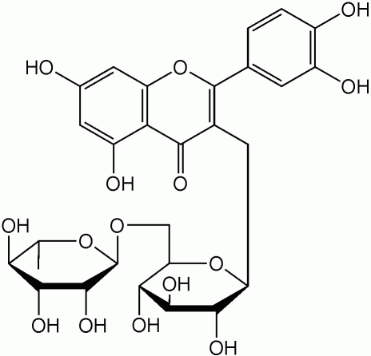
 | 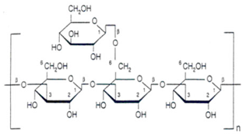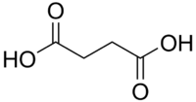
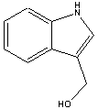 | 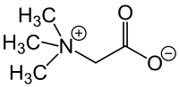
СН₃–(СН₂)₄–(СН=СН–СН₂)₃–(СН₂)₃–СООН |  | 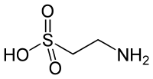
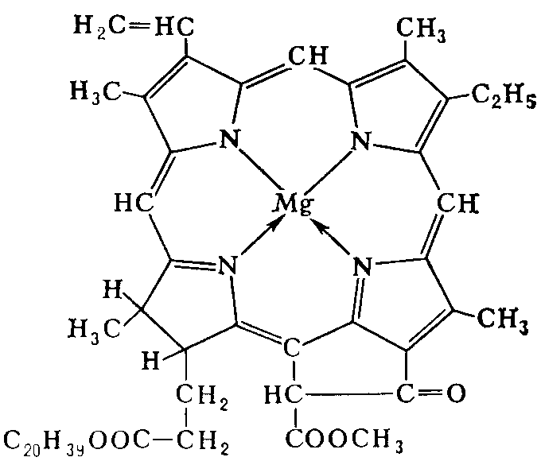 | 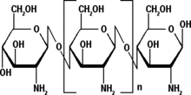 | 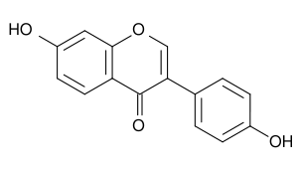
 | 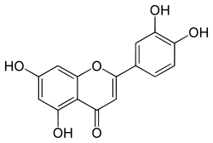 | 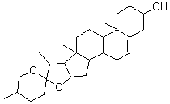
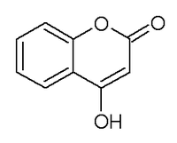 | 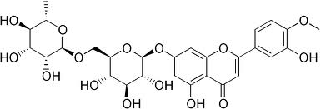
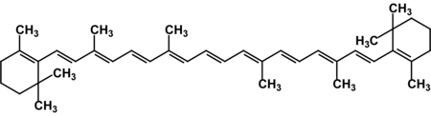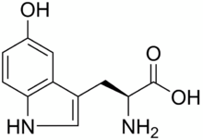

Safety rules in a chemical laboratory:
1. Safety to begin implementation of laboratory tasks, students must become familiar with the rules of work in a laboratory, by instructions on accident and protection, by the plan of fire-prevention measures.
2. Students are under an obligation to support a cleanness and order in a laboratory.
3. At implementation of work it is necessary to adhere to pointing on the use of all defence of facilitie. Working is settled only in a dressing-gown and special cap.
4. Before to begin work, it is necessary to study properties of substances that is used and appear as a result of chemical reactions.
5. Performing laboratory job is allowed after the preliminary theoretical training, the level of which controls the teacher at the beginning of each classes.
6. Chemical reagents are in laboratory tables, and chemical tableware is in the special closet. The concentrated acids and volatiles are kept in drawing closets.
7. Before realization of research it is necessary carefully to check an apparatus and tableware, make sure in that setting or devices is collected correctly, chemicals meets to requirements.
8. It is forbidden to carry out tests in dirty tableware. Tableware it is necessary to wash down right after realization of work.
9. It is categorically forbidden to eat food in laboratories, to drink water from chemical tableware, to smoke.
10. It is impossible to leave working laboratory installation, and also turn on devices without a supervision.
11. It is forbidden to taste chemical reagents.
12. It is impossible to lean over tableware with the heated liquid, send opening of such tableware to itself and on other working.
13. It is categorically forbidden to use reagents from bottles in default of labels or without labels.
14. Determination the smell of substance is necessary to make carefully, fumes direct to itself, do not inhale.
15. Work with dangerous substances, concentrated acids, which distinguish pairs, only under chemical oven.
16. Particular caution should be observed when working with toxic and harmful substances.
17. It is forbidden to pour out into the sink resude of acids, alkalis, flammable and combustible substances, throwing sand in the sink, matches and other solids. Acids, alkalis, organic solvents and reagents containing compounds, and precious metals is poured into special container.
18. It is forbidden to take away from a laboratory reagents and to carry out additional tests without a teacher's permission.
19. After completion of work it is necessary to put a workplace in an order, turn off working devices, gas, water and electricity.

The first medical aid:

1. During work in a laboratory it is necessary exactly to observe all safety measures according to rules and instructions.
2. In case of burns of ending make lotions with a solution of potassium permanganate or compress with an alcohol solution.
3. In ease of burns of skin and mucous membranes caused by acids, it is necessary to wash well the damaged place by water (in a flow 10-15 minutes), then by 2% sodium hydrogen carbonate and wash water again.
4. For burns cased by alkali rinse the affected area with water, followed by 1% acetic acid or citric acid.
5. At case of the burns of skin by a phenol, bromine and other similar pyretics, wash the damaged place plenty of 40% alcohol and apply ointment from burns.
6. In the case of poisoning by chlorine, bromine, nitrogen oxides and other dangerous substances you have to breathe ammonia and then go out into the fresh air, and drink milk.
7. In case of strong burns, wounds and poisoning, providing first aid to injured person immediately then need to be hospitalized.

CONTENT
Theme: The role of nutrition in providing vital processes organism
Topic: Macro and micronutrients
Topic: Diet. Nutritional status and methods for its determination. Medicinal nutrition
Topic: Dietary supplements: marking analysis and determination of good quality
Topic: Nutritional correction of food intolerance and food allergy
Topic: Nutritional correction of diabetes mellitus
Topic: Nutritional correction of obesity and diseases of the gastrointestinal tract
Topic: Nutritional correction of diseases of cardiovascular systems
Topic: Nutritional correction of diseases of the urinary system and musculoskeletal system
Self preparing tasks
General rules of work in the chemical laboratory

