SUBSTANTIAL MODULE 4.

MICROSCOPICAL DESCRIPTIONS:

Topic: ALKALOIDS.

BELLADONNA LEAF – BELLADONNAE FOLIА

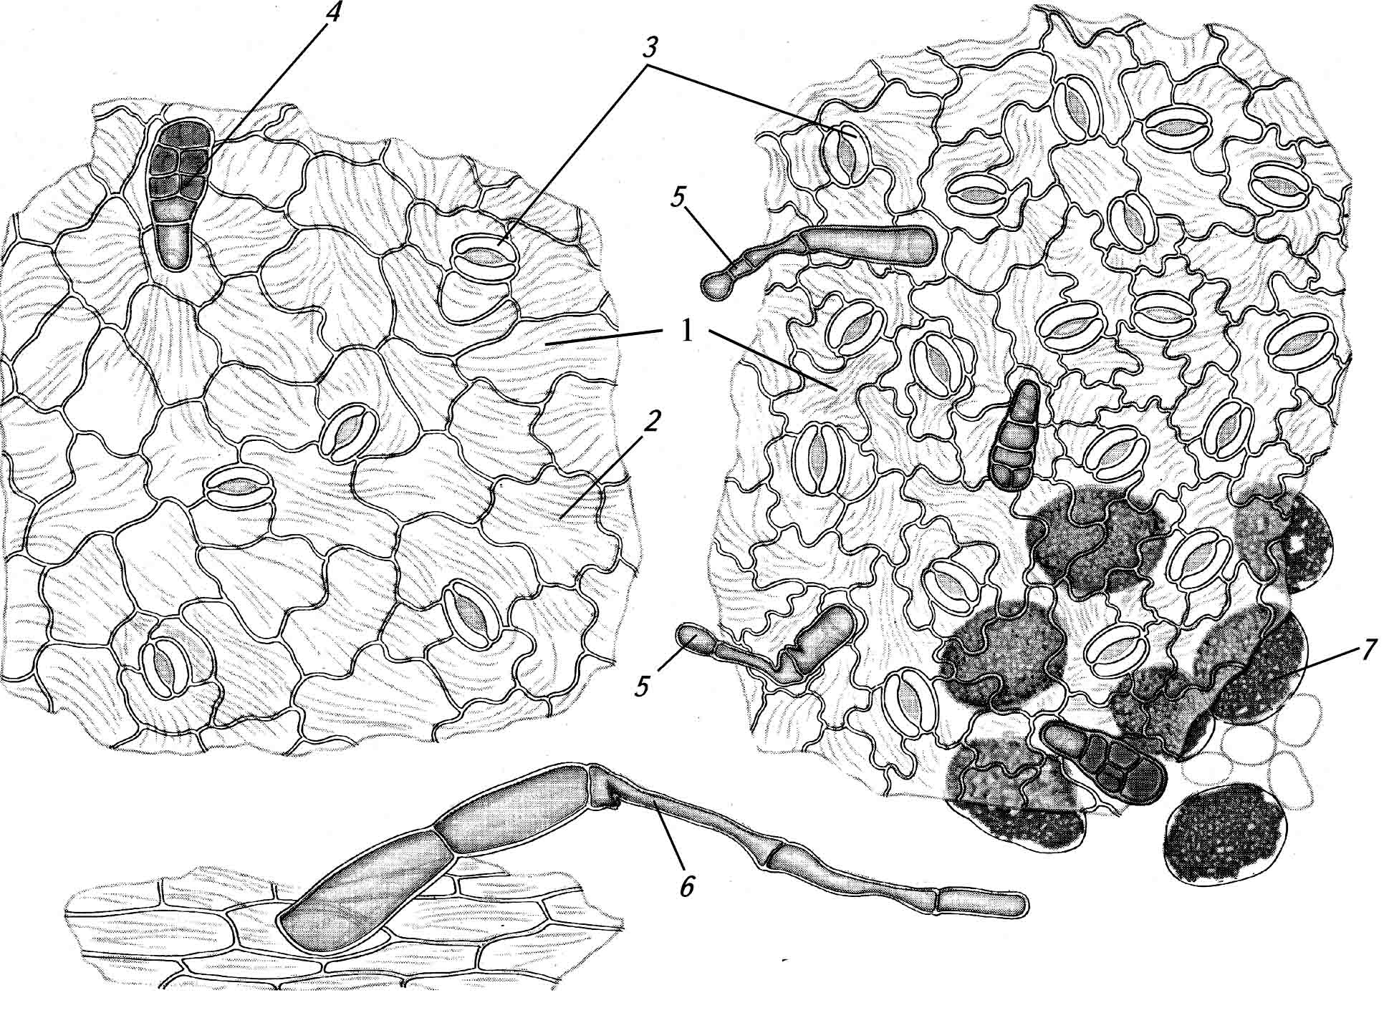 | Anatomical features of belladonna leaf:  1 – upper epidermal cells;  2 – lower epidermal cells;  3 – stomata;  4 – glandular hairs with small pedicel and a large multicellular head;
5 – glandular hairs with long pedicel and unicellular head;
6 – simple hairs;
7 – oval idioblasts filled with calcium oxalate sand.
STRAMONIUM LEAF – STRAMONII FOLIА

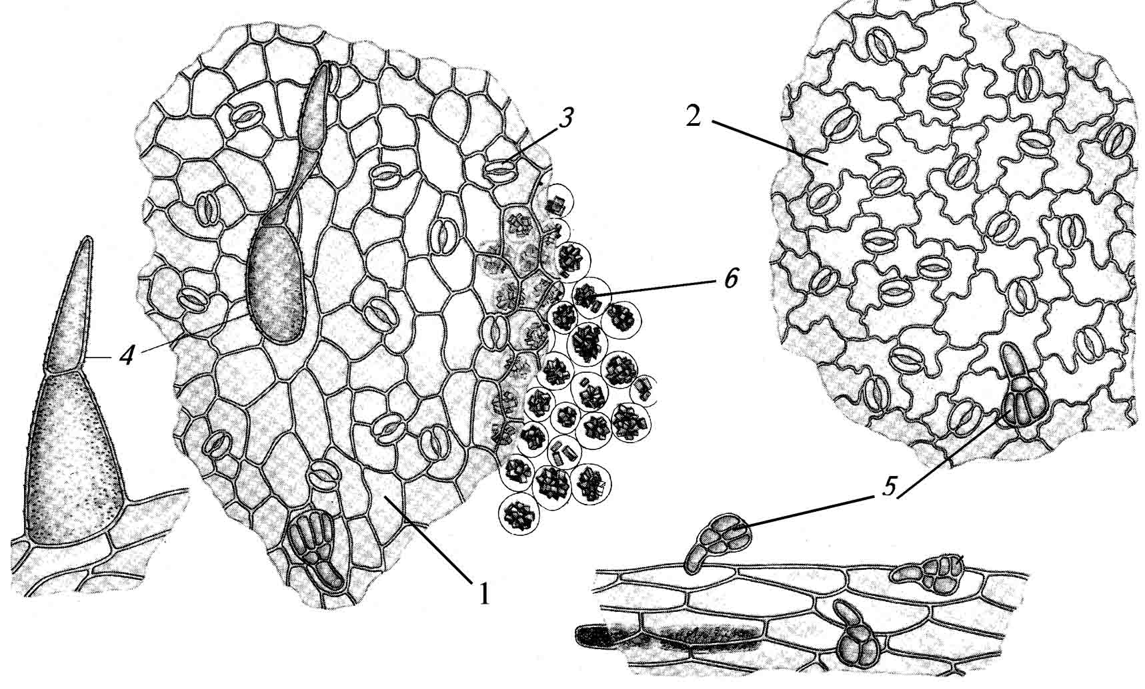 |  | Anatomical features of stramonium leaf:  1 – upper epidermal cells;  2 – lower epidermal cells;  3 – stomata;  4 – simple hairs;  5 – glandular hairs with small pedicel and a large multicellular head;  6 – druses of calcium oxalate.

HENBANE LEAF – HYOSCYAMI FOLIА

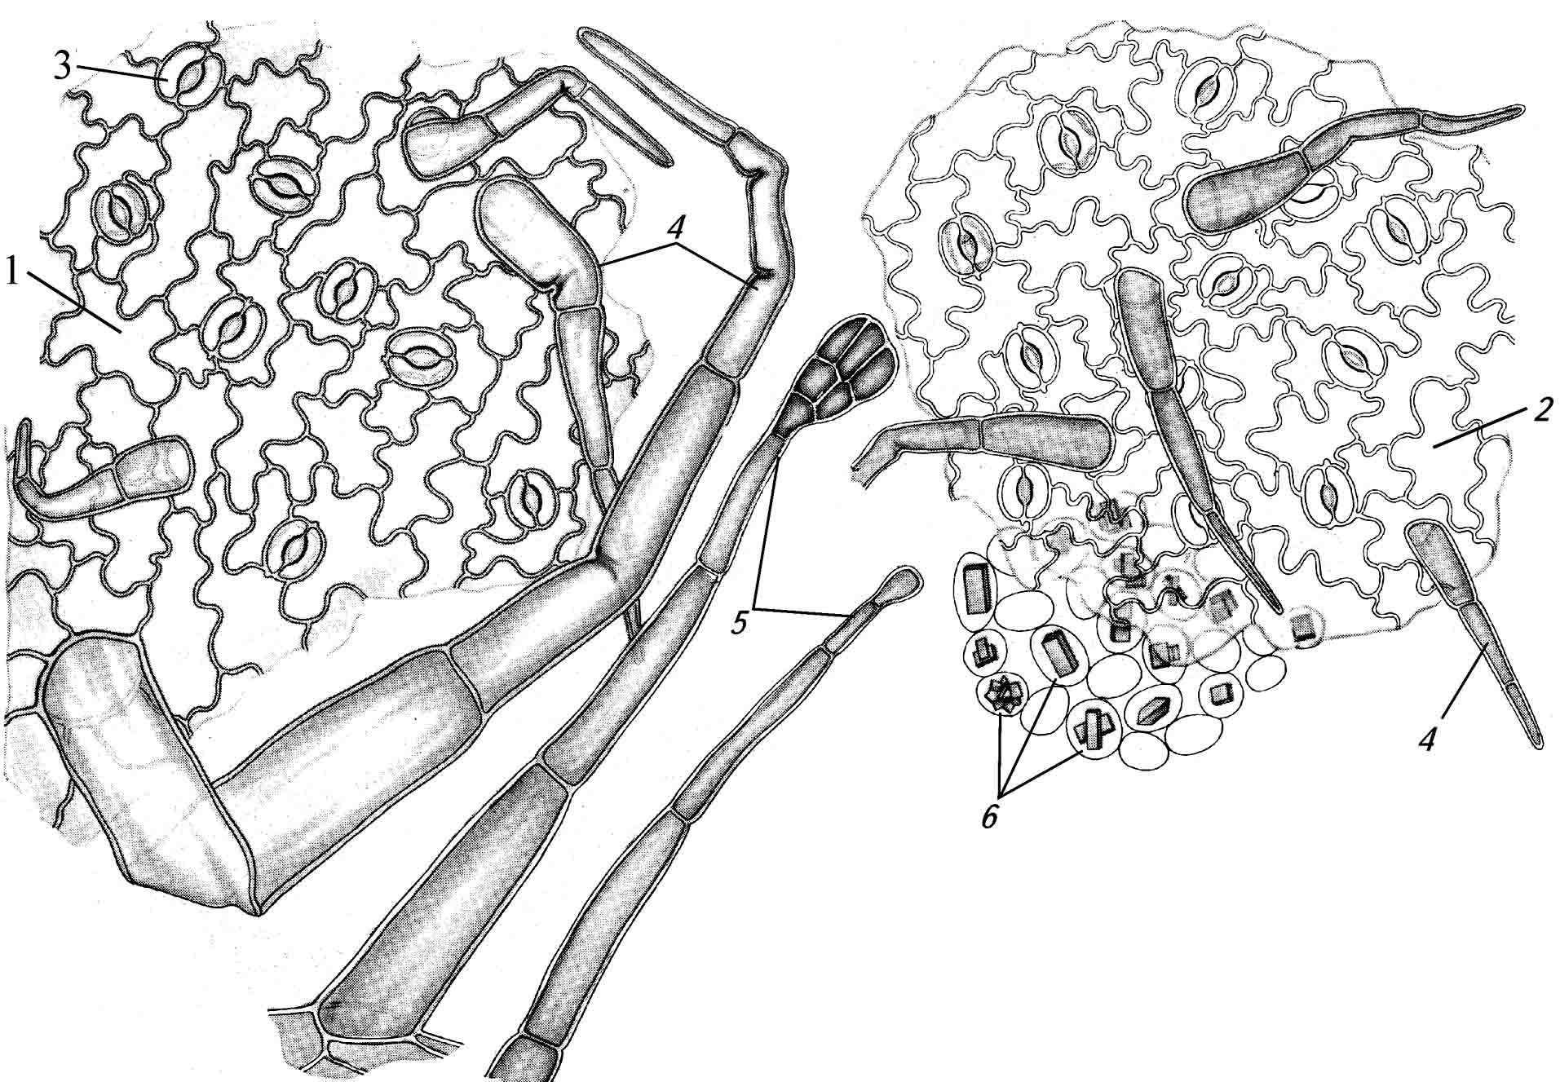 | Anatomical features of henbane leaf:  1 – upper epidermal cells;  2 – lower epidermal cells;  3 – stomata;  4 – simple hairs;  5 – glandular hairs; 6 – prismatic crystals of calcium oxalate.
BUSH PEA LEAF (THERMOPSIS LEAF)– THERMOPSIDIS HERBA

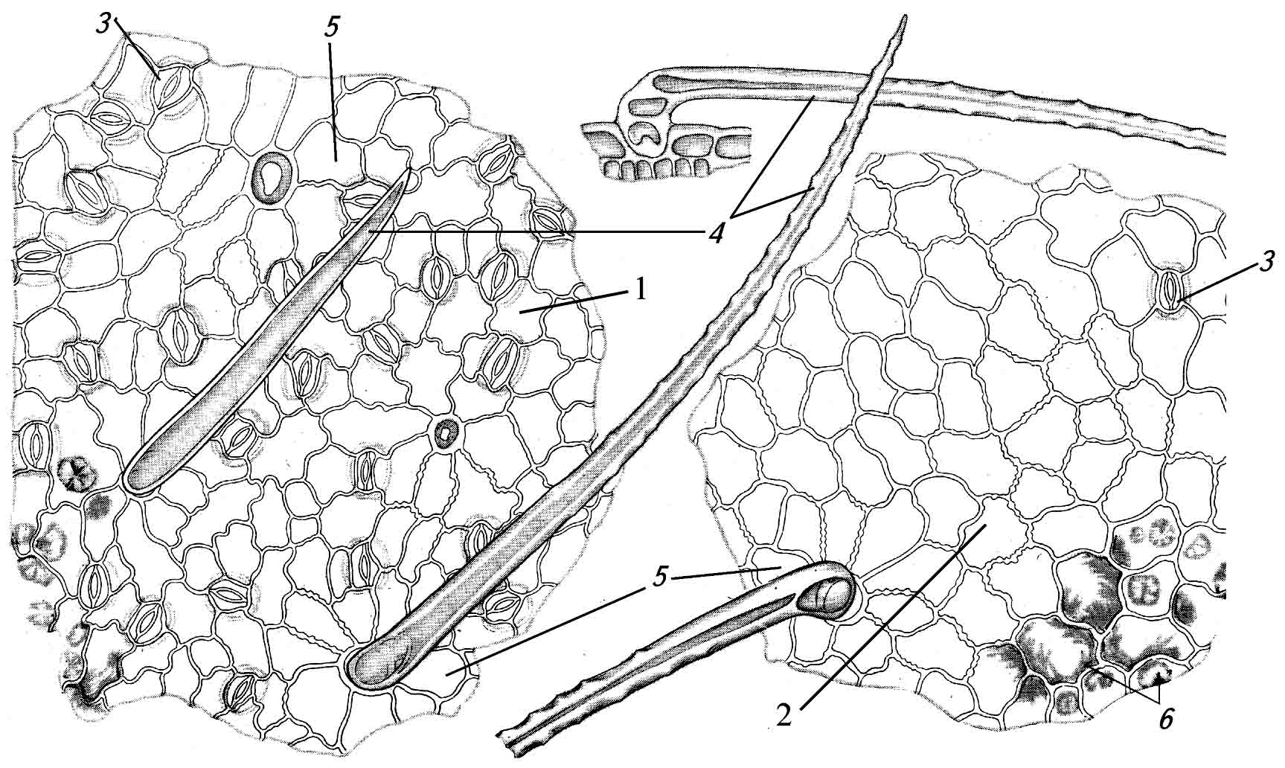 | Anatomical features of bush pea (thermopsis) leaf:  1 – lower epidermal cells;  2 – upper epidermal cells;  3 – stomata;  4 – simple hairs;  5 – rosette at the base of a hair;  6 – spheric crystals of phenolic glycoside
CELANDINE HERB – CHELIDONII HERBA

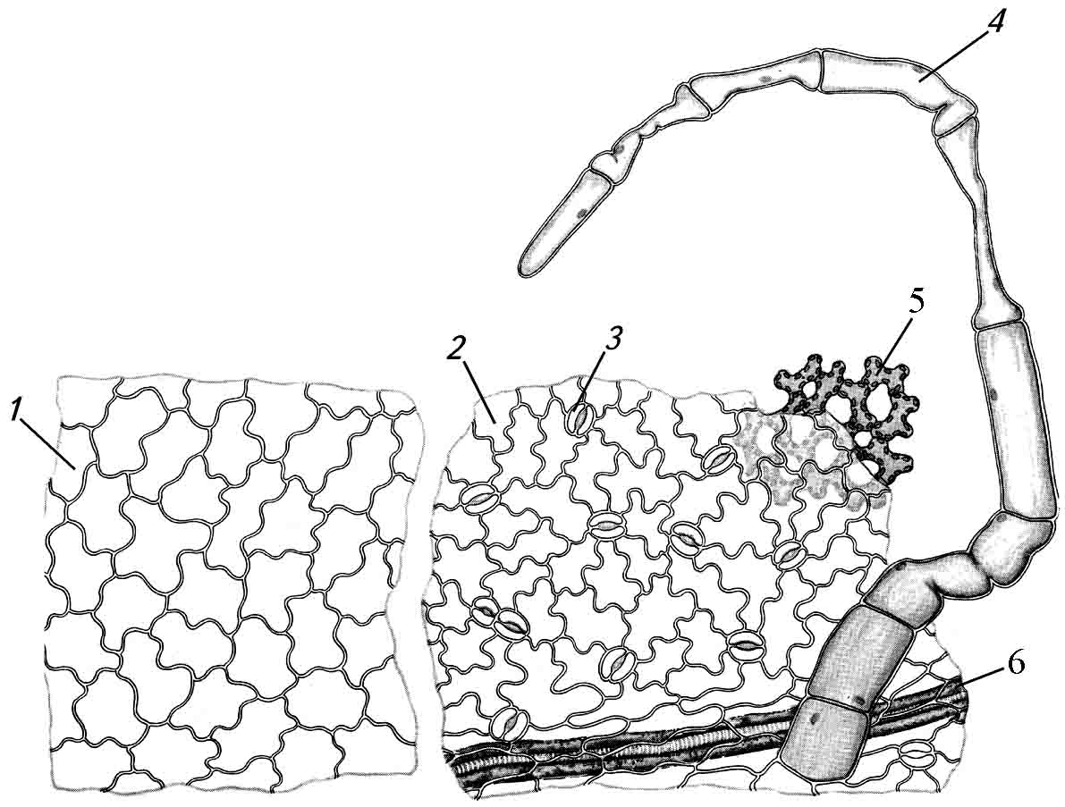 | Anatomical features of celandine herb:  1-upper epidermal cells;  2 – lower epidermal cells;  3 – stomata;  4 – simple hair;  5 – spongeous parenchymal cells with large intercellular ducts (aerenchyma);  6 – veins with lactifers filled with yellow contents.

