PHARMACOGNOSY
for 3^{rd*} year students 22 Public health 226 «Pharmacy, industrial pharmacy», educational program «Pharmacy» Фм18(5,0д) англ 1, 2, groups
15.04 groups 1
17.04 groups 2
Chemical and morphological analysis of Resin and Balsam - containing medicinal plant and herbal drugs .

LABORATORY CLASS. Topic: « Resin and Balsam »
OBJECTIVE.
Know the definition of the term “Resin and balsam”, their classification, physical and chemical properties, the identification and quantitative analysis, pharmacological properties.
RELEVANSE
Resin is a solid or highly viscous substance of plant that is typically convertible into polymers. Resins are usually mixtures of organic compounds.
Plants secrete resins for their protective benefits in response to injury. The resin protects the plant from insects and pathogens. Resins confound a wide range of herbivores, insects, and pathogens, while the volatile phenolic compounds may attract benefactors such as parasitoids or predators of the herbivores that attack the plant.
Balsam is the resinous exudate (or sap) which forms on certain kinds of trees and shrubs. Balsam (from Latin balsamum "gum of the balsam tree", ultimately from Semitic, Aramaic busma, Arabic balsam and Hebrew basam, "spice", "perfume") owes its name to the biblical Balm of Gilead.

CONTROL QUESTIONS
- Give the definition of the term “Resin”.
- Give the definition of the term “Balsam”.
- Describe the origin of Resin and Balsam.
- How to get (obtain) Resin and Balsam?
- Describe classification of Resin.
- Describe chemical composition of different Resin
- Describe chemical composition of different Balsam
- Where especially accumulate Resin and Balsam in plants.
- Describe usage of Balsam and Resin.
- Make the list of resin and balsam-containing plants.

- Match the compounds with balsam or resin where it found

- commiphoric acids | - Asafoetida
- abietic acid | - Balsam of Tolu
- balsamic acids | - Balsam of Peru
- mercaptan | - Colophony
- cinnamic | - Myrrha
- benzyl benzoate | - Benzoin

12. Match the names of resin and balsam with their plants origin
1Storax | - Styrax benzoin
2 Colophony | B. Ferula asafoetida
- Balsam of Peru | C Liquidambar orientalis
4 Myrrh | D Commiphora myrrha
5 Asafoetida | E Myroxylon toluifera
6 Benzoin | F Pinus sylvestris
7 Balsam of tolu | J Myroxylon balsamum

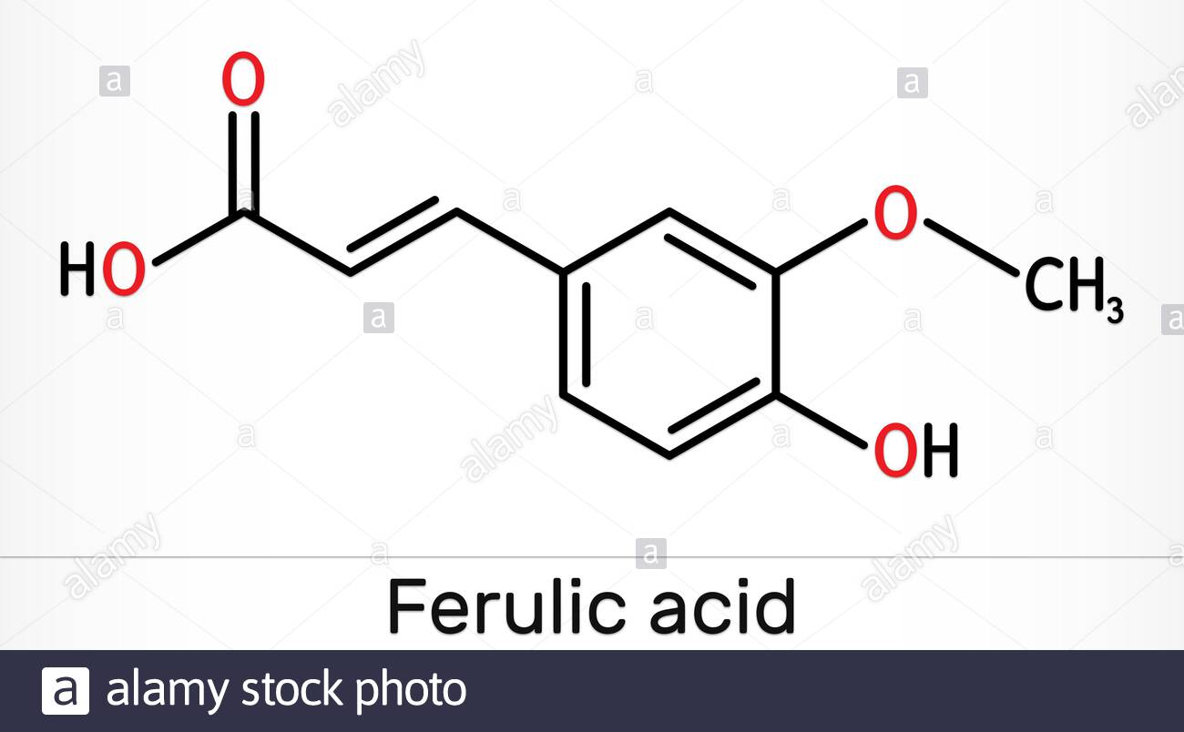

PRACTICAL TASKS.
You have to fill in your laboratory hand-book on the topic: Chemical, and morphological analysis of resin and balsam- containing herbal drugs.

