PHARMACOGNOSY

**LABORATORY CLASS. Topic: «Chemical, morphological and anatomical analysis of MPM containing alkaloids – IІ.»**

**THE THEORETICAL PART.**

**MEDICINAL PLANTS AND RAW MATERIAL CONTAINING PROTOALKALOIDS**

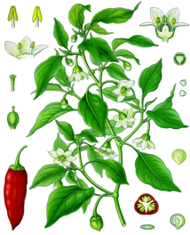

**CAPSICUM FRUIT - *CAPSICI FRUCTUS***

**Capsicum** - *Capsicum annum* L., Fam. Solanaceae.

Synonym(s): Cayenne, Chilli Pepper, Hot Pepper, Paprika, Red Pepper.

**Plant.** Capsicum is a perennial shrub, but is usually grown as an annual. The plant grow rapidly and yield fruit in about six months. The flowers are born on pedicels and are succeeded by fruits which are gathered when just beginning to change color and are dried in the sun.

**Area of distribution.** It is cultivated in many parts of the world such as southern India and South America, but more expressially in Africa. The drug is exported chiefly from Zanzibar, Malawi and Sierra Leone.

**Description.** Cayenne pepper consists of the dried, ripe, usually removed from the calyx, fruits, and its preparations in effective dosage.

German pharmacopeial grade cayenne pepper consists of dried, ripe fruit of *C. frutescens L*. usually removed from the calyx. It must contain not less than 0.4% capsaicinoids with reference to the dried drug.

**Constituents.** Cayenne pepper contains up to 1.5% capsaicinoids (pungent principles) including 0.1-1% capsaicin, 6,7-dihydrocapsaicin, nordihydrocapsaicin, homodihydrocapsaicin, and homocapsaicin; fixed oils; carotenoid pigments including capsanthin, capsorubin, α- and β-carotene; steroid glycosides, including capsicosides A, B, C, and D; 9-17% fats; 12-15% proteins; vitamins A and C; trace of volatile oil.



**Uses.** In many countries, cayenne pepper is official in the Pharmacopeia as a topical ointment for the relief of painful muscle spasms in the upper torso.

Preparations are used to treat arthritis, rheumatism, neuralgia, lumbago, and chilblains. Cayenne preparations have demonstrated significant efficacy in the treatment of shingles, trigeminal neuralgia. For topical arthritis relief, capsaicin interferes with the pain of inflammatory joint disease. It may block pain fibers by destroying substance P, which normally would mediate pain signals to the brain. It may also interfere with oxygen radical transfers that are intrinsic to pain-producing prostaglandin pathways. While its exact mechanisms are not fully understood, capsaicin is regarded as a neuropathic pain reliever.

Capsicum USP was used as a carminative, stimulant, and rubefacient. Capsaicin, isolated from Capsicum, is recognized by the U.S. FDA as a counterirritant for use in OTC topical analgesic drug products. It is used as a component in various counterirritant preparations, arthritis pain relieving rub, which contains Capsicum oleoresin (0,025% capsaicin) in combination with menthol USP and Aloe vera gel. Capsicum ointments, containing 0,025% or 0,075% capsaicin, are used topically to treat shingles (herpes zoster) and post-herpetic neuralgia. Duration of administration: Not longer than two days; 14 days must pass before a new application can be used in the same location. Longer use on the same area may cause damage to sensitive nerves.Drug:Liniment, ointment or cream, semi-solid paste or plaster; tincture.

**Contraindications:** Application on injured skin, allergies to cayenne preparations.

**Side Effects:** In rare cases hypersensitivity reaction may occur (urticaria).

**Pharmacopoeial and Other Monographs:** BHP 1996, BP 2009, Complete German Commission E (Paprika), Martindale 35th edition, Ph. Eur. 6.4, USP29/NF24, SPU.

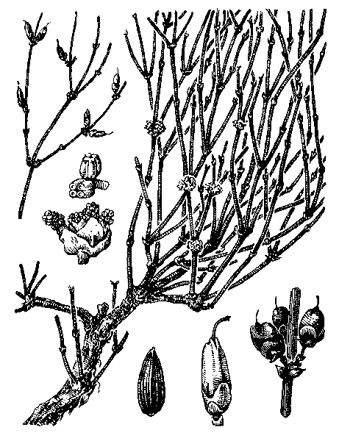

**EPHEDRA HERB - *HERBA EPHEDRAE***

**Ephedra** *- Ephedra equisetina* Bunge,Fam. Ephedraceae.

Synonym(s): Chinese ephedra, mahuang, cao mahuang.

Plant. Ephedra is a dioecious, perennial, evergreen subshrub

Area of distribution. It is native to central Asia, widely distributed throughout China, Tibet, India, Pakistan, Japan, and Southern Siberia, also cultivated extensively.

**Description.** Ephedra consists of the dried, young branchlets, harvested in the fall, of *Ephedra equisetina* or other equivalent Ephedra species (*E. sinica, E. intermedia, E. gerardiana, E. major*), and their equivalent preparations in effective dosage.

**Constituents.** The herb contains alkaloids0.5–2.0%; main alkaloids are ephedrine 50–90% (in most species, except *E. intermedia*) and pseudoephedrine also (-)-norephedrine, (+)-nor pseudoephedrine, (-)-methylephedrine and (+)-methylpseudoephedrine; volatile oil; tannins (catechin, gallic acid), ephedrans (glycans) and acids (citric, malic, oxalic).

The pure alkaloid ephedrine acts as an indirect sympathomimetic. It is structurally similar to adrenaline. It stimulates cardiac automaticity with a positive inotropic action. It accelerates and increases the intensity of respiration and functions as a bronchodilator.

 

**Uses.** The approved modern therapeutic applications for ephedra are supportable based on its history of clinical use in well established systems of traditional and conventional medicines, extensive phytochemical investigations, pharmacological studies in animals, and human clinical studies. It is approved the internal use of ephedra herb for diseases of the respiratory tract with mild bron-chospasms in adults and children over the age of 6.

The World Health Organization has found the following uses of ephedra preparations to be supported by clinical data: treatment of nasal congestion due to hay fever, allergic rhinitis, acute coryza (rhinitis), common cold, sinusitis, and as a bronchodilator in treatment of bronchial asthma.

In Oriental medicine, ephedra herb, known as mahuang, is the primary drug used in treatment of asthma and bronchitis. Mahuang has been used for more than two thousand years to treat bronchial asthma, cold and flu, fever, chills, lack of perspiration, headache, nasal congestion, aching joints and bones, and cough and wheezing

**Contraindications.** Ephedrine (and, therefore, ephedrine-containing products) should be used with caution in patients with diabetes, ischaemic heart disease, hypertension, hyperthyoidism, renal impairment and angle-closure glaucoma, and that in patients with prostate enlargement, ephedrine may increase difficulty with micturition. It has been recommended to reduce the dose or discontinue treatment if nervousness, tremor, sleeplessness, loss of appetite or nausea occur with use of ephedra preparations. There is a report of a professional sportsman who tested positive for norpseudoephedrine after having consumed a liquid herbal product listing ephedra as one of the 15 ingredients.

Ephedra became controversial in the 1980-1990s due to its popularity as a major ingredient in herbal dietary supplements in the United States. Regulators and health officials were becoming increasingly concerned about its use for various purposes that were not approved for OTC drug use by the FDA, e.g., in products intended as diet aids for weight loss, for stimulation of the central nervous system, for enhancement of athletic performance, and briefly, as substitutes for illegal street drugs . The FDA and state regulatory officials repeatedly voiced concerns about adverse reaction reports—in some cases, fatalities—that were claimed, but not always confirmed, to be associated with the ingestion of herbal supplement products containing ephedra, as well as products containing the ephedrine alkaloids (e.g., pure ephedrine). Consequently, federal and state regulatory agencies attempted to limit the uses of ephedra in supplements, the level of alkaloids per dose and per day, and, in some states, access to ephedrine-containing products.

**Drug interactions.** In combination with: Cardiac glycosides or halothane: Disturbance of heart rhythm. Guanethidine: Enhancement of the sympathomimetic effect. MAO-inhibitors: Greatly raising the sympathomimetic action of ephedrine. Secale alkaloid derivatives or oxytocin: Development of hypertension.

**Side-effects.** The most common adverse effects of ephedrine and pseudoephedrine are tachycardia, anxiety, restlessness and insomnia. Tremor, dry mouth, impaired circulation to the extremities, hypertension and cardiac arrhythmias may also occur with ephedrine, and skin rashes and urinary retention have been reported for pseudoephedrine. In higher dosage: development of dependency.

**Pharmacopoeial and Other Monographs:** Complete German Commission E, Martindale 35th edition, WHO (volume 1 1999).

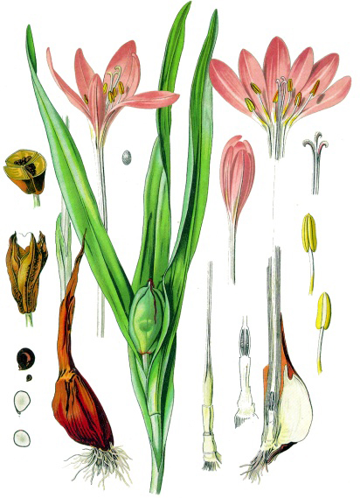

**COLCHICUM CORM - *COLCHICI BULBOTUBERA RECENS*  
Colchicum -** *Colchicum autumnale* Linne**,**Fam*.* Melanthiaceae*.*

**Plant.** Two to six flovers with long perianth tubes develop from the corm buds in the fall (hence, the name autumn crocus). The corm is collected in the spring before leaf development.

**Area of distribution.** The plant is cultivated in England. Italy and East European countries produce most of supplyof the corm. It is collected in spring. It is also cultivated as ornamental.

**Description.** Poisonous plant material! **List A (poisonous drug substances)!!!** The corm are collected, cut into transverse slices and dried at a temperature not exiding 65 ºC. The outer membranes are rejected. The whole corms are 2-3 cm diameter but the dried drug consist of somewhat reniform, transverse slices are occasional more ovate longitudinal slices, about 2-5 mm thick. The epidermal surface is cinnamon-brown and slightly wrinkled. The interior is white and starchy and, if carefully smoothed, shows scattered fibrovascular bundles.

**Constituents.** Colchicum contains the alkaloid colchicine up to 0,8% in the seed and up to 0,6% the corm. Colchicinehas also been found in other genera of the lily family.

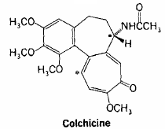Colchicine has one amido nitrogen atom. The compound lacks pronounced basicity and does not form a well-defined series of salts as do other alkaloids. Nevertheless, it is precipitated by many alkaloid reagents and is conventionally considered an alkaloid. The use of colchicine to double chromosomes has opened a large field in plant genetics. Any numeric change in chromosome number entails a mutation that becomes evident in a number of the characteristics of the experimental plant. The interrelationship between the action of colchicine and mitosis is being investigated in animals; preliminary experiments show that injections of colchicine can affect the dispersal of tumors.

**Uses.** Colchicum preparations are used to relieve gout, but must be employed with caution. It can affect the dispersal of tumors. It has been employed experimentally in the treatment of various neoplastic diseases.

**MEDICINAL PLANTS AND RAW MATERIAL,**

**CONTAINING PURINE ALKALOIDS**



The purines are derivatives of a heterocyclic nucleus consisting of the 6-membered pyrimidine ring fused to the 5-membered imidazole ring. Purine itself does not occur in nature, but numerous derivatives are biologically significant. The pharmaceutically important bases of this group are all methylated derivatives of 2,6-dioxypurine (xanthine). Caffeine is 1,3,7-trimethylxanthme, theophylline is 1,3-dimethylxanthine, and theobromine is 3,7-dimethylxanthine.

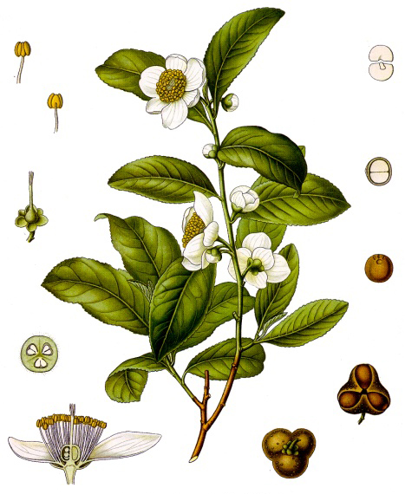**TEA LEAF - *THEAE FOLIUM***

**Black tea -** Camellia sinensis (L.) O.. and its cultivated varieties, syn. Thea sinensis L.,Fam*.* Theaceae*.*

**Plant.** In cultivation, the up to 15 m high shrub with many branches is kept low; only the young shoots are more or less densely pubescent. These are picked by hand and yield the best quality tea. Leaves are oblong-ovate, dark green, shiny with a distinctly serrate margin. The fragrant flowers are up to 3 cm in diameter, with 5-6 white petals and numerous yellow stamens, appearing singly.

**Area of distribution.** The tea plant is presumed to be originally native to the western Yunnan province, China (sinensis group) and to the warmer regions of Assam, Burma to Vietnam and southern China (assamica group). Long cultivated in China; it has been cultivated on a large scale in Indonesia since the 18th century and in India and Sri Lanka since the 19th century. It has also been planted in higher regions (500—2000 m) of other countries that have a mild climate and high levels of precipitation. The material of commerce is imported from the countries mentioned as well as from other tropical or subtropical cultivation regions.

**Description:** B**lack tea leaf -** *Folium Theae nigrae*Black tea consists of reddish brown to almost black, much shriveled leaf fragments, the original shape of which can only be determined after boiling and steeping in water. Higher quality tea consists of the leaf buds which are finely pubescent on the lower surface (visible under magnification). The margin is finely serrate, and the tip of each tooth bears a small glandular trichome. Odor: Faintly aromatic. Taste: Astringent, bitter.

Black tea is produced by partially drying ("withering") the young leaves in well- ventilated chambers. This process renders the leaves pliable and flaccid so that they can be rolled, which causes some of the cell sap to exude and the leaf structure to be partially broken down. During subse­quent fermentation, the polyphenols (tannin precursors) are converted to oligomeric proanthocyanidins (thearubigins) and at the same time, the characteristic aroma compounds are formed. The leaves are then dried ("fired") in a hot air current, sorted and packed.

Numerousdistinct varieties of black tea are commercially available with names that describe their grade, origin and/or quality (basedon leaf age). The classification of black tea grades is determined by particle size analysis as well as sorting by appearance (color) and method ofmanufacture (e.g. crush, tear, curl (CTC) or orthodox); for example, flowery orange pekoe (FOP) is a "whole leaf orthodox" grade, broken orange pekoe (BOP) is a "broken orthodox" grade, and broken pekoe (BP) is a "broken CTC" grade. Types of black tea are additionallyclassified according to their origin; for example, Assam black tea is grown in the state of Assam in north- estern India and Darjeeling black tea is grown in the Darjeeling area of northern WestBengal, India. Other black tea names describetheir flavor; for example, Earl Grey is a blended tea flavored with oil of bergamot orange peel.

**Green tea leaf -** *Theae viridis folium*are greenish yellow to brownish green leaf fragments, which are more or less curled. Odor is very faint and characteristic; taste - astringent, bitter.

In contrast to black tea, green tea is not fermented. The freshly harvested leaves of the tea shrub undergo a heat treatment (steam or dry heat) wherein the plant enzymes (phenol oxidases) are inactivated. The leaves are then rolled and dried.

Numerous distinct types of green tea are commercially available, classified according to a number of factors including origin, season of harvest, method of harvest, method of production, as well as leaf size and quality; whole leaf grades (e.g. Fine Young Hyson, Young Hyson), broken grades (e.g. Hyson, Gunpowder), Twanky, Fannings (or Soumee), and Dust. For Japanese green teas, the season of harvest, the region, and the precise part of the shrub from which the leaves and buds are harvested, are associated with the type (e.g. "matcha", "bancha", "sencha"). Some types, e.g. "sencha", are further sorted into several commercial grades.

Constituents: **Black tea:** The primary constituents are methylxanthines such as caffeine (theine) at up to 4% (partially bound to tannins) (according to Ph. Fr. X, not less than 2.5%, calculated with reference to the dried drug) in addition to smaller amounts of theobromine and theophylline (literature data varies) and traces of adenine and xanthine. In the fresh leaves, the polyphenols occur as genuine flavan-3-ols (catechins), partially esterified with gallic acid, and as dimeric proanthocyanidins, flavonols and flavonol glycosides; free phenolic carboxylic acids and depsides are also present. The oxidation reactions during the fermentation process generate reactive *o*-quinones which dimerize to chromophoric benzotropolone rings, such as the (orange-red) theaflavines (about 2%), in addition to low amounts of theaflavinic acid, theaflagalins and bisflavonols. Responsible for the taste and color of the tea infusion, however, are predominantly the oligomeric thearubigins (brown, acidic pigments), which make up to 20-30% of the dry weight; they form by mixed enzymatic condensation of the oxidized catechins wherein the flavonols and phenolic carboxylic acids probably participate in the polymerization.

The fresh leaves also contain smaller amounts of flavonol glycosides, mainly 3-O-di- and 3-O-triglycosides of quercetin and kaempferol as well as C-glycosyl derivatives of api- genin in certain tea varieties. Besides the predominant catechin-type tannins, low levels of gallo- and ellagitannins have also been detected. Other constituents include theanine, the 5-N-ethylamide of glutamic acid, which is a characteristic component in the amino acid profile of tea; it antagonizes the convulsant and CNS-stimulating effects of caffeine and can also be used as a marker for quality evaluation.



Volatile aroma compounds develop only during the fermentation process, or are released from glycosidic precursors. To date, 300 compounds have been identified, mostly monoterpene al­cohols and aldehydes, including linalool, geraniol and (Z)-3-hexene-l-ol as the essential odoriferous substances. Notable is the aluminum- and manga­nese accumulation as well as the very high levels of fluorides in older tea leaves.

**Green tea** differs from black tea based primarily upon its profile of polyphenols and aroma compounds. The content of methyl- xanthines is somewhat lower, on average about 2.2% caffeine (according to Ph. Fr. X, not less than 2.0%, calculated with reference to the dried drug). The main polyphenols of the fresh tea leaves also occur naturally in green tea leaf, consisting of monomelic flavan-3-ols (catechols) which are partially esterified with gallic acid; the main component is (-)-epigallocatechin- 3-*O*-galIate (EGCG), with di- and trimeric proanthocyanidins (some of them as gallate esters) in addition to gallo- and ellagitannins that have also been described for black tea.



Other polyphenols of green tea include abundant free flavonols (quercetin, kaempferol and myricetin) and their glycosides. The phenolic carboxylic acids and depsides of the fresh leaves are probably also present in green tea. The theaflavins and thearubigins, as well as the (aroma) compounds which form during the fermentation process of black tea are absent. Nevertheless, about 75 volatile compounds could also be identified (with GC) in green tea. Characteristic constituents are geraniol, linalool, trans-linalool- oxide, nerolidol, cis-jasmone, among others, as well as or-3-hexanal, its hexanic acid ester, and dimethyl sulfoxide.

The tea leaf specific amino acid theanine also occurs in green tea. Also present is ascorbic acid, which is absent from black tea due to the fermentation process. The mineral content is based on analyses of black tea; similar studies for green tea are lacking.

Indications: On the basis of its caffeine content, black tea serves as a stimulant, and on the basis of its tannin content, it can be used as an antidiarrheic. Whether the constipating action is dependent upon the content of theophylline is questionable. The action of black tea in bacterial dysentery can thereby be explained in that aqueous extracts of tea leaf have demonstrated bactericidal activity against various pathogenic bacteria and have inactivated cholera toxin in vivo. Black tea significantly accelerated gastrointestinal transit (GIT) in vivo, for which the thearubigin fraction was determined to be responsible. A range of interesting pharmacological effects have been demonstrated for the polyphenols occurring in tea leaf, mainly antioxidant and anticarcinogenic (chemo- preventive) activities

Although the majority of studies thus far have been carried out on green tea leaf or on isolated substances thereof, e.g. EGCG (=(-)- epigallocatechin-3-gallate), a range of comparable positive findings have also been shown for black tea leaf treatment of mild diarrhea, for functional asthenia, as a weight loss aid, and/or to enhance renal excretion of water.

Similar to black tea, **green tea** serves as a stimulant beverage. However, due to its slightly bitter and less pleasant taste, historically, there has been little demand for it in Europe. The situation has changed recently in that there is a new appreciation for its value based on the fact that numerous papers, primarily from Asia, have reported "health promoting" and "health preserving" effects. Studies have been conducted with infusions of green tea lea£ with green-tea-polyphenol-fractions (GTP) as well as with isolated constituents such as EGCG. In addition to various animal model experiments, studies have been carried out with human volunteers, e.g. to investigate the effects of drinking green tea on serum lipid levels. Individual case reports from medical journals have also found their way into the popular press, so much so that one may get the impression that Camellia sinensis has now reclaimed its original position as a medicinal plant. In addition to reports concerning the antiviral effects of EGCG or the actions of green tea, GTP and/or EGCG on pathogenic bacteria, including dental caries preventive effects, the anticarcinogenic (chemopreventive) activity of tea leaf remains in the foreground of interest. The following properties have been demonstrated, which are primarily attributed to the polyphenols contained in tea leaf:

* antioxidant capacity
* inhibits the activation of carcinogenic enzymes
* intercepts reactive intermediates of carcinogenic substances
* inhibits carcinogenesis induced by nitrosoguanidine
* protective effect against asbestos-induced injury of peritoneal macrophages and red blood cells.

A number of studies involve the isolated constituent EGCG, which has displayed the strongest antioxidant activity within the polyphenol fraction (GTP). EGCG is a main component in the polyphenol spectrum of green tea leaf; while most of the catechins are converted to thearubigins during the fermentation process from green tea to black tea, a small amount remain unchanged. This explains the stronger antioxidant activity of green tea. EGCG inhibits urokinase, an enzyme that can cause tumors to form secondary tumors. Catechins are viewed as interesting starting points for the development of antiviral and antitumor agents.

In spite of the many individual findings, of which only a few may be termed as proof, a critical question, however, must be answered as to whether results showing cancer prophylaxis activity for green tea in animal experiments can be applied to the use of green tea in humans, and which measurements of evidence are transferable. Whether the recommended daily dosage of 4 strong cups as a "preventative" or 5—10 cups as a "medicine" will provide an adequately high concentration of polyphenols in the human organism, requires further investigation. Though this dosage range is not at all unusual in Asia, a recommendation of up to 10 cups daily for persons with sensitive gustatory cells and stomachs may be a considerable challenge and not conducive to patient compliance.

In France, green tea preparations may be labeled as traditional medicines for treatment of mild diarrhea, for functional asthenia, as a weight loss aid, and/or to enhance renal excretion of water

Undesired effects and Interactions with other drugs: Due to the astringent action of the tannins, a reduced absorption of other concomitant medications can occur. Complexation with N-containing drugs can lead to a reduction of bioavailability in the gastrointestinal tract. This interaction with alkaloids (besides morphine) is a long known fact and has also been investi­gated in N-containing neuroleptic drugs and antidepressive medications

A compilation of clinically relevant interactions between certain medications and black tea can be found in a recent review article. Based on this study, it can be concluded that medications should not be administered simultaneously with the drinking of black tea. Whether the assertion that the excessive use of tannin-containing beverages may promote the occurrence of esophageal cancer is of any significance to "normal" tea drinkers is doubtful. For discussion of this question as well as the pharmacology and toxicology of botanical tannins, including those occurring in black tea.

Making the tea: Pour boiling water over 1 teaspoonful of black tea leaf and, depending on the purpose, steep in a covered cup for 2—10 min and then strain. As a stimulant, steep for only 2 min and drink one cup several times daily. As an antidiarrheic, in supportive treatment of diarrhea, steep for 10 min and drink one cup 2—3 times daily. The stimulant effect is strongest in tea which has been steeped for only a short time because caffeine dissolves rapidly in hot water. With a longer extraction time (10 min), the quantity of tannins dissolving in the hot water increases, and therefore, the stimulant effect of the tea diminishes (binding of the caffeine by the tannins retards the effect) and the antidiarrheic action is enhanced. 1 teaspoon = about 2.5 g.

Tea preparations: Black tea is offered by numerous manufacturers in many varieties, including flavored types, in loose pack as well as in filter tea bags and as instant tea (water soluble dried extracts).

Powdered green tea leaf and standardized dry extracts (capsules) are available as weight loss aids. Product examples: Arkocaps/ Phytotrim® (250 mg powdered green tea leaf per capsule); Exolise ® (375 mg alcoholic dry extract per capsule, standardized to 25% total catechins and 10% caffeine). In Germany, "Griintee-Extrakt amerigo" is available in capsule form (2—3 capsules correspond to 5 cups of green tea).

**Pharmacopoeial and Other Monographs.** Ph. Fr., USP 32.

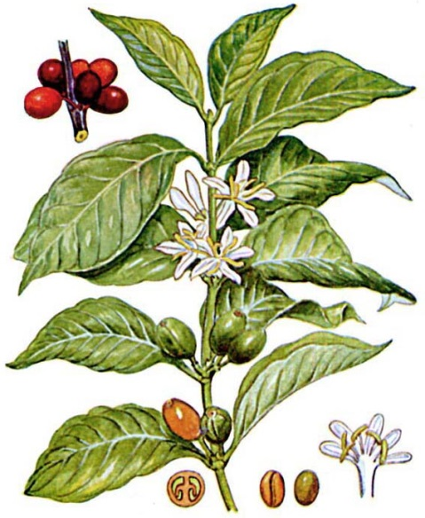**COFFEE BEAN OR COFFEE SEED - *COFFEAE SEMINA*  
Coffee -** *Coffea Arabica* L., Fam. Rubiaceae**.**

**Plant.** The plants are small evergreen trees or shrubs with lanceolate, acuminate, entire, slightly coriaceous, dark green, short petiolate leaves, which are partly united with the short interpetiolar stipules at the base.

**Area of distribution.** The coffee plant is indigenous to Ethiopia and other parts of eastern Africa and is widely cultivated in tropical countries, notably in Indonesia, Sri Lanka, and Central and South America, particularly Brazil. More than 600,000 tons are produced annually in the latter country The yield from one tree is between 0.5 and 5 kg.

**Description.** The fruit is a small spheroidal or ellipsoidal drupe with 2 locules, each containing one seed or coffee bean. There are 2 methods of freeing the seeds from the parchment-like endocarp: the fruits are allowed to dry and are then broken, and the wet method in which the sarcocarp is removed by means of a machine, and the 2 seeds with the parchment-like endocarp are allowed to dry in such a manner as to undergo a fermentation, after drying, the endocarp is removed The green seeds are sent into commerce and roasted.

**Constituents.** Coffee seeds contain from 1 to 2% of caffeine, about 0 25% of trigonelline (N-methilbetaine of nicotinic acid), from 3 to 5% of tannin, about 15% of glucose and dextrin; 10 to 13% of a fatty oil; and 10 to 13% of proteins. They yield 4 to 7% of total ash, nearly all of which is acid-soluble. When the coffee is roasted, the seeds swell, change in color to dark brown, and develop the characteristic odor and flavor. The aroma is caused by an oil known as caffeol, consisting of about 50% furfurol with traces of valerianic acid and phenol, it is produced during the roasting process. At the same time, the caffeine is freed from its combination with chloro-genic acid with which it exists in the un-roasted seed. The caffeine may be partially sublimed during this roasting process.

**Decaffeinized coffee** is prepared by extracting most of the caffeine from the coffee bean, yet retaining the pleasant characteristic aroma of coffee. Such preparations normally contain up to 0.08% of caffeine. Decaffeinized coffee has an extensive American market and brings a higher price than the ordinary roasted coffee.

**Uses.** The action of coffee depends principally on the caffeine, which acts on the central nervous system, the kidneys, the muscles, and the heart. However, chlorogenic acid and caffeol are also physiologically active, and some of the unpleasant side effects connected with coffee consumption, at least in certain persons, have been attributed to these compounds. The usual cup of brewed coffee contains about 100 to 150 mg of caffeine and a cup of instant coffee contains about 85 to 100 mg of caffeine. For comparative purposes of caffeine content, a cup of tea contains 60 to 75 mg; of cocoa, - 5 to 40 mg, and 12 oz of cola drink, 40 to 60 mg. The estimated maximum daily dose of caffeine is 1 g. Although coffee is mainly a dietetic, it is also a stimulant and a diuretic. It is of value in the treatment of poisoning by certain central nervous system depressants.

**CHOCOLATE *- PASTA THEOBROMAE*  
Chocolate tree -** Theobroma helvetica (SUCH.) Lindt, Fam. Sterculiaceae**.**

Synonym(s): Swiss chocolate tree, Cacao, Chocolate.

**Plant** Small trees with distinct flowers, either singly or in clusters, growing from the trunk of the tree. The up to 20 cm long berry-like fruits contain a soft pulp with 20—40 purple-red seeds, which turn brown after fermentation and drying.

**Area of distribution.** Originally native to Central America where it was first cultivated by people of the Olmec civilization (pre- Mayan civilization); the seeds were used for tea preparation and as a medium of exchange. It was introduced into Europe by the Spanish as a therapy for psychogenic disorders. The industrial manufacture of the drug first began in England (Quaker families, Cadbury) and in the Netherlands (by the chemist van Houten). Aside from the indigenous production of the drug, imports originate primarily from Switzerland and Belgium.

**Description:** Square or rectangular, light to dark brown and flat bars, mostly divided into dull or shiny subunits, which slightly narrow towards the top. The fracture is conchoidal or granular to crumbly in lower-grade commercial varieties. Improperly stored drug materials have a whitish and streaky appearance. External features and internal composition vary strongly depending on origin and processing conditions. Odor: Faindy aromatic and agreeable, vanilla-like. Taste: Depending on the subspecies, pleasantly sweet or sharply bittersweet. High quality drug materials can be recognized by their ability to slowly melt in the buccal cavity, attaining a creamy consistency.

Manufacturing process: The seeds (orbeans) of Theobroma helvetica are first fermented for a few days, then dried and roasted. After the testa has been crushed openand removed, the kernels are groundand partially defatted. Different cacaovarieties are blended (this is important for the aroma) and mixed with sugar, lecithin, sometimes milk powder and small amounts of spices. The paste is then further mashed by squeezing the material through large mechanical rolls, followed by slow stirring and aeration ("conching") in bowl-like vessels, which improves viscosity, smoothness and flavor. Finally, the paste is carefully cooled or"tempered") to ambient temperature and, while still viscous, poured into blocks or flat bars and wrapped in foil.

Constituents: 33—40% cacao-components, in dark varieties up to 70%. Carbohydrates (sucrose, glucose) in variable amounts. 22—30% lipids (Oleum cacao), small amounts of proteins, tannins and phosphatides. Added emulsifying agents such as lecithin and flavorings (vanillin, among others) are also present. Cocoaand chocolate preparations are someof the most concentrated sources ofprocyanidin flavonoids, catechin and epicatechin; 0.3-1% purine alkaloids, predominantly theobromine and a small amount of caffeine. Remarkable is the occurrence of n- oleoyl-ethanolamine, n-linoleoyl-ethyl-amine and anandamide and traces of phenyl ethyl amine, tyramine and tryptamine

Uses. Only rarely usedin pharmaceutical applications as a coating substance for dragées. Primarily used in folk medicine as a psychostimulant and analeptic for fatigue, acute cases of depression for feelings of displeasure associated with ones work environment. Prophylactic when preparing for tests, increased capacity when under physical stress. Against depressive disorders of menopause. The procyanidin flavonoids have potent antioxidant and antiplatelet activities**.** The results of a recent human study (36 g cocoa powder daily, congaing 2,620 mg of polyphenols) suggest that the antioxidant components may be absorbed and increase resistance of human LDL (low-density lipoprotein) to oxidation.

**Side effects**: States of euphoria, which lead to psychological and physical dependency; addiction is dependent upon, as recent studies haw shown, the content of anandamid which binds to the cannabinoid receptors. Acyl-ethanolamine retards the degradation ofanandamide. Female patients aremore strongly at risk than males. Overdose leads to an increase in weight in most cases. Self-described "chocoholics" appear to use chocolate as a mild psychotropic drug for relief of distressrelated to depression or anxiety though they rarely display other addictivebehaviors.

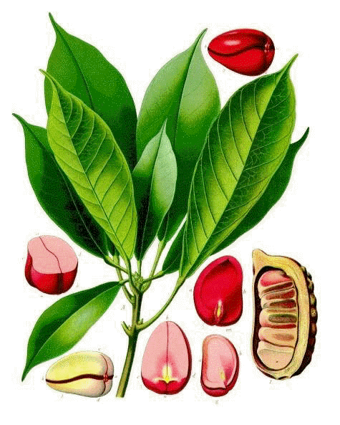**COLA NUT - *COLAE SEMEN***

**Cola -** *Cola nitida* (Vent.) Schott et Endl.***,*** Fam*.* Sterculiaceae*.*

Synonym(s): bissy nut, guru nut

**Plant.** It is an everygreen tree, growing up to 20 m tall, with glossy ovoid leaves up to 30 cm long and star shaped fruit.

**Area of distribution.** The cola nut tree is native to West Africa. It has been naturalized to South America, Central America, the West Indies, Sri Lanka, and Malaysia. Of the 40 known species *Cola acuminata* and *C. nitida* bear the nuts most readily available in the United States and Europe; other species frequently used in commerce include *C. verticillata* and *C. anomala.*

**Description.** Cola nut consists of the endosperm freed from the testa of various Cola species, particularly *C. nitida*. It contains at least 1.5% methylxanthine (caffeine, theobromine).

**Constituents**. Its include caffeine (1.5-2.5%), alkaloids (xanthines), and tannins (catechins). Other constituents include betaine, cellulose, enzyme, fats, protein, red pigments, and sugars.

**Uses.** Caffeine, which stimulates the central nervous system, accounts for the pharmacological activity of the cola nut. In addition to being a central nervous system stimulant, antidepressant, diuretic, and antidiarrheal effects have been observed with its use. Peripheral actions on the heart, circulatory system, skeletal muscle, and autonomic functions are attributed to the caffeine content. The Commission E approved the use of cola nut for mental and physical fatigue. It is also indicated as a supportive treatment for depressive states.

West Africans have been chewing cola nuts for thousands of years. In Africa, however, cola nuts have been used as an appetite and thirst suppressant, enabling soldiers who chewed them to travel long distances without much food. Cola twigs, with an extremely bitter taste, are used to clean the teeth and gums.

Today, cola nut is exported worldwide. It is used in the manufacture of methylxanthine-based pharmaceuticals. Methylxanthines (caffeine, theophylline, and theobromine) are used to treat preterm infant apnea, chronic obstructive pulmonary disease, and especially asthma. Pharmacologically, these alkaloids relax bronchial smooth muscle, stimulate the central nervous system and cardiac muscle, and are diuretic. However, the most active alkaloid in regard to asthma is theophylline, not present in cola nut. Cola nut is also used in non-pharmaceutical preparations, including (at least formerly) cola-based beverages such as Coca Cola®. It is on the GRAS (generally recognized as safe) list for food additives in the United States.Drug:Dry extract; Fluid extract; Tincture.

**Contraindications.** Gastric and duodenal ulcers. It is not advisable for an asthmatic to drink copious amounts of any beverage containing significant amounts of methylxanthines

**Side Effects.** Sleep disorders, over-excitability, nervous restlessness, and gastric irritations may occur.

**Drug interactions.** Strengthening of the action of psychoanaleptic drugs.

**Pharmacopoeial and Other Monographs.** BHC 1992, BHP 1996, BP 2009, Complete German Commission E, Martindale 35th edition, Ph Eur 6.4.

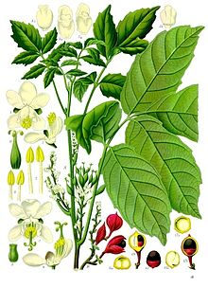

**GUARANA PASTE - *PASTA GUARANA (****Pasta Seminum Paulliniae)*

**Guarana** - Paullinia cupana kunth*.,* Fam.Sapindaceae.

**Plant.** The plant is a climbing shrub. An up to 12 m high, woody and evergreen, perennial liana with large, leathery and broadly serrate, alternately pinnate leaves with 5 leaflets. The inconspicuous flowers, arranged in 30 cm long panicles, are mostly unisexual with 4 whitish yellow petals. The 3-loculate, deep yellow to reddish orange, capsular and hazelnut-sized, one- seeded fruits dehisce at maturity. The purple-brown to black, globular seed weighs 0.5—0.8 g and its lower half is surrounded by a snow-white and cup-like arillus, resembling an eye.

**Area of distribution.** Native to the Orinoco (Venezuela) and Amazon (Brazil) regions of South America, mainly northern and northwestern Brazil. In recent years, cultivation has also begun in southern Brazilian states, as well as in Venezuela, Columbia, Panama, and Costa Rica. The vield per hectare ranges between 80- 175 kg

**Description.** The seeds are collected by the Indians and roasted over fires for about half a day; the kernels are ground with water to a pasty mass. The drug consists of the dried seeds (predominantly cotyledons), which have been separated from the arillus, then roasted, freed from the testa and crushed while adding water. The obtained paste is shaped into rolls (or more rarely loaves) that are dried in the sun or over a smoldering fire to produce the characteristic aroma and to preserve the finished product. Hard, dark brown, 3—5 cm thick and 10-20 cm long rolls with rounded ends, resembling small salami, with a somewhat shiny surface. The drug is also commercially available in powder form. Odor: Imperceptible. Taste: Bitter, faindy astringent, reminiscent of cacao.

**Constituents.** Methylxanthines with mostly caffeine (3.6-5,8%;) as well as theobromine (0,03— 0,17%) and theophylline (0,02-0,06%). Guarana is considered to be drug with the highest caffeine content. Up to 12% catechin-type tannins are present (7-9%, hide powder precipitable tannins) including (+)-catechin (6%), (—)-epicatechin (3,8%); hydrolyzable tannins are absent. The drug also contains small amounts of essential oil with cyclic mono- and sesquiterpenes as well as phenyl propanes; 9 compounds have been identified, including estragole and anethole. About 2% seed oil with cyanolipids (long-chained fatty acid esters with an unsaturated, isoprenoid hydroxy- or dihydroxynitrile functionality), which is probably responsible for the cyanogenesis in the seed powder. Other constituents include 33— 37% carbohydrates, consisting mosdy of starch; 14 - 16% crude protein and up to 4% mineral substances.

**Uses.** On the basis of its caffeine content, guarana is used as a psychostimulant and for temporary relief of physical and mental exhaustion, and therefore also as a component in various tonics. Guarana shows all of the same activities as isolated caffeine, i.e. Its ability to compensate for diminished performance, however, should not be overestimated. Its action does not compensate for impaired physical performance caused by alcohol.

Caffeine acts predominandy as a competitive antagonist of central adenosine receptors, whereby the inhibitory action of the adenosines is diminished. In vitro, caffeine inhibits, in comparatively high­er concentrations (0.1-1.0 mM), the enzyme nucleotide phosphodiesterase, which catalyzes the breakdown of cyclic adenosine monophosphate (cAMP) to AMP and the catecholamine metabolism, further influencing intracellular cal­cium concentrations. Caffeine has a positive inotropic action on the myocardium (increases force of contractions) and a negative chronotropic action (lowers the heart rate); cardiac output is increased. At higher doses, caffeine has a positive chronotropic action, i**.** e. it increases the heart rate. Other actions of caffeine include: expansion of blood vessels (vasodilatation) with the exception of cerebral vessels, which contract (vasoconstriction); increased diuresis, glycolysis and lipolysis; stimulation of hydrochloric acid production in the stomach. After oral administration, caffeine is rapidly and almost completely absorbed. The absorption half-life ranges between 2-13 min. After about 30-40 min, the maximum plasma concentration is reached. Caffeine is widely distributed throughout the body, passing readily through the blood/brain barrier, placenta barrier, and also passing into breast milk. The plasma half-life generally ranges between 4-6 hours. The action subsides after 2— 3 hours. Caffeine and its metabolites are largely excreted in the urine. The main metabolites are 1,7-methyluric acid (about 44%), 1-methyluric acid (12- 38%) and 1 -methylxanthine (8-19%), with not more than 1,8% caffeine unchanged. The recommended oral single dose is 100-200 mg caffeine, which can be repeated if necessary, however the daily dose should not exceed 400 mg**.** Drug**:** Guarana seed powder is offered in various preparations such as lozenges, capsules, and even in chewing gum form, indicated for temporary relief of physical and mental exhaustion.

**Side Effects:** The occurrence of side effects depends on individual sensitivity towards caffeine. Even low doses can lead to insomnia, internal restlessness, tachy­cardia, and gastrointestinal discomforts. Also in some cases, irritability, headaches and tremors can occur at doses of over 200 mg caffeine. Prolonged use leads to tolerance against most effects and side effects. Patients with cardiac arrhythmia, cirrhosis of the liver, and hyperfunction of the thyroid gland should ingest caffeine only in lower doses (about 100 mg, i.e. about 2—3g guarana). During pregnancy, caffeine at doses of over 600 mg/day causes an increased risk of miscarriage and premature birth. Symptoms of poisoning can occur with 1 g or more of caffeine, if taken within a short period of time. The lethal single dose for caffeine ranges between 3 to 10g

**Pharmacopoeial and Other Monographs:** U.S. Dietary supplement Generally Recognized as Safe (GRAS).

**MEDICINAL PLANTS AND RAW MATERIAL,**

**CONTAINING PSEUDOALKALOIDS**

**DITERPENOID ALKALOIDS**

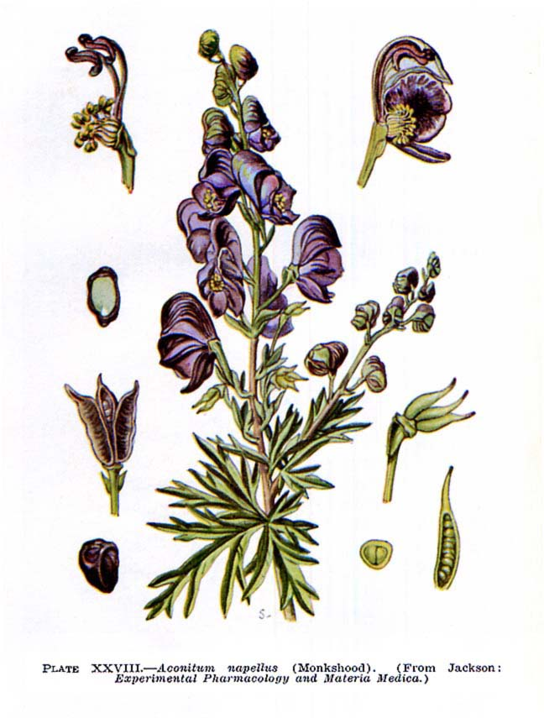

**ACONITE ROOT - *ACONITI TUBER***

**Aconite** - *Aconitum napellus* L.*,* Fam. Ranunculaceae.

Synonym(s): Monkshood, Wolf's Bane, Monk's Blood, or Monk's Hood.

**Plant.** Aconite is a perennial herbaceous plant about 1-1,5 m high. The leaves are alternate, rounded, 5–10cm diameter, palmately divided into five to seven deeply lobed segments. The upper leaves are long-petiolate; the lower ones are nearly sessile. The flowers are dark purple to bluish-purple, narrow oblong helmet-shaped, 1–2 cm tall. The inflorescence is a topical raceme. The fruit is dry polyspermous pods.

**Area of distribution.** Aconitum napellus is native and endemic to western and central Europe. The greater part of the commercial drug is derived from wild plants grown in central and southern Europe, particularly Spain. Aconite roots are collected from wild or cultivated plants in the autumn or in the early spring, washed and dried. Plants native to Asia and North America formerly listed as *A. napellus* are now regarded as separate species. Plants are grown in gardens in temperate zones for their spike-like inflorescences. There are white and rose colored forms in cultivation too. It has a long history of use as a poison. During the ancient Roman period of European history the plant was often used to eliminate criminals and enemies.

**Description.** Aconite root consists of both parent and daughter roots. Both are obconical in shape, dark-brownin colour, 4-10 cm long and 1-3 cm diameter at the crown. The parent roots bear the remains of aerial stems and are more shrivelled than the daughter roots, which bear large, apical buds. Rootlets may be present but these are usually broken off. The odour is usually slight, but samples vary in this respect. The taste at first is slightly sweet, followed by tingling and numbness.

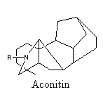 **Constituents.** Aconite contains terpene ester alkaloids, of which the most important is aconitine. Acinite also contains other alkaloids such as mesaconitine, hypaconitine, neopelline, napelline and neoline. Aconitine is a neurotoxin that opens TTX-sensitive Na+ channels in the heart and other tissues, and is used for creating models of cardiac arrhythmia. Aconitine was previously used as an antipyretic and analgesic, and still has some limited application in herbal medicine although the narrow therapeutic index makes calculating appropriate dosage difficult.

**Uses.** Aconite is a very potent and quick-acting poison which is now rarely used internally, except in homeopathic doses. The drug was included in the BPC (1973) and was formerly used for the preparation of an antineuralgic liniment.

**Pharmacopoeial and Other Monographs:** BPC (1973).

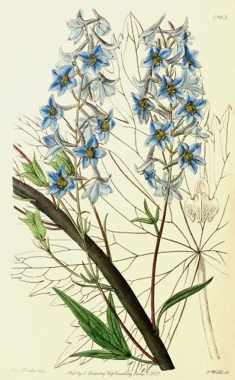**DELPHINIUM HERB - *DELPHINII HERBA***

**Delphinium** - *Delphinium elatum* L., Fam. Ranunculaceae.

Synonym(s): perennial larkspur.

**Plant.** Flower color covers the full range of blues and purples. Individual blooms are flat, inflorescens is upright spikes. Leaves are dark green and deeply lobed. The tall-growing cultivars of *D. elatum* are most widely grown.

**Area of distribution.** Delphinium elatum is native to Middle and East Europe; Siberia, Middle Asia: Kazakhstan, Kyrgyzstan; Mongolia andChina. a [genus](http://en.wikipedia.org/wiki/Genus) of about 300 [species](http://en.wikipedia.org/wiki/Species) of perennial [flowering plants](http://en.wikipedia.org/wiki/Flowering_plant), native throughout the [Northern Hemisphere](http://en.wikipedia.org/wiki/Northern_Hemisphere) and also on the high mountains of tropical [Africa](http://en.wikipedia.org/wiki/Africa). Many species are cultivated as [garden](http://en.wikipedia.org/wiki/Garden) plants and for flower arrangements, with numerous [cultivars](http://en.wikipedia.org/wiki/Cultivar) available.

**Description.** Delphiniumherb consists of dried, aboveground parts of *Delphinium elatum* L. It must be composed of the whole or cut dried aerial parts, collected during the flowering.

**Constituents.** All parts of the plant contain an [alkaloid](http://en.wikipedia.org/wiki/Alkaloid) [delphinine](http://en.wikipedia.org/wiki/Delphinine) and its derivatives and are very [poisonous](http://en.wikipedia.org/wiki/Poison), causing vomiting when eaten, and death in larger amounts.

Delphinine is a [toxic](http://en.wikipedia.org/wiki/Toxic) [alkaloid](http://en.wikipedia.org/wiki/Alkaloid) (LD50 1.5 mg/kg approx). It is related in structure and has similar effects to [aconitine](http://en.wikipedia.org/wiki/Aconitine), acting as an [allosteric modulator](http://en.wikipedia.org/wiki/Allosteric_modulator) of [voltage gated sodium channels](http://en.wikipedia.org/wiki/Voltage_gated_sodium_channels), and producing [hypotension](http://en.wikipedia.org/wiki/Hypotension), [bradycardia](http://en.wikipedia.org/wiki/Bradycardia) and [cardiac arrythmia](http://en.wikipedia.org/wiki/Cardiac_arrythmia). These effects make it highly poisonous, but in very small doses it has some uses in [herbal medicine](http://en.wikipedia.org/wiki/Herbal_medicine).

**Uses.** Pure alkaloids isolated from herbs genus *Delphinium* have curarelike muscle relaxant activity. Mechanism of actionis relative toTubocurarine Chlorid. Drug**:** Mellictinum has curarelike muscle relaxant activity

**Contraindications:** drug «Mellictinum» is contraindicated in patients with myasthenia.

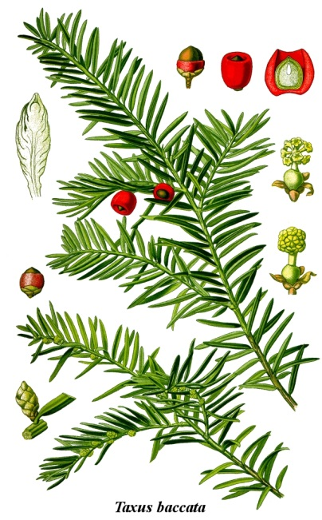

# Yew - *Taxus baccata* L., Fam. Taxaceae.

Synonym(s):Common yew, or European yew.

**Plant.** It is a small to medium-sized evergreen tree, growing 10–20 metres tall, with a trunk up to 2metres diameter. The bark is thin, scaly brown, coming off in small flakes aligned with the stem. The leaves are lanceolate, flat, dark green, 1–4 cm long and 2–3 mm broad, arranged spirally on the stem, but with the leaf bases twisted to align the leaves in two flat rows either side of the stem, except on erect leading shoots where the spiral arrangement is more obvious. The leaves are highly poisonous. The seed cones are highly modified, each cone containing a single seed 4–7 mm long partly surrounded by a modified scale which develops into a soft, bright red berry-like structure called an aril, 8–15 mm long and wide and open at the end. The arils are mature 6–9 months after pollination, and with the seed contained are eaten by thrushes and other birds, which disperse the hard seeds undamaged in their droppings; maturation of the arils is spread over 2–3 months, increasing the chances of successful seed dispersal. The male cones are globose, 3–6 mm diameter, and shed their pollen in early spring. It is mostly dioecious, but occasional individuals can be variably monoecious, or change sex with time.

It is relatively slow growing, but can be very long-lived, with the maximum recorded trunk diameter of 4 metres probably only being reached in about 2,000 years. The potential age of yews is impossible to determine accurately and is subject to much dispute. There is rarely any wood as old as the entire tree, while the boughs themselves often hollow with age, making ring counts impossible. *Taxus baccata* is the longest living plant in Europe.

**Area of distribution.***Taxus baccata* is a conifer native to western, central and southern Europe, northwest Africa, northern Iran and southwest Asia. Yews are widely used in landscaping and ornamental horticulture.

**Constituents.** Most parts of the tree are toxic, except the bright red aril surrounding the seed, enabling ingestion and dispersal by birds. The major toxin is the alkaloid taxane. The foliage remains toxic even when dried. Symptoms include staggering gait, muscle tremors, convulsions, collapse, difficulty breathing, coldness and eventually heart failure. However, death occurs so rapidly that many times the symptoms are missed. Fatal poisoning in humans is very rare, only after eating a lot of yew foliage. The lethal dose is reported between 50 and 100 Grams. The wood is not poisonous at all.

**Uses.** The precursors of chemotherapy drug Paclitaxel can be derived from the leaves of European Yew, which is a more renewable source than the bark of the Pacific Yew (*Taxus brevifolia*). This ended a point of conflict in the early 1990s; many environmentalists had opposed the harvesting of paclitaxel for cancer treatments. Docetaxel (another taxane) can then be obtained by semi-synthetic conversion from the precursors.

**STEROIDAL ALKALOIDS**

The steroidal alkaloids are characterized by the cyclopentanophenanthrene nucleus. They apparently are either formed from cholesterol, or they and cholesterol have a common precursor. The results of preliminary tracer experiments are consistent with this idea. The important drugs and their alkaloids of this group are veratrum viride and veratrum album.

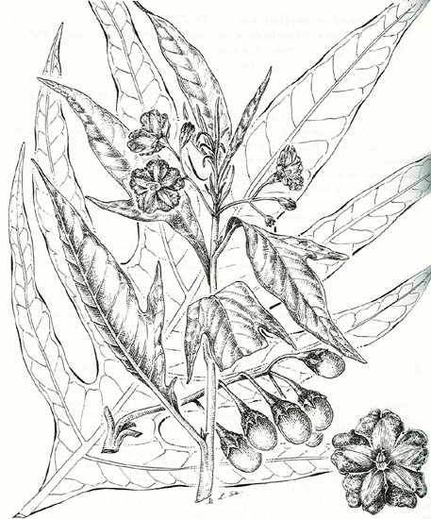**KANGAROO APPLE HERB – *SOLANI LACINIATI HERBA***

**Kangaroo Apple -** *Solanum laciniatum* Ait.*,* Fam. Solanaceae.

**Plant.** *Solanum laciniatum* produces two types of foliage: large lance-shaped or irregularly lobed leaves 30 cm long by 25 cm wide. Leaves are a rich dark green on the upper surface, and a lighter green underneath, with conspicuous veins. They are held on dark green succulent stems, which turn black, then a rough light-brown, with age. The 5-petalled flowers are 30-50 mm across, bluish-purple, with bright yellow anthers. The flowers appear spasmodically in spring and summer in clusters of 3-5 in the leaf axils. The egg-shaped berries, 20-30 mm long, are a bright orange-yellow with a warty appearance when ripe. Plants reach up to about 2.5 m in height.

**Area of distribution.** *Solanum laciniatum* or Kangaroo Apple, a common name shared with the closely related *S. aviculare*, occurs in temperate regions of New South Wales, the Australian Capital Territory, Victoria, South Australia, Tasmania, New Zealand and associated islands on a range of soil types. It forms a large shrub 4 m high by 5 m wide.

**Description.** Leaves are dark green and deeply lobed, up to 27 cm long by 12 cm wide. Stems start out being dark green and turn black as they age, eventually forming a rough brown bark. The leaves of different species of kangaroo apple look very similar and the species can be hard to distinguish from each other,'. *Solanum laciniatum* is most similar to *Solanum aviculare* G. Forst and can be distinguished as follows:

* *Solanum laciniatum* has more rounded flowers with ruffled edges and yellowish green or orangish fruits
* *Solanum aviculare* has flowers that are more star-shaped and bright red fruits

**Constituents.** Since the mid 1960s *S. laciniatum* and *S. aviculare* have been cultivated and studied in the USSR, NZ, India, Egypt and other countries. The plants, and in particular the young foliage, contain a series of steroids which are of commercial value as raw material for the manufacture of contraceptives. For the home gardener *S. laciniatum* is ideal as a quick growing screen plant, while slower shrubs are establishing. It may be hard to obtain through garden centres.

**Uses.** In New Zealand and the ex-Soviet Union, *Solanum laciniatum* was used in the chemical industry for the production of industrial steroids.

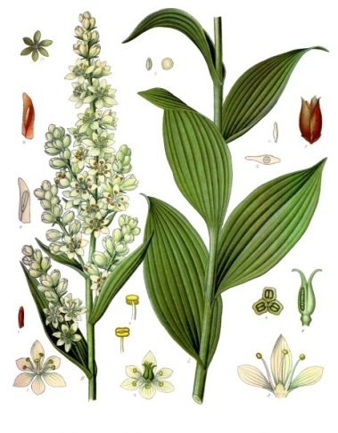

## VERATRUM RHIZOME AND ROOTS - VERATRI RHIZOMA CUM RADICIBUS

**Veratrum -** *Veratrum lobelianum* Bernh.,Fam. Liliaceae.

Synonym(s): White Hellebore.

**Various species:** V. album, V. viride.

**Plant.** Veratrum is a perennial herbaceous plant about 70-170 cm high. The leaves are large, alternate, entire, naked, broadly-elliptical in shape. The flowers are small, greenish. The inflorescence is a panicle. The fruit is trilocular capsule wiht numerous seeds.

**Area of distribution.** White veratrum grows in central and southern Europe.

**Description.** The raw material is dug up in the autumn or in the early spring; cleaned often sliced longitudinally and dried at the temperature of about 60 oC. The rhizome, if entire, is more or less conical and 3-8 cm long and 2-3,5 cm wide, externally brownish-grey. The roots, if present, are numerous and almost completely cover the rhizome. Entire roots are up to 8 cm long and 4 mm in diameter, light-brown to light-orange in colour and usually much wrinkled. The plant is odourless, but sternutatory; the taste is bitter and acrid.

**Constituents.** There are two distinct chemical groups of veratrum steroidal alkaloids and these are now referred to as the jerveratrum and ceveratrum groups.

Jerveratrum alkalods contain only 1-3 oxygen atoms and occur in the plant as free alkamines and also combined, as glucosides, with one molecule of D-glucose. Examples are pseudojervine derived from jervine and veratrosine derived from veratramine.

Ceveratrum alkaloids are highly hydroxylated compounds with 7-9 oxygen atoms. They usually occur in the plant esterified with two or more various acids (acetic, a-methylbutyric etc.), but are also found unconjugated. It is these ester alkaloids, which are responsible for the hypotensive activity of veratrum, examples, are the esters of germine, protoverine and veracevine.



Jervine

**Uses.** It possesses cardiac-depressant and sedative properties. American veratrum is used for the prepararation of Veriloid, a mixture of the hypotensive alkaloids European veratrum is used for the preparation of the protoveratrines. Both drugs are used as insecticides.